UNITED STATES SECURITIES AND EXCHANGE COMMISSION

Washington, D.C. 20549

Form 10-Q

- QUARTERLY REPORT PURSUANT TO SECTION 13 OR 15(d) OF THE SECURITIES EXCHANGE ACT OF 1934

For the Quarterly Period Ended June 30, 2019

or

- TRANSITION REPORT PURSUANT TO SECTION 13 OR 15(d) OF THE SECURITIES EXCHANGE ACT OF 1934

For the transition period from | to
 | Commission File Number 000-29472
AMKOR TECHNOLOGY, INC.
 | (Exact name of registrant as specified in its charter)
Delaware |  | 23-1722724
(State of incorporation) |  | (I.R.S. Employer
 | 2045 East Innovation Circle | Identification Number)
 | Tempe, AZ 85284
(Address of principal executive offices and zip code)
 | (480) 821-5000
(Registrant’s telephone number, including area code)
Securities registered pursuant to Section 12(b) of the Act:
Title of Each Class | Trading Symbol | Name of Each Exchange on Which Registered
Common Stock, $0.001 par value | AMKR | The NASDAQ Global Select Market

Indicate by check mark whether the registrant: (1) has filed all reports required to be filed by Section 13 or 15(d) of the Securities Exchange Act of 1934, during the preceding 12 months (or for such shorter period that the registrant was required to file such reports), and (2) has been subject to filing requirements for the past 90 days. Yes ☑ No ☐

Indicate by check mark whether the registrant has submitted electronically every Interactive Data File required to be submitted pursuant to Rule 405 of Regulation S-T (§ 232.405 of this chapter) during the preceding 12 months (or for such shorter period that the registrant was required to submit such files). Yes ☑ No ☐

Indicate by check mark whether the registrant is a large accelerated filer, an accelerated filer, a non-accelerated filer, a smaller reporting company, or an emerging growth company. See the definitions of “large accelerated filer,” “accelerated filer,” “smaller reporting company,” and “emerging growth company” in Rule 12b-2 of the Exchange Act. (Check one):

☑

☐

☐

☐

☐

Large accelerated filer

Accelerated filer

Non-accelerated filer

Smaller reporting company

Emerging growth company

If an emerging growth company, indicate by check mark if the registrant has elected not to use the extended transition period for complying with any new or revised financial accounting standards provided pursuant to Section 13(a) of the Exchange Act. ☐

Indicate by check mark whether the registrant is a shell company (as defined in Rule 12b-2 of the Exchange Act). Yes ☐ No ☑ The number of outstanding shares of the registrant’s Common Stock as of July 26, 2019 was 239,704,033.

QUARTERLY REPORT ON FORM 10-Q

For the Quarter Ended June 30, 2019

TABLE OF CONTENTS

 |  |  |  |  |  |  |  |  |  |  |  |  |  |  |  |  |  |  |  |  |  |  | Page
 |  |  |  |  |  |  |  |  |  |  | PART I. Financial Information
Item 1. |  |  | Financial Statements (unaudited) |  |  |  |  |  |  |  |  |  |  |  |  |  |  |  |  |  |  |  | 2
 |  |  | Consolidated Statements of Income - Three and Six Months Ended June 30, 2019 and 2018 |  |  |  |  |  |  |  |  |  |  |  |  |  |  |  |  |  |  |  | 2
 |  |  | Consolidated Statements of Comprehensive Income - Three and Six Months Ended June 30, 2019 and
 |  |  |  |  | 2018 |  |  |  |  |  |  |  |  |  |  |  |  |  |  |  |  |  | 3
 |  |  | Consolidated Balance Sheets - June 30, 2019 and December 31, 2018 |  |  |  |  |  |  |  |  |  |  |  |  |  |  |  |  |  |  |  | 4
 |  |  | Consolidated Statements of Stockholders’ Equity — Three and Six Months Ended June 30, 2019 and
 |  |  |  |  | 2018 |  |  |  |  |  |  |  |  |  |  |  |  |  |  |  |  |  | 5
 |  |  | Condensed Consolidated Statements of Cash Flows - Six Months Ended June 30, 2019 and 2018 |  |  |  |  |  |  |  |  |  |  |  |  |  |  |  |  |  |  |  | 7
 |  |  | Notes to Consolidated Financial Statements |  |  |  |  |  |  |  |  |  |  |  |  |  |  |  |  |  |  |  | 8
Item 2. |  |  | Management’s Discussion and Analysis of Financial Condition and Results of Operations |  |  |  |  |  |  |  |  |  |  |  |  |  |  |  |  |  |  |  | 20
Item 3. |  |  | Quantitative and Qualitative Disclosures About Market Risk |  |  |  |  |  |  |  |  |  |  |  |  |  |  |  |  |  |  |  | 27
Item 4. |  |  | Controls and Procedures |  |  |  |  |  |  |  |  |  |  |  |  |  |  |  |  |  |  |  | 29
 |  |  |  |  |  |  |  |  |  |  |  | PART II. Other Information
Item 1. |  |  | Legal Proceedings |  |  |  |  |  |  |  |  |  |  |  |  |  |  |  |  |  |  |  | 30
Item 1A. |  |  | Risk Factors |  |  |  |  |  |  |  |  |  |  |  |  |  |  |  |  |  |  |  | 30
Item 2. |  |  | Unregistered Sales of Equity Securities and Use of Proceeds |  |  |  |  |  |  |  |  |  |  |  |  |  |  |  |  |  |  |  | 47
Item 3. |  |  | Defaults Upon Senior Securities |  |  |  |  |  |  |  |  |  |  |  |  |  |  |  |  |  |  |  | 47
Item 4. |  |  | Mine Safety Disclosures |  |  |  |  |  |  |  |  |  |  |  |  |  |  |  |  |  |  |  | 47
Item 5. |  |  | Other Information |  |  |  |  |  |  |  |  |  |  |  |  |  |  |  |  |  |  |  | 47
Item 6. |  |  | Exhibits |  |  |  |  |  |  |  |  |  |  |  |  |  |  |  |  |  |  |  | 48
Signatures |  |  |  |  |  |  |  |  |  |  |  |  |  |  |  |  |  |  |  |  |  |  |  | 49

This report contains forward-looking statements within the meaning of the federal securities laws, including but not limited to statements regarding (1) the amount, timing and focus of our expected capital investments in 2019 including expenditures in support of advanced packaging and test equipment, (2) our ability to fund our operating activities and financial requirements for the next twelve months, (3) the effect of changes in revenue levels and capacity utilization on our gross margin, (4) the focus of our research and development activities, (5) the anticipated impact of the Tax Cuts and Jobs Act (the “Tax Act”) on our taxes, (6) the grant and expiration of tax holidays in jurisdictions in which we operate and expectations regarding our effective tax rate and the availability of tax incentives, (7) the creation or release of valuation allowances related to taxes in the future, (8) our repurchase or repayment of outstanding debt, (9) payment of dividends, (10) compliance with our covenants, (11) expected contributions to foreign pension plans, (12) liability for unrecognized tax benefits and the potential impact of our unrecognized tax benefits on our effective tax rate, (13) the effect of foreign currency exchange rate exposure on our financial results, (14) the volatility of the trading price of our common stock, (15) changes to our internal controls related to integration of acquired operations and implementation of an enterprise resource planning system, (16) our efforts to enlarge our customer base in certain geographic areas and markets, (17) demand for advanced packages in mobile and automotive devices and our technology leadership and potential growth in this market, and (18) other statements that are not historical facts. In some cases, you can identify forward-looking statements by terminology such as “may,” “will,” “should,” “expects,” “plans,” “anticipates,” “believes,” “estimates,” “predicts,” “potential,” “continue,” “intend” or the negative of these terms or other comparable terminology. Because such statements include risks and uncertainties, actual results may differ materially from those anticipated in such forward-looking statements as a result of various factors, including those set forth in the following report as well as in Part II, Item 1A of this Quarterly Report on Form 10-Q.

-1-

Table of Contents

 |  | PART I. FINANCIAL INFORMATION
Item 1. | Financial Statements
 |  | AMKOR TECHNOLOGY, INC.
 |  | CONSOLIDATED STATEMENTS OF INCOME
 |  |  |  | (Unaudited)
 |  |  |  | For the Three Months Ended June 30, |  |  |  |  |  | For the Six Months Ended June 30,
 |  |  |  | 2019 |  |  | 2018 |  |  | 2019 |  |  | 2018
 |  |  |  |  |  |  | (In thousands, except per share data)
Net sales |  | $ |  | 895,305 |  | $ | 1,065,684 |  | $ | 1,790,269 |  | $ | 2,091,003
Cost of sales |  |  |  | 771,851 |  |  | 895,967 |  |  | 1,546,054 |  |  | 1,763,515
Gross profit |  |  |  | 123,454 |  |  | 169,717 |  |  | 244,215 |  |  | 327,488
Selling, general and administrative |  |  |  | 64,758 |  |  | 74,700 |  |  | 136,345 |  |  | 155,423
Research and development |  |  |  | 36,186 |  |  | 41,076 |  |  | 71,940 |  |  | 82,005
Total operating expenses |  |  |  | 100,944 |  |  | 115,776 |  |  | 208,285 |  |  | 237,428
Operating income |  |  |  | 22,510 |  |  | 53,941 |  |  | 35,930 |  |  | 90,060
Interest expense |  |  |  | 18,653 |  |  | 21,127 |  |  | 37,926 |  |  | 41,138
Other (income) expense, net |  |  |  | 6,966 |  |  | (11,001) |  |  | 2,401 |  |  | (7,569)
Total other expense, net |  |  |  | 25,619 |  |  | 10,126 |  |  | 40,327 |  |  | 33,569
Income (loss) before taxes |  |  |  | (3,109) |  |  | 43,815 |  |  | (4,397) |  |  | 56,491
Income tax expense |  |  |  | 5,897 |  |  | 10,631 |  |  | 27,277 |  |  | 13,112
Net income (loss) |  |  |  | (9,006) |  |  | 33,184 |  |  | (31,674) |  |  | 43,379
Net income attributable to non-controlling interests |  |  |  | (444) |  |  | (593) |  |  | (655) |  |  | (1,244)
Net income (loss) attributable to Amkor |  | $ |  | (9,450) |  | $ | 32,591 |  | $ | (32,329) |  | $ | 42,135
Net income (loss) attributable to Amkor per common share:
Basic |  |  | $ | (0.04) |  | $ | 0.14 |  | $ | (0.14) |  | $ | 0.18
Diluted |  | $ |  | (0.04) |  | $ | 0.14 |  | $ | (0.14) |  | $ | 0.18
Shares used in computing per common share amounts:
Basic |  |  |  | 239,508 |  |  | 239,351 |  |  | 239,461 |  |  | 239,283
Diluted |  |  |  | 239,508 |  |  | 239,804 |  |  | 239,461 |  |  | 239,805

The accompanying notes are an integral part of these statements.

- 2-

Table of Contents

AMKOR TECHNOLOGY, INC.

CONSOLIDATED STATEMENTS OF COMPREHENSIVE INCOME

(Unaudited)

 |  | For the Three Months Ended June 30, |  |  |  |  |  | For the Six Months Ended June 30,
 |  | 2019 |  |  | 2018 |  |  | 2019 |  |  | 2018
 |  |  |  |  | (In thousands)
Net income (loss) | $ | (9,006) |  | $ | 33,184 |  | $ | (31,674) |  | $ | 43,379
Other comprehensive income (loss), net of tax:
Adjustments to unrealized components of defined benefit pension plans |  | (57) |  |  | (42) |  |  | (189) |  |  | (81)
Foreign currency translation |  | 5,918 |  |  | (11,144) |  |  | 3,694 |  |  | 3,947
Total other comprehensive income (loss) |  | 5,861 |  |  | (11,186) |  |  | 3,505 |  |  | 3,866
Comprehensive income (loss) |  | (3,145) |  |  | 21,998 |  |  | (28,169) |  |  | 47,245
Comprehensive income attributable to non-controlling interests |  | (444) |  |  | (593) |  |  | (655) |  |  | (1,244)
Comprehensive income (loss) attributable to Amkor | $ | (3,589) |  | $ | 21,405 |  | $ | (28,824) |  | $ | 46,001

The accompanying notes are an integral part of these statements.

- 3-

Table of Contents

AMKOR TECHNOLOGY, INC.

CONSOLIDATED BALANCE SHEETS

(Unaudited)

 |  | June 30, |  |  | December 31,
 |  | 2019 |  |  | 2018
 |  | (In thousands, except per share data)
ASSETS
Current assets:
Cash and cash equivalents | $ | 551,438 |  | $ | 681,569
Restricted cash |  | 2,590 |  |  | 2,589
Accounts receivable, net of allowances |  | 702,466 |  |  | 724,456
Inventories |  | 217,638 |  |  | 230,589
Other current assets |  | 38,988 |  |  | 32,005
Total current assets |  | 1,513,120 |  |  | 1,671,208
Property, plant and equipment, net |  | 2,515,533 |  |  | 2,650,448
Operating lease right of use asset |  | 132,763 |  |  | —
Goodwill |  | 26,159 |  |  | 25,720
Restricted cash |  | 2,878 |  |  | 3,893
Other assets |  | 118,831 |  |  | 144,178
Total assets | $ | 4,309,284 |  | $ | 4,495,447
LIABILITIES AND EQUITY
Current liabilities:
Short-term borrowings and current portion of long-term debt | $ | 198,230 |  | $ | 114,579
Trade accounts payable |  | 459,548 |  |  | 530,398
Capital expenditures payable |  | 134,500 |  |  | 255,237
Accrued expenses |  | 246,615 |  |  | 258,209
Total current liabilities |  | 1,038,893 |  |  | 1,158,423
Long-term debt |  | 1,109,945 |  |  | 1,217,732
Pension and severance obligations |  | 174,897 |  |  | 184,321
Long-term operating lease liability |  | 80,049 |  |  | —
Other non-current liabilities |  | 74,324 |  |  | 79,071
Total liabilities |  | 2,478,108 |  |  | 2,639,547
Commitments and contingencies (Note 15)
Stockholders’ equity:
Preferred stock, $0.001 par value, 10,000 shares authorized, designated Series A, none issued |  | — |  |  | —
Common stock, $0.001 par value, 500,000 shares authorized; 285,510 and 285,352 shares issued; and 239,532 and 239,385 shares
outstanding in 2019 and 2018, respectively |  | 285 |  |  | 285
Additional paid-in capital |  | 1,913,103 |  |  | 1,909,425
Retained earnings |  | 80,860 |  |  | 113,189
Accumulated other comprehensive income (loss) |  | 27,317 |  |  | 23,812
Treasury stock, at cost, 45,978 and 45,967 shares, in 2019 and 2018, respectively |  | (216,254) |  |  | (216,171)
Total Amkor stockholders’ equity |  | 1,805,311 |  |  | 1,830,540
Non-controlling interests in subsidiaries |  | 25,865 |  |  | 25,360
Total equity |  | 1,831,176 |  |  | 1,855,900
Total liabilities and equity | $ | 4,309,284 |  | $ | 4,495,447

The accompanying notes are an integral part of these statements.

- 4-

Table of Contents

AMKOR TECHNOLOGY, INC.

CONSOLIDATED STATEMENTS OF STOCKHOLDERS’ EQUITY

(Unaudited)

 | Common Stock |  |  |  |  |  |  |  |  |  |  |  | Accumulated |  |  | Treasury Stock
 |  |  |  |  |  |  |  |  |  |  |  |  | Other |  |  |  |  |  |  |  |  | Total Amkor |  |  | Noncontrolling
 |  |  |  |  |  |  | Additional Paid- |  |  |  |  |  | Comprehensive |  |  |  |  |  |  |  |  | Stockholders’ |  |  | Interest in |  |  | Total
 | Shares |  |  | Par Value |  |  | In Capital |  |  | Retained Earnings |  |  | Income (Loss) |  |  | Shares |  |  | Cost |  |  | Equity |  |  | Subsidiaries |  |  | Equity
 |  |  |  |  |  |  |  |  |  |  |  |  | (In thousands)
Balance at March 31, 2019 | 285,430 |  | $ | 285 |  | $ | 1,911,179 |  | $ | 90,310 |  | $ | 21,456 |  |  | (45,972) |  | $ | (216,219) |  | $ | 1,807,011 |  | $ | 25,571 |  | $ | 1,832,582
Net income (loss) | — |  |  | — |  |  | — |  |  | (9,450) |  |  | — |  |  | — |  |  | — |  |  | (9,450) |  |  | 444 |  |  | (9,006)
Other comprehensive income (loss) | — |  |  | — |  |  | — |  |  | — |  |  | 5,861 |  |  | — |  |  | — |  |  | 5,861 |  |  | — |  |  | 5,861
Treasury stock acquired through
surrender of shares for tax
withholding | — |  |  | — |  |  | — |  |  | — |  |  | — |  |  | (6) |  |  | (35) |  |  | (35) |  |  | — |  |  | (35)
Issuance of stock through share-based
compensation plans | 80 |  |  | — |  |  | 150 |  |  | — |  |  | — |  |  | — |  |  | — |  |  | 150 |  |  | — |  |  | 150
Share-based compensation | — |  |  | — |  |  | 1,774 |  |  | — |  |  | — |  |  | — |  |  | — |  |  | 1,774 |  |  | — |  |  | 1,774
Subsidiary dividends to
noncontrolling interests | — |  |  | — |  |  | — |  |  | — |  |  | — |  |  | — |  |  | — |  |  | — |  |  | (150) |  |  | (150)
Balance at June 30, 2019 | 285,510 |  | $ | 285 |  | $ | 1,913,103 |  | $ | 80,860 |  | $ | 27,317 |  |  | (45,978) |  | $ | (216,254) |  | $ | 1,805,311 |  | $ | 25,865 |  | $ | 1,831,176
Balance at December 31, 2018 | 285,352 |  | $ | 285 |  | $ | 1,909,425 |  | $ | 113,189 |  | $ | 23,812 |  |  | (45,967) |  | $ | (216,171) |  | $ | 1,830,540 |  | $ | 25,360 |  | $ | 1,855,900
Net income (loss) | — |  |  | — |  |  | — |  |  | (32,329) |  |  | — |  |  | — |  |  | — |  |  | (32,329) |  |  | 655 |  |  | (31,674)
Other comprehensive income (loss) | — |  |  | — |  |  | — |  |  | — |  |  | 3,505 |  |  | — |  |  | — |  |  | 3,505 |  |  | — |  |  | 3,505
Treasury stock acquired through
surrender of shares for tax
withholding | — |  |  | — |  |  | — |  |  | — |  |  | — |  |  | (11) |  |  | (83) |  |  | (83) |  |  | — |  |  | (83)
Issuance of stock through share-based
compensation plans | 158 |  |  | — |  |  | 436 |  |  | — |  |  | — |  |  | — |  |  | — |  |  | 436 |  |  | — |  |  | 436
Share-based compensation | — |  |  | — |  |  | 3,242 |  |  | — |  |  | — |  |  | — |  |  | — |  |  | 3,242 |  |  | — |  |  | 3,242
Subsidiary dividends to
noncontrolling interests | — |  |  | — |  |  | — |  |  | — |  |  | — |  |  | — |  |  | — |  |  | — |  |  | (150) |  |  | (150)
Balance at June 30, 2019 | 285,510 |  | $ | 285 |  | $ | 1,913,103 |  | $ | 80,860 |  | $ | 27,317 |  |  | (45,978) |  | $ | (216,254) |  | $ | 1,805,311 |  | $ | 25,865 |  | $ | 1,831,176

The accompanying notes are an integral part of these statements.

- 5-

Table of Contents

AMKOR TECHNOLOGY, INC.

CONSOLIDATED STATEMENTS OF STOCKHOLDERS’ EQUITY

(Unaudited)

 | Common Stock |  |  |  |  |  |  |  |  |  |  |  | Accumulated |  |  | Treasury Stock
 |  |  |  |  |  |  |  |  |  | Retained Earnings |  |  | Other |  |  |  |  |  |  |  |  | Total Amkor |  |  | Noncontrolling
 |  |  |  |  |  |  | Additional Paid- |  |  | (Accumulated |  |  | Comprehensive |  |  |  |  |  |  |  |  | Stockholders’ |  |  | Interest in |  |  | Total
 | Shares |  |  | Par Value |  |  | In Capital |  |  | Deficit) |  |  | Income (Loss) |  |  | Shares |  |  | Cost |  |  | Equity |  |  | Subsidiaries |  |  | Equity
 |  |  |  |  |  |  |  |  |  |  |  |  | (In thousands)
Balance at March 31, 2018 | 285,284 |  | $ | 285 |  | $ | 1,905,666 |  | $ | (4,359) |  | $ | 37,571 |  |  | (45,950) |  | $ | (216,038) |  | $ | 1,723,125 |  | $ | 23,949 |  | $ | 1,747,074
Net income | — |  |  | — |  |  | — |  |  | 32,591 |  |  | — |  |  | — |  |  | — |  |  | 32,591 |  |  | 593 |  |  | 33,184
Other comprehensive income (loss) | — |  |  | — |  |  | — |  |  | — |  |  | (11,186) |  |  | — |  |  | — |  |  | (11,186) |  |  | — |  |  | (11,186)
Treasury stock acquired through
surrender of shares for tax
withholding | — |  |  | — |  |  | — |  |  | — |  |  | — |  |  | (6) |  |  | (49) |  |  | (49) |  |  | — |  |  | (49)
Issuance of stock through share-based
compensation plans | 38 |  |  | — |  |  | 1 |  |  | — |  |  | — |  |  | — |  |  | — |  |  | 1 |  |  | — |  |  | 1
Share-based compensation | — |  |  | — |  |  | 1,269 |  |  | — |  |  | — |  |  | — |  |  | — |  |  | 1,269 |  |  | — |  |  | 1,269
Subsidiary dividends to
noncontrolling interests | — |  |  | — |  |  | — |  |  | — |  |  | — |  |  | — |  |  | — |  |  | — |  |  | (135) |  |  | (135)
Balance at June 30, 2018 | 285,322 |  | $ | 285 |  | $ | 1,906,936 |  | $ | 28,232 |  | $ | 26,385 |  |  | (45,956) |  | $ | (216,087) |  | $ | 1,745,751 |  | $ | 24,407 |  | $ | 1,770,158
Balance at December 31, 2017 | 285,129 |  | $ | 285 |  | $ | 1,903,357 |  | $ | (13,903) |  | $ | 22,519 |  |  | (45,945) |  | $ | (215,982) |  | $ | 1,696,276 |  | $ | 23,433 |  | $ | 1,719,709
Net income | — |  |  | — |  |  | — |  |  | 42,135 |  |  | — |  |  | — |  |  | — |  |  | 42,135 |  |  | 1,244 |  |  | 43,379
Other comprehensive income (loss) | — |  |  | — |  |  | — |  |  | — |  |  | 3,866 |  |  | — |  |  | — |  |  | 3,866 |  |  | — |  |  | 3,866
Treasury stock acquired through
surrender of shares for tax
withholding | — |  |  | — |  |  | — |  |  | — |  |  | — |  |  | (11) |  |  | (105) |  |  | (105) |  |  | — |  |  | (105)
Issuance of stock through share-based
compensation plans | 193 |  |  | — |  |  | 1,023 |  |  | — |  |  | — |  |  | — |  |  | — |  |  | 1,023 |  |  | — |  |  | 1,023
Share-based compensation | — |  |  | — |  |  | 2,556 |  |  | — |  |  | — |  |  | — |  |  | — |  |  | 2,556 |  |  | — |  |  | 2,556
Subsidiary dividends to
noncontrolling interests | — |  |  | — |  |  | — |  |  | — |  |  | — |  |  | — |  |  | — |  |  | — |  |  | (270) |  |  | (270)
Balance at June 30, 2018 | 285,322 |  | $ | 285 |  | $ | 1,906,936 |  | $ | 28,232 |  | $ | 26,385 |  |  | (45,956) |  | $ | (216,087) |  | $ | 1,745,751 |  | $ | 24,407 |  | $ | 1,770,158

The accompanying notes are an integral part of these statements.

- 6-

Table of Contents

AMKOR TECHNOLOGY, INC.

CONDENSED CONSOLIDATED STATEMENTS OF CASH FLOWS

(Unaudited)

 | For the Six Months Ended June 30,
 | 2019 |  |  | 2018
 |  | (In thousands)
Cash flows from operating activities:
Net income (loss) | $ | (31,674) |  | $ | 43,379
Depreciation and amortization |  | 268,819 |  |  | 285,515
Other operating activities and non-cash items |  | 33,112 |  |  | (3,239)
Changes in assets and liabilities |  | (101,329) |  |  | (119,276)
Net cash provided by operating activities |  | 168,928 |  |  | 206,379
Cash flows from investing activities:
Payments for property, plant and equipment |  | (273,672) |  |  | (389,568)
Proceeds from sale of property, plant and equipment |  | 8,247 |  |  | 603
Proceeds from insurance recovery for property, plant and equipment |  | 1,538 |  |  | —
Other investing activities |  | 2,864 |  |  | 2,647
Net cash used in investing activities |  | (261,023) |  |  | (386,318)
Cash flows from financing activities:
Proceeds from revolving credit facilities |  | 85,000 |  |  | —
Payments of revolving credit facilities |  | (5,000) |  |  | —
Proceeds from short-term debt |  | 29,781 |  |  | 7,264
Payments of short-term debt |  | (25,548) |  |  | (31,546)
Proceeds from issuance of long-term debt |  | 614,375 |  |  | 64,000
Payments of long-term debt |  | (732,178) |  |  | (77,015)
Payments of finance lease obligations |  | (2,746) |  |  | (1,689)
Other financing activities |  | (3,865) |  |  | 492
Net cash used in financing activities |  | (40,181) |  |  | (38,494)
Effect of exchange rate fluctuations on cash, cash equivalents and restricted cash |  | 1,131 |  |  | 1,347
Net decrease in cash, cash equivalents and restricted cash |  | (131,145) |  |  | (217,086)
Cash, cash equivalents and restricted cash, beginning of period |  | 688,051 |  |  | 602,851
Cash, cash equivalents and restricted cash, end of period | $ | 556,906 |  | $ | 385,765
Non-cash investing and financing activities:
Property, plant and equipment included in capital expenditures payable | $ | 135,126 |  | $ | 239,460
Right of use assets acquired through finance lease liabilities |  | 2,304 |  |  | 6,477
Right of use assets acquired through operating lease liabilities |  | 21,238 |  |  | —

The accompanying notes are an integral part of these statements.

- 7-

Table of Contents

AMKOR TECHNOLOGY, INC.

NOTES TO CONSOLIDATED FINANCIAL STATEMENTS

(Unaudited)

1. Interim Financial Statements

Basis of Presentation. The Consolidated Financial Statements and related disclosures as of June 30, 2019, and for the three and six months ended June 30, 2019 and 2018, are unaudited, pursuant to the rules and regulations of the United States Securities and Exchange Commission (“SEC”). The December 31, 2018 Consolidated Balance Sheet data was derived from audited financial statements but does not include all disclosures required by accounting principles generally accepted in the United States of America (“U.S.”). Certain information and footnote disclosures normally included in financial statements prepared in accordance with U.S. generally accepted accounting principles (“U.S. GAAP”) have been condensed or omitted pursuant to such rules and regulations. In our opinion, these financial statements include all adjustments (consisting only of normal recurring adjustments) necessary for the fair statement of the results for the interim periods. These financial statements should be read in conjunction with the financial statements included in our Annual Report for the year ended December 31, 2018, filed on Form 10-K with the SEC on February 22, 2019. The results of operations for the three and six months ended June 30, 2019 are not necessarily indicative of the results to be expected for the full year. Unless the context otherwise requires, all references to “Amkor,” “we,” “us,” “our” or the “company” are to Amkor Technology, Inc. and our subsidiaries.

Use of Estimates. The Consolidated Financial Statements have been prepared in conformity with U.S. GAAP, using management’s best estimates and judgments where appropriate. These estimates and judgments affect the reported amounts of assets and liabilities and disclosure of contingent assets and liabilities at the date of the financial statements. The estimates and judgments will also affect the reported amounts for certain revenues and expenses during the reporting period. Actual results could differ materially from these estimates and judgments.

Goodwill. The balance of goodwill in our Consolidated Balance Sheets reflects adjustments for foreign currency translation.

Unbilled Receivables. Total unbilled receivables as of June 30, 2019 and December 31, 2018 were $88.7 million and $89.3 million, respectively.

2. New Accounting Standards

Recently Adopted Standards

In February 2016, the FASB issued ASU 2016-02, Leases (Topic 842), which was subsequently amended and clarified. Topic 842 requires a dual approach for lease accounting under which a lessee would account for leases as finance leases or operating leases. The standard also requires the lessee to recognize a right-of-use asset and a corresponding lease liability for both finance leases and operating leases. For finance leases, the lessee recognizes interest expense and amortization of the right-of-use asset, and for operating leases, the lessee recognizes a straight-line lease expense. The standard permits the use of two alternative transition approaches, either with application in all comparative periods presented, or with application beginning with the effective date without restating comparative period financial statements.

Effective January 1, 2019, we adopted the requirements of Topic 842 using the modified transition approach without restating the comparative period financial statements. The new standard resulted in increases in our operating lease right of use asset, accrued expenses and long-term operating lease liability account balances to record our operating leases on our Consolidated Balance Sheet. The new standard also resulted in additional disclosures for our operating and finance leases (Note 10).

In accordance with Topic 842, we applied practical expedients permitted under the transition guidance, which allowed us to not:

- Reassess whether any existing contracts are or contain a lease,

- Reassess the lease classification for any existing contracts,

- Reassess initial direct costs for any existing leases, and

- Separate non-lease components from lease components and instead to account for them as a single lease component for all asset classes.

  - 8-

Table of Contents

AMKOR TECHNOLOGY, INC.

NOTES TO CONSOLIDATED FINANCIAL STATEMENTS — (Continued)

(Unaudited)

3. Net Sales by Product Group and End Market

Net sales by product group consist of the following:

For the Three Months Ended June 30,

2019 | 2018
 | (In thousands)

For the Six Months Ended June 30,

2019 2018

(In thousands)

Advanced products (1) | $ | 432,639 |  | $ | 496,241 |  | $ | 855,084 |  | $ | 971,993
Mainstream products (2) |  | 462,666 |  |  | 569,443 |  |  | 935,185 |  |  | 1,119,010
Total net sales | $ | 895,305 |  | $ | 1,065,684 |  | $ | 1,790,269 |  | $ | 2,091,003

- Advanced products include flip chip and wafer-level processing and related test services.

- Mainstream products include wirebond packaging and related test services.

Net sales by end market consist of the following:

 | For the Three Months Ended June 30, |  |  |  |  | For the Six Months Ended June 30,
 | 2019 |  |  | 2018 |  | 2019 |  | 2018
Communications (handheld devices, smartphones, tablets) |  | 37% |  | 42% |  | 38% |  | 42%
Automotive, industrial and other (driver assist, infotainment, performance, safety) |  | 29% |  | 26% |  | 29% |  | 26%
Computing (datacenter, infrastructure, PC/laptop, storage) |  | 19% |  | 19% |  | 19% |  | 19%
Consumer (connected home, set-top boxes, televisions, visual imaging, wearables) |  | 15% |  | 13% |  | 14% |  | 13%
Total net sales |  | 100% |  | 100% |  | 100% |  | 100%

4. Other Income and Expense

Other income and expense consists of the following:

 | For the Three Months Ended June 30, |  |  |  |  |  |  | For the Six Months Ended June 30,
 | 2019 |  |  | 2018 |  |  |  | 2019 |  |  | 2018
 |  |  |  |  | (In thousands)
Interest income | $ | (1,598) |  | $ | (955) |  | $ | (3,662) |  | $ | (1,943)
Foreign currency (gain) loss, net |  | 606 |  |  | (7,110) |  |  | (1,407) |  |  | (2,397)
Loss on debt retirement |  | 8,356 |  |  | 18 |  |  | 8,356 |  |  | 18
Other |  | (398) |  |  | (2,954) |  |  | (886) |  |  | (3,247)
Other (income) expense, net | $ | 6,966 |  | $ | (11,001) |  | $ | 2,401 |  | $ | (7,569)

5. Income Taxes

Income tax expense of $27.3 million for the six months ended June 30, 2019 reflects income taxes, foreign withholding taxes and minimum taxes. Income tax expense for the six months ended June 30, 2019 also includes a $14.9 million non-cash discrete tax expense primarily for the recognition of a valuation allowance for certain deferred tax assets.

We monitor on an ongoing basis our ability to utilize our deferred tax assets and whether there is a need for a related valuation allowance. In evaluating our ability to recover our deferred tax assets in the jurisdictions from which they arise, we consider

- 9-

Table of Contents

AMKOR TECHNOLOGY, INC.

NOTES TO CONSOLIDATED FINANCIAL STATEMENTS — (Continued)

(Unaudited)

all available positive and negative evidence, including scheduled reversals of deferred tax liabilities, projected future taxable income, tax-planning strategies and results of recent operations. Based on current projections of future taxable income in foreign jurisdictions, foreign deferred tax assets of $14.9 million are not expected to be realized, including certain tax credit carryforwards that are expected to expire unused.

We maintain a valuation allowance on a portion of our U.S. net deferred tax assets for deferred interest expense carryforwards, net operating loss carryforwards and foreign tax credit carryforwards that are expected to expire unused. Such valuation allowances are released as the related tax benefits are realized or when sufficient evidence exists to conclude that it is more likely than not that the deferred tax assets will be realized.

Unrecognized tax benefits represent reserves for potential tax deficiencies or reductions in tax benefits that could result from federal, state or foreign tax audits. Gross unrecognized tax benefits were $25.3 million at December 31, 2018 and $25.7 million as of June 30, 2019. All of our unrecognized tax benefits would reduce our effective tax rate, if recognized. Our unrecognized tax benefits are subject to change for effective settlement of examinations, changes in the recognition threshold of tax positions, the expiration of statutes of limitations and other factors.

We have tax returns that are open to examination in various jurisdictions for tax years 2012-2018. The open years contain matters that could be subject to differing interpretations of applicable tax laws and regulations related to the amount and/or timing of income, deductions and tax credits. There can be no assurance that the outcome of the examinations will be favorable. Current examinations include income tax returns in the Philippines (2012-2013), Singapore (2014-2016) and Korea (2015-2018).

6. Earnings Per Share

Basic earnings per share (“EPS”) is computed by dividing net income attributable to Amkor common stockholders by the weighted-average number of common shares outstanding during the period.

The weighted-average number of common shares outstanding is reduced for treasury stock.

Diluted EPS is computed based on the weighted-average number of common shares outstanding plus the effect of dilutive potential common shares outstanding during the period. Dilutive potential common shares include outstanding stock options and unvested restricted shares.

The following table summarizes the computation of basic and diluted EPS:

 | For the Three Months Ended June 30, |  |  |  |  |  |  | For the Six Months Ended June 30,
 | 2019 |  |  | 2018 |  |  |  | 2019 |  |  | 2018
 |  |  |  |  | (In thousands,
 |  |  |  |  | except per share data)
Net income (loss) attributable to Amkor common stockholders | $ | (9,450) |  | $ | 32,591 |  | $ | (32,329) |  | $ | 42,135
Weighted-average number of common shares outstanding — basic |  | 239,508 |  |  | 239,351 |  |  | 239,461 |  |  | 239,283
Effect of dilutive securities:
Stock options and restricted share awards |  | — |  |  | 453 |  |  | — |  |  | 522
Weighted-average number of common shares outstanding — diluted |  | 239,508 |  |  | 239,804 |  |  | 239,461 |  |  | 239,805
Net income (loss) attributable to Amkor per common share:
Basic | $ | (0.04) |  | $ | 0.14 |  | $ | (0.14) |  | $ | 0.18
Diluted |  | (0.04) |  |  | 0.14 |  |  | (0.14) |  |  | 0.18
 | - 10-

Table of Contents

AMKOR TECHNOLOGY, INC.

NOTES TO CONSOLIDATED FINANCIAL STATEMENTS — (Continued)

(Unaudited)

The following table summarizes the potential shares of common stock that were excluded from diluted EPS because the effect of including these potential shares was anti-dilutive:

 |  | For the Three Months Ended June 30, |  |  |  |  |  | For the Six Months Ended June 30,
2019 |  |  |  |  | 2018 |  |  | 2019 |  |  |  | 2018
 |  |  |  |  | (In thousands)
 | Stock options and restricted share awards |  | 7,618 |  | 3,644 |  |  | 7,618 |  |  |  | 3,524
7. Accumulated Other Comprehensive Income (Loss)
Changes in accumulated other comprehensive income (loss), net of tax, consist of the following:
 |  |  |  |  | Defined Benefit Pension |  |  | Foreign Currency |  |  |  | Total
 |  |  |  |  |  |  |  | Translation |  |  |  | Total
 |  |  |  |  |  |  |  | (In thousands)
 | Accumulated other comprehensive income (loss) at December 31, 2018 |  | $ |  | 2,659 |  | $ | 21,153 |  |  | $ | 23,812
 | Other comprehensive income (loss) before reclassifications |  |  |  | — |  |  | 3,694 |  |  |  | 3,694
 | Amounts reclassified from accumulated other comprehensive income (loss) |  |  |  | (189) |  |  | — |  |  |  | (189)
 | Other comprehensive income (loss) |  |  |  | (189) |  |  | 3,694 |  |  |  | 3,505
 | Accumulated other comprehensive income (loss) at June 30, 2019 |  | $ |  | 2,470 |  | $ | 24,847 |  |  | $ | 27,317
 |  |  |  |  | Defined Benefit Pension |  |  | Foreign Currency |  |  |  | Total
 |  |  |  |  |  |  |  | Translation |  |  |  | Total
 |  |  |  |  |  |  |  | (In thousands)
 | Accumulated other comprehensive income (loss) at December 31, 2017 |  | $ |  | 6,303 |  | $ | 16,216 |  |  | $ | 22,519
 | Other comprehensive income (loss) before reclassifications |  |  |  | — |  |  | 3,947 |  |  |  | 3,947
 | Amounts reclassified from accumulated other comprehensive income (loss) |  |  |  | (81) |  |  | — |  |  |  | (81)
 | Other comprehensive income (loss) |  |  |  | (81) |  |  | 3,947 |  |  |  | 3,866
 | Accumulated other comprehensive income (loss) at June 30, 2018 |  | $ |  | 6,222 |  | $ | 20,163 |  |  | $ | 26,385

Amounts reclassified out of accumulated other comprehensive income (loss) are included as a component of net periodic pension cost (Note 13).

8. Factoring of Accounts Receivable

For certain accounts receivable, we use non-recourse factoring arrangements with third-party financial institutions to manage our working capital and cash flows. Under this program, we sell receivables to a financial institution for cash at a discount to the face amount. As part of the factoring arrangements, we perform certain collection and administrative functions for the receivables sold. For the three and six months ended June 30, 2019, we sold receivables totaling $149.1 million and $304.8 million, net of discounts and fees of $1.1 million and $2.2 million, respectively. For the three and six months ended June 30, 2018, we sold receivables totaling $203.1 million and $428.6 million, net of discounts and fees of $2.0 million and $3.8 million, respectively.

- 11-

Table of Contents

AMKOR TECHNOLOGY, INC.

NOTES TO CONSOLIDATED FINANCIAL STATEMENTS — (Continued)

(Unaudited)

9. Property, Plant and Equipment

Property, plant and equipment consist of the following:

 |  | June 30, |  |  | December 31, 2018
 |  | 2019 |  |  | December 31, 2018
 |  | (In thousands)
Land | $ | 219,991 |  | $ | 222,884
Land use rights (1) |  | — |  |  | 26,845
Buildings and improvements |  | 1,569,785 |  |  | 1,523,065
Machinery and equipment |  | 5,266,111 |  |  | 5,196,930
Finance lease assets |  | 26,414 |  |  | 25,874
Software and computer equipment |  | 218,268 |  |  | 213,440
Furniture, fixtures and other equipment |  | 18,877 |  |  | 17,204
Construction in progress |  | 16,753 |  |  | 44,381
Total property, plant and equipment |  | 7,336,199 |  |  | 7,270,623
Accumulated depreciation and amortization |  | (4,820,666) |  |  | (4,620,175)
Total property, plant and equipment, net | $ | 2,515,533 |  | $ | 2,650,448

- Effective January 1, 2019, and in connection with the adoption of Topic 842, land use rights were reclassified to operating lease right of use asset within our Consolidated Balance Sheet. The following table summarizes our depreciation expense:
 |  | For the Three Months Ended June 30, |  |  |  |  | For the Six Months Ended June 30,
 |  | 2019 |  | 2018 |  |  | 2019 |  | 2018
 |  |  |  | (In thousands)
Depreciation expense | $ | 132,642 | $ | 142,497 |  | $ | 268,139 | $ | 284,502

10. Leases

We lease certain machinery and equipment, office space, and manufacturing facilities. Leases with an initial term of 12 months or less are not recorded on the balance sheet, and we recognize lease expense for these leases on a straight-line basis over the lease term. We account for lease components (e.g., fixed payments including rent, real estate taxes and insurance costs) combined with the non-lease components (e.g., common-area maintenance costs). We use our incremental borrowing rate based on the information available at the lease commencement date to determine the lease liability. Our leases have remaining lease terms ranging from less than one year to 86 years. For purposes of calculating our lease liabilities, our lease terms include options to extend or terminate the lease when it is reasonably certain that we will exercise those options. Certain leases also include options to purchase the leased property.

- 12-

Table of Contents

AMKOR TECHNOLOGY, INC.

NOTES TO CONSOLIDATED FINANCIAL STATEMENTS — (Continued)

(Unaudited)

The components of lease expense were as follows:

 |  | For the Three Months Ended June 30, |  |  |  |  | For the Six Months Ended June 30,
 |  |  | 2019 |  |  |  | 2019
 |  |  | (In thousands)
 | Operating lease cost | $ | 9,679 | $ |  |  | 17,726
 | Finance lease cost
 | Amortization of leased assets |  | 1,145 |  |  |  | 2,210
 | Interest on lease liabilities |  | 198 |  |  |  | 413
 | Total finance lease cost |  | 1,343 |  |  |  | 2,623
 | Short-term lease cost |  | 1,933 |  |  |  | 4,361
 | Variable lease cost |  | 1,479 |  |  |  | 3,129
 | Net lease cost | $ | 14,434 |  |  | $ | 27,839
Rent expense was $11.2 million and $24.0 million for three and six months ended June 30, 2018, respectively.
Other information related to leases was as follows:
 |  |  |  |  | For the Six Months Ended June 30, 2019
 | Supplemental Cash Flows Information (in thousands)
 | Cash paid for amounts included in the measurement of lease liabilities:
 | Operating cash flows for operating leases |  |  | $ |  |  | 17,408
 | Operating cash flows for finance leases |  |  |  |  |  | 419
 | Financing cash flows for finance leases |  |  |  |  |  | 2,746
 | Weighted Average Remaining Lease Term (Years)
 | Operating leases |  |  |  |  |  | 4.8
 | Finance leases |  |  |  |  |  | 4.3
 | Weighted Average Discount Rate
 | Operating leases |  |  |  |  |  | 4.3%
 | Finance leases |  |  |  |  |  | 4.8%
- 13-

Table of Contents

AMKOR TECHNOLOGY, INC.

NOTES TO CONSOLIDATED FINANCIAL STATEMENTS — (Continued)

(Unaudited)

Maturities of lease liabilities were as follows:

 |  | June 30, 2019 |  |  |  |  |  | December 31, 2018
 |  | Operating Leases |  | Finance Leases |  |  |  | Operating Leases |  |  | Finance Leases
 |  |  |  |  | (In thousands)
2019 - Remaining | $ | 19,752 |  | $ | 4,051 | $ |  | 32,461 |  | $ | 6,430
2020 |  | 34,340 |  |  | 5,557 |  |  | 24,630 |  |  | 4,555
2021 |  | 24,658 |  |  | 5,642 |  |  | 17,676 |  |  | 4,748
2022 |  | 13,349 |  |  | 1,410 |  |  | 10,942 |  |  | 936
2023 |  | 9,307 |  |  | 946 |  |  | 9,008 |  |  | 936
Thereafter |  | 26,515 |  |  | 3,846 |  |  | 26,070 |  |  | 3,807
Total future minimum lease payments |  | 127,921 |  |  | 21,452 | $ |  | 120,787 |  | $ | 21,412
Less: Imputed interest |  | (13,952) |  |  | (2,402)
Total | $ | 113,969 |  | $ | 19,050

As of June 30, 2019, we have entered into additional lease agreements that have not yet commenced of approximately $21.8 million.

11. Accrued Expenses

Accrued expenses consist of the following:

 |  |  | June 30, |  |  | December 31,
 |  |  | 2019 |  |  | 2018
 |  |  | (In thousands)
Payroll and benefits | $ |  | 95,452 |  | $ | 124,943
Short-term operating lease liability |  |  | 33,920 |  |  | —
Income taxes payable |  |  | 19,748 |  |  | 38,567
Deferred revenue and customer advances |  |  | 16,621 |  |  | 16,736
Accrued severance plan obligations |  |  | 13,423 |  |  | 13,179
Accrued interest |  |  | 11,652 |  |  | 10,302
Other accrued expenses |  |  | 55,799 |  |  | 54,482
Total accrued expenses |  | $ | 246,615 |  | $ | 258,209
 | - 14-

Table of Contents

AMKOR TECHNOLOGY, INC.

NOTES TO CONSOLIDATED FINANCIAL STATEMENTS — (Continued)

(Unaudited)

12. Debt

Following is a summary of short-term borrowings and long-term debt:

 |  | June 30, |  |  | December 31,
 |  | 2019 |  |  | 2018
 |  | (In thousands)
Debt of Amkor Technology, Inc.:
Senior notes:
6.375% Senior notes, due October 2022 (1) | $ | — |  | $ | 524,971
6.625% Senior notes, due September 2027 (1) |  | 525,000 |  |  | —
Debt of subsidiaries:
Amkor Technology Korea, Inc.:
$30 million revolving credit facility, LIBOR plus the applicable bank rate, due October 2019 (2) |  | — |  |  | —
Term loan, fixed rate at 3.70%, due May 2020 (3) |  | 40,000 |  |  | 120,000
Term loan, fund floating rate plus 1.60%, due June 2020 (4) |  | 84,000 |  |  | 125,000
Term loan, LIBOR plus 2.56%, due December 2023 |  | 200,000 |  |  | 200,000
Term loan, applicable bank rate plus 1.98%, due December 2028 (4) |  | 66,000 |  |  | 24,000
J-Devices Corporation:
Short-term term loans, variable rate (5) |  | 12,888 |  |  | 8,232
Term loan, fixed rate at 0.86%, due June 2022 |  | 27,816 |  |  | 31,908
Term loan, fixed rate at 0.60%, due July 2022 |  | 6,027 |  |  | 6,838
Term loan, fixed rate at 1.30%, due July 2023 |  | 204,915 |  |  | 225,180
Amkor Assembly & Test (Shanghai) Co., Ltd.:
Term loan, LIBOR plus 1.80%, due December 2019 (6) |  | — |  |  | 48,000
Term loan, LIBOR plus 1.60%, due March 2022 (6) |  | 29,500 |  |  | —
Term loan, LIBOR Plus 1.40%, due March 2022 (6) |  | 19,750 |  |  | —
Other:
$250 million senior secured revolving credit facility, LIBOR plus 1.25%-1.75%, due July 2023 (Singapore) (7) |  | 80,000 |  |  | —
Revolving credit facility, TAIFX plus the applicable bank rate, due November 2020 (Taiwan) (8) |  | 20,000 |  |  | 20,000
 |  | 1,315,896 |  |  | 1,334,129
Less: Unamortized premium, discount and deferred debt costs, net |  | (7,721) |  |  | (1,818)
Less: Short-term borrowings and current portion of long-term debt |  | (198,230) |  |  | (114,579)
Long-term debt | $ | 1,109,945 |  | $ | 1,217,732

- In April 2019, we redeemed the outstanding $525 million aggregate principal amount of our 6.375% Senior Notes due 2022 (“2022 Notes”). In accordance with the terms of the indenture governing the 2022 Notes, the redemption price was 101.594% of the principal amount of the 2022 Notes plus accrued and unpaid interest. We recorded an $8.4 million loss on extinguishment related to the call premium paid and other debt related costs associated with the 2022 Notes. The redemption of the 2022 Notes was funded with net proceeds from our issuance of $525 million of 6.625% Senior Notes due September 2027 (“2027 Notes”) in March 2019, together with cash on hand. The 2027 Notes were issued at a discount of 99.5% or $2.6 million and are senior unsecured obligations. Interest is

  - 15-

Table of Contents

AMKOR TECHNOLOGY, INC.

NOTES TO CONSOLIDATED FINANCIAL STATEMENTS — (Continued)

(Unaudited)

payable semiannually on March 15 and September 15 of each year, commencing September 15, 2019. We incurred $3.6 million of debt issuance costs associated with the 2027 Notes.

- In October 2018, we entered into a revolving credit facility agreement with availability of $30.0 million. Principal will be payable at maturity in October 2019. Interest will be payable monthly in arrears, at LIBOR plus the applicable bank rate. As of June 30, 2019, $30.0 million was available to be drawn.

- In May 2017, we entered into a $120.0 million term loan agreement due May 2020 with a fixed interest rate of 3.7%. During the six months ended June 30, 2019, we repaid $80 million.

In July 2019, we entered into a term loan agreement pursuant to which we may borrow up to $180.0 million for purchases of materials. Principal is payable at maturity in July 2022. Interest will be payable quarterly in arrears, at the applicable bank rate plus 2.03%. We borrowed $40.0 million at 3.8% in July 2019 under this term loan to repay the remaining $40.0 million outstanding balance for the term loan due May 2020.

- In May 2015, we entered into a term loan agreement pursuant to which we may borrow up to $150.0 million for capital expenditures. Principal is payable at maturity in June 2020. Interest is payable quarterly in arrears, at a fund floating rate plus 1.60% (4.54% as of June 30, 2019). During the six months ended June 30, 2019, we repaid $41.0 million of the outstanding balance of this term loan using the proceeds from our term loan due December 2028.

In December 2018, we entered into a term loan agreement pursuant to which we may borrow up to $90.0 million for capital expenditures. During the six months ended June 30, 2019, we borrowed $42.0 million of this term loan and used the proceeds to repay part of the term loan due June 2020. Principal of this term loan is payable in semiannual installments beginning June 2022 and ending at maturity in December 2028. Interest is payable quarterly in arrears, at the applicable bank rate plus 1.98% (4.50% as of June 30, 2019). As of June 30, 2019, $24.0 million was available to be drawn.

- We entered into various short-term term loans which mature semiannually. Principal and interest are payable in monthly installments. Interest as of June 30, 2019 is at TIBOR plus 0.10% to 0.20% (weighted average of 0.20% as of June 30, 2019). As of June 30, 2019, $4.0 million was available to be drawn.

- In December 2016, we entered into a $50.0 million term loan agreement. Principal is payable in semiannual installments of $0.5 million, with the remaining balance due at maturity in December 2019. Interest is payable quarterly at a floating rate of LIBOR plus 1.80%. During the six months ended June 30, 2019, we repaid the entire $48.0 million outstanding balance of this term loan using the proceeds from our term loans due March 2022.

In March 2019, we entered into a $30.0 million term loan agreement due March 2022. We borrowed $30.0 million under this term loan and repaid part of the term loan due December 2019. Principal is payable in semiannual installments of $0.5 million, with the remaining balance due at maturity. Interest is payable quarterly at a floating rate of LIBOR plus 1.60% (4.06% as of June 30, 2019).

In April 2019, we entered into a term loan agreement with availability of $20.0 million due March 2022. We borrowed $20.0 million under this term loan and repaid part of the term loan due December 2019. Principal is payable in semiannual installments of $0.5 million, with the remaining balance due at maturity. Interest is payable quarterly at a floating rate of LIBOR plus 1.40% (3.85% as of June 30, 2019).

- In July 2018, our subsidiary, Amkor Technology Singapore Holding Pte, Ltd., entered into a $250.0 million senior secured revolving credit facility, which is guaranteed by Amkor Technology, Inc. The availability for our revolving credit facility is based on the amount of eligible accounts receivable. Principal is payable at maturity. Interest is payable monthly at LIBOR plus 1.25% to 1.75% (3.69% as of June 30, 2019). We borrowed $80 million in June 2019, which was repaid in July 2019. As of June 30, 2019, $83.0 million was available to be drawn.

  - 16-

Table of Contents

AMKOR TECHNOLOGY, INC.

NOTES TO CONSOLIDATED FINANCIAL STATEMENTS — (Continued)

(Unaudited)

- In November 2015, we entered into a $39.0 million revolving credit facility. Principal is payable at maturity. Interest is payable monthly at TAIFX plus the applicable bank rate (3.59% as of June 30, 2019). As of June 30, 2019, $19.0 million was available to be drawn.

Certain of our foreign debt is collateralized by the land, buildings, equipment and accounts receivable in the respective locations. The carrying value of the collateral exceeds the carrying amount of the debt.

The debt of Amkor Technology, Inc. is structurally subordinated in right of payment to all existing and future debt and other liabilities of our subsidiaries. From time to time, Amkor Technology, Inc. also guarantees certain debt of our subsidiaries. The agreements governing our indebtedness contain affirmative and negative covenants which restrict our ability to pay dividends and could restrict our operations. We have never paid a dividend to our stockholders, and we do not have any present plans for doing so. We were in compliance with all debt covenants at June 30, 2019.

13. Pension Plans

Foreign Defined Benefit Pension Plans

Our subsidiaries in Japan, Korea, Malaysia, the Philippines and Taiwan sponsor defined benefit pension plans. Charges to expense are based upon actuarial analyses. The components of net periodic pension cost for these defined benefit pension plans are as follows:

 | For the Three Months Ended June 30, |  |  |  |  |  |  | For the Six Months Ended June 30,
 | 2019 |  |  | 2018 |  |  |  | 2019 |  |  | 2018
 |  |  |  |  | (In thousands)
Service cost | $ | 7,789 |  | $ | 8,299 |  | $ | 15,766 |  | $ | 16,715
Interest cost |  | 1,305 |  |  | 1,226 |  |  | 2,629 |  |  | 2,469
Expected return on plan assets |  | (1,595) |  |  | (1,417) |  |  | (3,213) |  |  | (2,859)
Recognized actuarial gain |  | (94) |  |  | (42) |  |  | (188) |  |  | (77)
Net periodic pension cost | $ | 7,405 |  | $ | 8,066 |  | $ | 14,994 |  | $ | 16,248

The components of net periodic pension cost other than the service cost component are included in other (income) expense, net in our Consolidated Statements of Income.

Defined Contribution Pension Plans

We sponsor defined contribution pension plans in Korea, Malaysia, Taiwan and the U.S. The following table summarizes our defined contribution expense:

 |  | For the Three Months Ended June 30, |  |  |  |  | For the Six Months Ended June 30,
 |  | 2019 |  | 2018 |  |  | 2019 |  | 2018
 |  |  |  | (In thousands)
Defined contribution expense | $ | 3,352 | $ | 3,017 |  | $ | 7,756 | $ | 7,013

- 17-

Table of Contents

AMKOR TECHNOLOGY, INC.

NOTES TO CONSOLIDATED FINANCIAL STATEMENTS — (Continued)

(Unaudited)

14. Fair Value Measurements

The accounting framework for determining fair value includes a hierarchy for ranking the quality and reliability of the information used to measure fair value, which enables the reader of the financial statements to assess the inputs used to develop those measurements. The fair value hierarchy consists of three tiers as follows: Level 1, defined as quoted market prices in active markets for identical assets or liabilities; Level 2, defined as inputs other than Level 1 that are observable, either directly or indirectly, such as quoted prices for similar assets or liabilities, quoted prices in markets that are not active, model-based valuation techniques for which all significant assumptions are observable in the market or other inputs that are observable or can be corroborated by observable market data for substantially the full term of the assets or liabilities and Level 3, defined as unobservable inputs that are not corroborated by market data.

The fair values of cash, accounts receivable, trade accounts payable, capital expenditures payable, and certain other current assets and accrued expenses approximate carrying values because of their short-term nature. The carrying value of certain other non-current assets and liabilities approximates fair value. Our assets and liabilities recorded at fair value on a recurring basis include cash equivalent money market funds and restricted cash money market funds. We also review goodwill for impairment annually during the fourth quarter of each year. Cash equivalent money market funds and restricted cash money market funds are invested in U.S. money market funds and various U.S. and foreign bank operating and time deposit accounts, which are due on demand or carry a maturity date of less than three months when purchased. No restrictions have been imposed on us regarding withdrawal of balances with respect to our cash equivalents as a result of liquidity or other credit market issues affecting the money market funds we invest in or the counterparty financial institutions holding our deposits. Money market funds are valued using quoted market prices in active markets for identical assets.

Recurring fair value measurements consist of the following:

 | June 30, |  |  | December 31,
 | 2019 |  |  | 2018
 |  | (In thousands)
Cash equivalent money market funds (Level 1) | $ | 58,812 | $ | 74,407
Restricted cash money market funds (Level 1) |  | 2,590 |  | 2,589

We also measure certain assets and liabilities, including property, plant and equipment and goodwill, at fair value on a nonrecurring basis.

We measure the fair value of our debt for disclosure purposes. The following table presents the fair value of financial instruments that are not recorded at fair value on a recurring basis:

 |  | June 30, 2019 |  |  |  |  |  | December 31, 2018
 |  | Fair |  |  | Carrying |  |  | Fair |  |  | Carrying
 |  | Value |  |  | Value |  |  | Value |  |  | Value
 |  |  |  |  | (In thousands)
Senior notes (Level 1) | $ | 522,443 |  | $ | 518,930 |  | $ | 526,131 |  | $ | 524,978
Revolving credit facilities and term loans (Level 2) |  | 795,096 |  |  | 789,245 |  |  | 803,867 |  |  | 807,333
Total debt | $ | 1,317,539 |  | $ | 1,308,175 |  | $ | 1,329,998 |  | $ | 1,332,311

The estimated fair value of our senior notes is based primarily on quoted market prices reported on or near the respective balance sheet dates. The estimated fair value of our revolving credit facilities and term loans is calculated using a discounted cash flow analysis, which utilizes market-based assumptions including forward interest rates adjusted for credit risk.

- 18-

Table of Contents

AMKOR TECHNOLOGY, INC.

NOTES TO CONSOLIDATED FINANCIAL STATEMENTS — (Continued)

(Unaudited)

15. Commitments and Contingencies

We generally warrant that our services will be performed in a professional and workmanlike manner and in compliance with our customers’ specifications. We accrue costs for known warranty issues.

Historically, our warranty costs have been immaterial.

Legal Proceedings

We are involved in claims and legal proceedings and may become involved in other legal matters arising in the ordinary course of our business. We evaluate these claims and legal matters on a case-by-case basis to make a determination as to the impact, if any, on our business, liquidity, results of operations, financial condition or cash flows. Although the outcome of these matters is uncertain, we believe that the ultimate outcome of these claims and proceedings, individually and in the aggregate, will not have a material adverse impact to us. Our evaluation of the potential impact of these claims and legal proceedings on our business, liquidity, results of operations, financial condition or cash flows could change in the future.

In accordance with the accounting guidance for loss contingencies, including legal proceedings, lawsuits, pending claims and other legal matters, we accrue for a loss contingency when we conclude that the likelihood of a loss is probable and the amount of the loss can be reasonably estimated. We adjust our accruals from time to time as we receive additional information, but the loss we incur may be significantly greater than or less than the amount we have accrued. We disclose loss contingencies if we believe they are material and there is at least a reasonable possibility that a loss has been incurred. Attorney fees related to legal matters are expensed as incurred.

- 19-

Table of Contents

Item 2. Management’s Discussion and Analysis of Financial Condition and Results of Operations

Overview

Amkor is one of the world’s leading providers of outsourced semiconductor packaging and test services. Our financial goals are sales growth and improved profitability. To achieve these goals, we are focused on generating increased value from our investments in advanced technologies, improving utilization of existing assets, executing our balanced growth strategy and selectively growing our scale and scope through strategic investments.

We are an industry leader in developing and commercializing cost-effective advanced packaging and test technologies. These advanced technology solutions provide increased value to our customers. This is particularly true in the mobile communications market, where growth generally outpaces the semiconductor industry rate. Advanced packages are now the preferred choice in both the high-end and the mid-range segments of the smartphone market, which together account for a high portion of mobile phone semiconductor value. The demand for advanced packages is also being driven by second-wave mobile device customers, who are transitioning out of wirebond into wafer-level and flip-chip packages. Our sales

of advanced packages into the automotive market are growing as well, largely due to new, data-intensive applications, which require increased pin count and performance. We believe that our technology leadership and this technology transition create significant growth opportunities for us.

We typically look for opportunities in the advanced packaging and test area where we can generate reasonably quick returns on investments made for customers seeking leading edge technologies. We also focus on developing a second wave of customers to fill the capacity that becomes available when leading edge customers transition to newer packaging and test equipment and platforms. For example, we are continuing our efforts to expand our sales to Chinese and Taiwanese fabless chip companies that make up a significant portion of the growing mid-tier and entry-level segments of the mobile device market. In addition, we are seeking new customers and deepening our engagement with existing customers. This includes an expanded emphasis on the automotive market where semiconductor content continues to grow and in the analog area for our mainstream wirebond technologies.

From time to time, we identify attractive opportunities to grow our customer base and expand the markets we serve through joint ventures, acquisitions and other strategic investments. For example, in May 2017 we acquired Nanium, which has strengthened our position in the market for wafer-level fan-out packaging. In December 2015 we completed the acquisition of J-Devices, the largest provider of outsourced semiconductor assembly and test services in Japan. J-Devices is primarily focused on the automotive, industrial and consumer end markets. We believe that taking advantage of these opportunities helps diversify our revenue streams, improve our profits, broaden our portfolio of services and maintain our technological leadership.

Our IDM customers include: Intel Corporation; Renesas Electronics Corporation; STMicroelectronics N.V.; Texas Instruments Incorporated and Toshiba Corporation. Our fabless customers include: Broadcom Limited; Qualcomm Incorporated; and Toshiba Memory Corporation. Our contract foundry customers include: Samsung Electronics Company Limited; and Taiwan Semiconductor Manufacturing Company Limited.

As a supplier in the semiconductor industry, our business is cyclical and impacted by broad economic factors. Historically, there has been a strong correlation between world-wide gross domestic product levels, consumer spending and semiconductor industry cycles. The semiconductor industry has experienced significant and sometimes prolonged cyclical upturns and downturns in the past. We believe that there is currently an inventory correction in the smartphone market and that the general semiconductor market is going through a typical cyclical correction. We cannot predict the timing, strength or duration of any correction, economic slowdown or subsequent economic recovery.

Our net sales, gross profit, operating income, cash flows, liquidity and capital resources have historically fluctuated significantly from quarter to quarter as a result of many factors, including the seasonality of our business, the cyclical nature of the semiconductor industry and other factors discussed in Part II, Item 1A of this Quarterly Report on Form 10-Q.

We operate in a capital-intensive industry and have a significant level of debt. Servicing our current and future customers requires that we incur significant operating expenses and continue to make significant capital expenditures, which are generally made in advance of the related revenues and without firm customer commitments. We fund our operations,

- 20-

Table of Contents

including capital expenditures and debt service requirements, with cash flows from operations, existing cash and cash equivalents, borrowings under available credit facilities and proceeds from any additional financing. Maintaining an appropriate level of liquidity is important to our business and depends on, among other things, the performance of our business, our capital expenditure levels and our ability to repay debt out of our operating cash flows or proceeds from debt or equity financings.

Financial Summary

Our net sales decreased $170.4 million or 16.0% to $895.3 million for the three months ended June 30, 2019 from $1,065.7 million for the three months ended June 30, 2018. This decrease was attributable to inventory corrections in the smartphone market and a cyclical correction of the general semiconductor market.

Gross margin for the three months ended June 30, 2019 decreased to 13.8% from 15.9% for the three months ended June 30, 2018. The decline in gross margin was primarily due to lower revenue and reduced capacity utilization, partially offset by favorable changes in product mix and foreign currency exchange rates.

Our capital expenditures totaled $273.7 million for the six months ended June 30, 2019, compared to $389.6 million for the six months ended June 30, 2018. The decrease in spending is primarily due to our decision to reduce spending on incremental capacity during a period of reduced demand.

Net cash provided by operating activities was $168.9 million for the six months ended June 30, 2019, compared to $206.4 million for the six months ended June 30, 2018. This decrease was primarily due to lower net income, partially offset by changes in our net working capital.

In March 2019, we issued $525 million aggregate principal amount of our 6.625% Senior Notes due 2027. The net proceeds from this issuance were used, together with cash on hand, to redeem the $525 million aggregate principal amount of our 6.375% Senior Notes due 2022 in April 2019.

Results of Operations

The following table sets forth certain operating data as a percentage of net sales for the periods indicated:

 | For the Three Months Ended June 30, |  |  |  |  |  | For the Six Months Ended June 30,
 | 2019 |  |  | 2018 |  |  | 2019 |  | 2018
Net sales |  | 100.0 % |  |  | 100.0% |  | 100.0 % |  | 100.0%
Materials |  | 38.0 % |  |  | 38.9% |  | 38.0 % |  | 37.9%
Labor |  | 17.4 % |  |  | 16.0% |  | 17.4 % |  | 16.8%
Other manufacturing costs |  | 30.8 % |  |  | 29.2% |  | 31.0 % |  | 29.6%
Gross margin |  | 13.8 % |  |  | 15.9% |  | 13.6 % |  | 15.7%
Operating income |  | 2.5 % |  |  | 5.1% |  | 2.0 % |  | 4.3%
Net income attributable to Amkor |  | (1.1)% |  |  | 3.1% |  | (1.8)% |  | 2.0%

Net Sales

 |  |  |  | For the Three Months Ended June 30, |  |  |  |  |  |  |  | For the Six Months Ended June 30,
 |  | 2019 |  | 2018 |  | Change |  |  |  | 2019 |  | 2018 |  | Change
 |  |  |  |  |  |  | (In thousands, except percentages)
Net sales | $ | 895,305 | $ | 1,065,684 | $ | (170,379) | (16.0)% $ |  |  | 1,790,269 | $ | 2,091,003 | $ | (300,734) | (14.4)%

The decrease in net sales for the three and six months ended June 30, 2019, compared to the three and six months ended June 30, 2018, was attributable to inventory corrections in the smartphone market and a cyclical correction of the general semiconductor market.

- 21-

Table of Contents

Gross Margin

 |  | For the Three Months Ended June 30, |  |  |  |  |  |  | For the Six Months Ended June 30,
 |  | 2019 |  | 2018 |  | Change |  |  | 2019 |  | 2018 |  | Change
 |  |  |  |  |  | (In thousands, except percentages)
Gross profit | $ | 123,454 | $ | 169,717 | $ | (46,263) |  | $ | 244,215 | $ | 327,488 | $ | (83,273)
Gross margin |  | 13.8% |  | 15.9% |  | (2.1)% |  |  | 13.6% |  | 15.7% |  | (2.1)%

Our cost of sales consists principally of materials, labor, depreciation and manufacturing overhead. Since a substantial portion of the costs at our factories is fixed, there tends to be a strong relationship between our revenue levels and gross margin. Accordingly, relatively modest increases or decreases in revenue can have a significant effect on margin, depending upon product mix, utilization and seasonality.

Gross margin decreased for the three months ended June 30, 2019 compared to the three months ended June 30, 2018 primarily due to lower revenue and reduced capacity utilization, partially offset by favorable changes in product mix and foreign currency exchange rates.

Gross margin decreased for the six months ended June 30, 2019 compared to the six months ended June 30, 2018 primarily due to lower revenue and reduced capacity utilization, partially offset by lower employee compensation costs at our factories and favorable changes in foreign currency exchange rates.

Selling, General and Administrative

 |  |  |  | For the Three Months Ended June 30, |  |  |  |  |  |  |  | For the Six Months Ended June 30,
 |  | 2019 |  | 2018 |  | Change |  |  |  | 2019 |  | 2018 |  | Change
 |  |  |  |  |  |  | (In thousands, except percentages)
Selling, general and administrative | $ | 64,758 | $ | 74,700 | $ | (9,942) | (13.3)% $ |  |  | 136,345 | $ | 155,423 | $ | (19,078) | (12.3)%

Selling, general and administrative expenses for the three and six months ended June 30, 2019 decreased compared to the three and six months ended June 30, 2018, primarily due to decreased employee compensation costs, a gain on sale of real estate in Japan and favorable foreign currency exchange rate movements.

Research and Development

 |  |  |  | For the Three Months Ended June 30, |  |  |  |  |  |  |  | For the Six Months Ended June 30,
 |  | 2019 |  | 2018 |  | Change |  |  |  | 2019 |  | 2018 |  | Change
 |  |  |  |  |  |  | (In thousands, except percentages)
Research and development | $ | 36,186 | $ | 41,076 | $ | (4,890) | (11.9)% $ |  |  | 71,940 | $ | 82,005 | $ | (10,065) | (12.3)%

Research and development activities are focused on developing new packaging and test services and improving the efficiency and capabilities of our existing production processes. The costs related to our technology and product development projects are included in research and development expense until the project moves into production. Once production begins, the costs related to production become part of the cost of sales, including ongoing depreciation for the equipment previously held for research and development activities. Research and development expenses for the three and six months ended June 30, 2019 decreased compared to the three and six months ended June 30, 2018. We realized reductions in costs for projects that moved into production, partially offset by new development projects, primarily at K5, our factory and research and development facility in Korea.

- 22-

Table of Contents

Other Income and Expense

 |  |  |  |  | For the Three Months Ended June 30, |  |  |  |  |  |  |  |  |  |  | For the Six Months Ended June 30,
 |  | 2019 |  |  | 2018 |  |  | Change |  |  |  |  | 2019 |  |  | 2018 |  |  | Change
 |  |  |  |  |  |  |  |  |  | (In thousands, except percentages)
Interest expense | $ | 18,653 |  | $ | 21,127 |  | $ | (2,474) |  | (11.7)% |  | $ | 37,926 |  | $ | 41,138 |  | $ | (3,212) |  | (7.8)%
Interest income |  | (1,598) |  |  | (955) |  |  | (643) |  | 67.3 % |  |  | (3,662) |  |  | (1,943) |  |  | (1,719) |  | 88.5 %
Foreign currency (gain) loss, net |  | 606 |  |  | (7,110) |  |  | 7,716 |  | >(100)% |  |  | (1,407) |  |  | (2,397) |  |  | 990 |  | (41.3)%
Loss on debt retirement |  | 8,356 |  |  | 18 |  |  | 8,338 |  | >100% |  |  | 8,356 |  |  | 18 |  |  | 8,338 |  | >100%
Other (income) expense, net |  | (398) |  |  | (2,954) |  |  | 2,556 |  | (86.5)% |  |  | (886) |  |  | (3,247) |  |  | 2,361 |  | (72.7)%
Total other expense, net | $ | 25,619 |  | $ | 10,126 |  | $ | 15,493 |  | >100% |  | $ | 40,327 |  | $ | 33,569 |  | $ | 6,758 |  | 20.1 %

Interest expense decreased for the three and six months ended June 30, 2019 compared to the three and six months ended June 30, 2018, primarily due to the redemption of $200 million of our 6.625% Senior Notes due 2021 in August 2018. This redemption was funded with proceeds from a term loan with a significantly lower interest rate. The interest expense decrease was partially offset by the interest incurred under our new $525 million aggregate principal amount of our 6.625% Senior Notes due September 2027 which were issued in March 2019.

The changes in foreign currency (gain) loss, net for the three months ended June 30, 2019 compared to the three months ended June 30, 2018 were due to foreign currency exchange rate movements, mainly the Korean Won, and the associated impact on our net monetary exposure at our foreign subsidiaries.

Loss on debt retirement increased for the three and six months ended June 30, 2019 compared to the three and six months ended June 30, 2018, primarily due to the early redemption in April 2019 of the outstanding $525 million aggregate principal amount of our 6.375% Senior Notes due 2022.

Income Tax Expense

 |  | For the Three Months Ended June 30, |  |  |  |  |  |  | For the Six Months Ended June 30,
 | 2019 |  |  | 2018 |  | Change |  |  | 2019 |  | 2018 |  | Change
 |  |  |  |  |  | (In thousands)
Income tax expense | $ | 5,897 | $ | 10,631 | $ | (4,734) |  | $ | 27,277 | $ | 13,112 | $ | 14,165

The majority of our income is earned and taxed in foreign jurisdictions in the Asia Pacific region with applicable tax rates similar to the U.S. federal and state combined tax rate of approximately 25%. Income tax expense, which includes foreign withholding taxes and minimum taxes, reflects the applicable tax rates in effect in the various countries where our income is earned and is subject to volatility depending on the relative mix of earnings in each location. Income tax expense for the six months ended June 30, 2019 also includes a $14.9 million non-cash discrete tax expense primarily for the recognition of a valuation allowance for certain deferred tax assets.

During the six months ended June 30, 2019 and 2018, our subsidiaries in Korea, the Philippines and Singapore operated under tax holidays. The tax holidays granted to our Malaysia operations and certain operations in the Philippines expired during 2018. As these tax holidays expire, income earned in these jurisdictions will be subject to higher statutory income tax rates, which may cause our effective tax rate to increase.

- 23-

Table of Contents

Liquidity and Capital Resources

We assess our liquidity based on our current expectations regarding sales, operating expenses, capital spending, debt service requirements and other funding needs. Based on this assessment, we believe that our cash flow from operating activities, together with existing cash and cash equivalents and availability under our credit facilities, will be sufficient to fund our working capital, capital expenditure, debt service and other financial requirements for at least the next twelve months. Our liquidity is affected by, among other factors, volatility in the global economy and credit markets, the performance of our business, our capital expenditure levels, other uses of our cash including any purchases of stock under our stock repurchase program, any acquisitions or investments in joint ventures and our ability to either repay debt out of operating cash flow or refinance it at or prior to maturity with the proceeds of debt or equity offerings. There can be no assurance that we will generate the necessary net income or operating cash flows, or be able to borrow sufficient funds, to meet the funding needs of our business beyond the next twelve months due to a variety of factors, including the cyclical nature of the semiconductor industry and other factors discussed in Part II, Item 1A of this Quarterly Report on Form 10-Q.

Our primary source of cash and the source of funds for our operations are cash flows from operations, current cash and cash equivalents, borrowings under available credit facilities and proceeds from any additional debt or equity financings. In March 2019, we issued $525 million of 6.625% Senior Notes due September 2027 (the “2027 Notes”). Additionally, in April 2019, we redeemed the outstanding $525 million aggregate principal amount of our 6.375% Senior Notes due October 2022 (the “2022 Notes”). The redemption was funded with net proceeds from our issuance of the 2027 Notes, together with cash on hand. We refer you to Note 12 to our Consolidated Financial Statements in Part 1, Item 1 of this Quarterly Report on Form 10-Q for additional information.

As of June 30, 2019, we had cash and cash equivalents of $551.4 million. Included in our cash balance as of June 30, 2019 is $489.3 million held offshore by our foreign subsidiaries. We have the ability to access cash held offshore by our foreign subsidiaries primarily through the repayment of intercompany debt obligations. Due to the changes in the U.S. tax law under the Tax Act, distributions of cash to the U.S. as dividends generally will not be subject to U.S. federal income tax. If we were to distribute this offshore cash to the U.S. as dividends from our foreign subsidiaries, we may be subject to foreign withholding and state income taxes.

The borrowing base under our $250.0 million first lien senior secured revolving credit facility entered into by our subsidiary, Amkor Technology Singapore Holding Pte, Ltd. (“Singapore Revolver”), is limited to the amount of eligible accounts receivable. As of June 30, 2019, we had outstanding borrowings of $80.0 million, additional availability of $83.0 million, and no outstanding standby letters of credit. Our foreign subsidiaries had $132.0 million available to be drawn under revolving credit facilities, including the Singapore Revolver, and $28.0 million available to be borrowed under term loan credit facilities for working capital purposes and capital expenditures.

As of June 30, 2019, we had $1,308.2 million of debt. Our scheduled principal repayments on debt include $43.6 million due over the remainder of 2019, $205.3 million due in 2020, $61.3 million due in 2021, $107.9 million due in 2022, $325.6 million due in 2023, and $572.1 million due thereafter. We were in compliance with all debt covenants at June 30, 2019, and we expect to remain in compliance with these covenants for at least the next twelve months.

For certain accounts receivable, we use non-recourse factoring arrangements with third-party financial institutions to manage our working capital and cash flows. Under this program, we sell receivables to a financial institution for cash at a discount to the face amount. Available capacity under these programs is dependent on the level of our trade accounts receivable eligible to be sold, the financial institutions’ willingness to purchase such receivables and the limits provided by the financial institutions. These factoring arrangements can be reduced or eliminated at any time due to market conditions and changes in the credit worthiness of customers. For the six months ended June 30, 2019 and 2018, we sold receivables totaling $304.8 million and $428.6 million, net of discounts and fees of $2.2 million and $3.8 million, respectively.

In order to reduce our debt and future cash interest payments, we may from time to time repurchase or redeem our outstanding notes for cash or exchange shares of our common stock for our outstanding notes. Any such transaction may be made in the open market, through privately negotiated transactions or otherwise and is subject to the terms of our indentures and other debt agreements, market conditions and other factors.

- 24-

Table of Contents

Certain debt agreements have restrictions on dividend payments and the repurchase of stock and subordinated securities. These restrictions are determined in part by calculations based upon cumulative net income or borrowing availability. We have never paid a dividend to our stockholders, and we do not have any present plans for doing so. From time to time, Amkor Technology, Inc. also guarantees certain debt of our subsidiaries.

We operate in a capital-intensive industry. Servicing our current and future customers may require that we incur significant operating expenses and make significant investments in equipment and facilities, which are generally made in advance of the related revenues and without firm customer commitments.

Our Board of Directors previously authorized the repurchase of up to $300 million of our common stock, exclusive of any fees, commissions or other expenses. At June 30, 2019, approximately $91.6 million was available to repurchase common stock pursuant to the stock repurchase program. The purchase of stock may be made in the open market or through privately negotiated transactions. The timing, manner, price and amount of any repurchases will be determined by us at our discretion and will depend upon a variety of factors including economic and market conditions, the cash needs and investment opportunities for the business, the current market price of our stock, applicable legal requirements and other factors. We have not purchased any stock under the program since 2012.

Investments

We make significant capital expenditures in order to service the demand of our customers. We expect 2019 capital expenditures to be approximately $475 million. During the six months ended June 30, 2019, our capital expenditures totaled $273.7 million. Ultimately, the amount of our 2019 capital expenditures will depend on several factors including, among others, the timing and implementation of any capital projects under review, the performance of our business, economic and market conditions, the cash needs and investment opportunities for the business, the need for additional capacity to service anticipated customer demand and the availability of cash flows from operations or financing.

In addition, we are subject to risks associated with our capital expenditures, including those discussed in Part II, Item 1A of this Quarterly Report on Form 10-Q under the caption “Capital Expenditures - We Make Substantial Investments in Equipment and Facilities To Support the Demand Of Our Customers, Which May Adversely Affect Our Business If the Demand Of Our Customers Does Not Develop As We Expect or Is Adversely Affected.”

Cash Flows

Net cash provided by (used in) operating, investing and financing activities for the six months ended June 30, 2019 and 2018, was as follows:

 | For the Six Months Ended June 30,
 | 2019 |  | 2018
 |  | (In thousands)
Operating activities | $ | 168,928 | $ | 206,379
Investing activities |  | (261,023) |  | (386,318)
Financing activities |  | (40,181) |  | (38,494)

Operating activities: Our cash flows provided by operating activities for the six months ended June 30, 2019 decreased by $37.5 million compared to the six months ended June 30, 2018, primarily due to lower net income, partially offset by changes in our net working capital.

Investing activities: Our cash flows used in investing activities, which decreased compared to the six months ended June 30, 2018, are principally for payments for property, plant and equipment.

The decrease is primarily due to our initiative to reduce spending on incremental capacity during a period of reduced demand.

Financing activities: The net cash used in financing activities for the six months ended June 30, 2019 was primarily due to the redemption of the 2022 Notes as well as repayments of debt in Japan and Korea, partially offset by our issuance of

- 25-

Table of Contents

the 2027 Notes and draw down of our Singapore Revolver. The net cash used in financing activities for the six months ended June 30, 2018 was primarily due to repayments of debt in Japan.

We provide the following supplemental data to assist our investors and analysts in understanding our liquidity and capital resources. We define free cash flow as net cash provided by operating activities less payments for property, plant and equipment, plus proceeds from the sale of and insurance recovery for property, plant and equipment, if applicable. Free cash flow is not defined by U.S. GAAP. We believe free cash flow to be relevant and useful information to our investors because it provides them with additional information in assessing our liquidity, capital resources and financial operating results. Our management uses free cash flow in evaluating our liquidity, our ability to service debt and our ability to fund capital expenditures. However, free cash flow has certain limitations, including that it does not represent the residual cash flow available for discretionary expenditures since other, non-discretionary expenditures, such as mandatory debt service, are not deducted from the measure. The amount of mandatory versus discretionary expenditures can vary significantly between periods. This measure should be considered in addition to, and not as a substitute for, or superior to, other measures of liquidity or financial performance prepared in accordance with U.S. GAAP, such as net cash provided by operating activities. Furthermore, our definition of free cash flow may not be comparable to similarly titled measures reported by other companies.

 | For the Six Months Ended June 30,
 | 2019 |  |  | 2018
 |  | (In thousands)
Net cash provided by operating activities | $ | 168,928 |  | $ | 206,379
Payments for property, plant and equipment |  | (273,672) |  |  | (389,568)
Proceeds from sale of and insurance recovery for property, plant and equipment |  | 9,785 |  |  | 603
Free cash flow | $ | (94,959) |  | $ | (182,586)

Contractual Obligations

The following table summarizes our contractual obligations at June 30, 2019, and the effect such obligations are expected to have on our liquidity and cash flows in future periods.

 |  |  |  |  |  |  |  |  | Payments Due for Year Ending December 31,
 |  | Total |  |  | 2019 - Remaining |  |  | 2020 |  |  | 2021 |  |  | 2022 |  |  | 2023 |  |  | Thereafter
 |  |  |  |  |  |  |  |  |  |  | (In thousands)
Total debt | $ | 1,315,896 |  | $ | 43,559 |  | $ | 205,342 | $ |  | 61,342 |  | $ | 107,920 |  | $ | 325,590 |  | $ | 572,143
Scheduled interest payment obligations (1) |  | 375,538 |  |  | 29,240 |  |  | 54,577 |  |  | 50,960 |  |  | 48,684 |  |  | 47,123 |  |  | 144,954
Purchase obligations (2) |  | 102,914 |  |  | 78,444 |  |  | 8,943 |  |  | 7,857 |  |  | 4,883 |  |  | 1,411 |  |  | 1,376
Operating lease obligations (3) |  | 127,921 |  |  | 19,752 |  |  | 34,340 |  |  | 24,658 |  |  | 13,349 |  |  | 9,307 |  |  | 26,515
Finance lease obligations (3) |  | 21,452 |  |  | 4,051 |  |  | 5,557 |  |  | 5,642 |  |  | 1,410 |  |  | 946 |  |  | 3,846
Severance obligations (4) |  | 130,993 |  |  | 6,712 |  |  | 11,260 |  |  | 10,239 |  |  | 9,278 |  |  | 8,437 |  |  | 85,067
Total contractual obligations | $ | 2,074,714 |  | $ | 181,758 |  | $ | 320,019 | $ |  | 160,698 |  | $ | 185,524 |  | $ | 392,814 |  | $ | 833,901

- Represents interest payment obligations calculated using stated coupon rates for fixed rate debt and interest rates applicable at June 30, 2019 for variable rate debt.

- Represents off-balance sheet purchase obligations for capital expenditures, long-term supply contracts and other contractual commitments outstanding at June 30, 2019.

- Represents future minimum lease payments including interest payments.

- Represents estimated benefit payments for our Korean subsidiary severance plan.

In addition to the obligations identified in the table above, other non-current liabilities recorded in our Consolidated Balance Sheet at June 30, 2019 include:

- 26-

Table of Contents

- $57.0 million of foreign pension plan obligations, for which the timing and actual amount of impact on our future cash flow is uncertain.

- $31.3 million net liability associated with unrecognized tax benefits. Due to the uncertainty regarding the amount and the timing of any future cash outflows associated with our unrecognized tax benefits, we are unable to reasonably estimate the amount and period of ultimate settlement, if any, with the various taxing authorities.

Off-Balance Sheet Arrangements

As of June 30, 2019, we had no off-balance sheet guarantees or other off-balance sheet arrangements as defined in Item 303(a)(4)(ii) of SEC Regulation S-K.

Contingencies, Indemnifications and Guarantees

We refer you to Note 15 to our Consolidated Financial Statements in Part I, Item 1 of this Quarterly Report on Form 10-Q for a discussion of our contingencies related to litigation and other legal matters.

Critical Accounting Policies

Our critical accounting policies are disclosed in our Annual Report on Form 10-K for the year ended December 31, 2018. During the six months ended June 30, 2019, there were no significant changes in our critical accounting policies as reported in our 2018 Annual Report on Form 10-K.

New Accounting Pronouncements

For information regarding recent accounting pronouncements, we refer you to Note 2 to our Consolidated Financial Statements in Part I, Item 1 of this Quarterly Report on Form 10-Q.

Item 3. Quantitative and Qualitative Disclosures about Market Risk

Market Risk Sensitivity

We are exposed to market risks, primarily related to foreign currency and interest rate fluctuations. In the normal course of business, we employ established policies and procedures to manage the exposure to fluctuations in foreign currency values and changes in interest rates.

Foreign Currency Risk

The U.S. dollar is the reporting and functional currency for us and our subsidiaries, except for J-Devices, where the Japanese Yen is the functional currency. In order to reduce our exposure to foreign currency gains and losses, we generally use natural hedging techniques to reduce foreign currency rate risk. On a limited basis, we use forward contracts to mitigate foreign currency risk of certain monetary liabilities denominated in foreign currencies.

We have foreign currency exchange rate risk associated with the remeasurement of monetary assets and liabilities on our Consolidated Balance Sheets that are denominated in currencies other than the functional currency. We performed a sensitivity analysis of our foreign currency exposure as of June 30, 2019 to assess the potential impact of fluctuations in exchange rates for all foreign denominated assets and liabilities. Assuming that all foreign currencies appreciated 10% against the U.S. dollar, taking into account our foreign currency forward contracts, our income before taxes for the six months ended June 30, 2019 would have been approximately $14 million lower, due to the remeasurement of monetary assets and liabilities. We have a significant net monetary liability at our subsidiary in Korea, principally related to our Korean severance plan.

In addition, we have foreign currency exchange rate exposure for our results of operations. For the six months ended June 30, 2019, approximately 75% of our net sales were denominated in U.S. dollars. Our remaining net sales were principally denominated in Japanese Yen for local country sales. For the six months ended June 30, 2019, approximately 50% of our cost of sales and operating expenses were denominated in U.S. dollars and were largely for raw materials and costs associated

- 27-

Table of Contents

with property, plant and equipment. The remaining portion of our cost of sales and operating expenses was principally denominated in the Asian currencies of the country where our production facilities are located and largely consisted of labor. To the extent that the U.S. dollar weakens against these currencies in Asia, similar foreign currency denominated income and expenses in the future will result in higher sales, higher cost of sales and operating expenses, with cost of sales and operating expenses having the greater impact on our financial results. Similarly, our sales, cost of sales and operating expenses will decrease if the U.S. dollar strengthens against these foreign currencies. We performed a sensitivity analysis of our foreign currency exposure as of June 30, 2019 to assess the potential impact of fluctuations in exchange rates for all foreign denominated sales and operating expenses. Assuming that all foreign currencies appreciated 10% against the U.S. dollar, our operating income for the six months ended June 30, 2019 would have been approximately $49 million lower.

There are inherent limitations in the sensitivity analysis presented, primarily the assumption that foreign exchange rate movements across multiple jurisdictions would change instantaneously in an equal fashion. As a result, the analysis is unable to reflect the potential effects of more complex market or other changes that could arise which may positively or negatively affect our results of operations.

Our Consolidated Financial Statements are impacted by changes in exchange rates at the entity where the local currency is the functional currency. The effect of foreign exchange rate translation for these entities was a gain of $3.7 million and $3.9 million for the six months ended June 30, 2019 and 2018, respectively, and was recognized as an adjustment to equity through other comprehensive income (loss).

Interest Rate Risk

We have interest rate risk with respect to our debt. Our fixed and variable rate debt includes foreign borrowings and revolving credit facilities. Our fixed rate debt also consists of senior notes. Changes in interest rates have different impacts on the fixed and variable rate portions of our debt portfolio. A change in interest rates on the fixed portion of the debt portfolio impacts the fair value of the debt instrument but has no impact on interest expense or cash flows. A change in interest rates on the variable portion of the debt portfolio impacts the interest incurred and cash flows but does not generally impact the fair value of the instrument.

The table below presents the interest rates, maturities and fair value of our fixed and variable rate debt as of June 30, 2019:

 |  | 2019 - Remaining |  |  | 2020 |  |  | 2021 |  |  | 2022 |  |  | 2023 |  |  | Thereafter |  |  | Total |  |  | Fair Value
 |  |  |  |  |  |  |  |  |  |  | ($ in thousands)
Fixed rate debt | $ | 29,671 |  | $ | 99,342 |  | $ | 59,342 |  | $ | 54,242 |  | $ | 36,161 |  | $ | 525,000 |  | $ | 803,758 |  | $ | 801,527
Average interest rate |  | 1.2% |  |  | 2.2% |  |  | 1.2% |  |  | 1.2% |  |  | 1.3% |  |  | 6.6% |  |  | 4.9%
Variable rate debt | $ | 13,888 |  | $ | 106,000 |  | $ | 2,000 |  | $ | 53,678 |  | $ | 289,429 |  | $ | 47,143 |  | $ | 512,138 |  | $ | 516,012
Average interest rate |  | 0.5% |  |  | 4.3% |  |  | 4.0% |  |  | 4.1% |  |  | 4.6% |  |  | 4.5% |  |  | 4.3%
Total debt maturities | $ | 43,559 |  | $ | 205,342 |  | $ | 61,342 |  | $ | 107,920 |  | $ | 325,590 |  | $ | 572,143 |  | $ | 1,315,896 |  | $ | 1,317,539

For information regarding the fair value of our long-term debt, see Note 14 to our Consolidated Financial Statements in Part I, Item 1 of this Quarterly Report on Form 10-Q.

- 28-

Table of Contents

Item 4. Controls and Procedures

Evaluation of Disclosure Controls and Procedures

We maintain disclosure controls and procedures that are designed to ensure that information required to be disclosed in our periodic reports to the Securities and Exchange Commission (“SEC”) is recorded, processed, summarized and reported within the time periods specified in the SEC’s rules and forms and that such information is accumulated and communicated to our management, including the Chief Executive Officer and the Chief Financial Officer, as appropriate, to allow timely decisions regarding required disclosure, based on the definition of “disclosure controls and procedures” in Rule 13a-15(e) and Rule 15d-15(e) under the Securities Exchange Act of 1934, as amended. In designing and evaluating the disclosure controls and procedures, management recognizes that any disclosure controls and procedures, no matter how well designed and operated, can provide only reasonable assurance of achieving the desired control objectives, and management necessarily is required to apply its judgment in evaluating the cost-benefit relationship of possible disclosure controls and procedures.

We carried out an evaluation, under the supervision and with the participation of management, including our Chief Executive Officer and our Chief Financial Officer, of the effectiveness of the design and operation of our disclosure controls and procedures as of June 30, 2019 and concluded those disclosure controls and procedures were effective as of that date.

Changes in Internal Control Over Financial Reporting

As previously reported, we are implementing an enterprise resource planning system in a multi-year program in certain of our factories. There have been no changes in our internal control over financial reporting that occurred during the three months ended June 30, 2019 that have materially affected, or are reasonably likely to materially affect, our internal control over financial reporting.

- 29-

Table of Contents

PART II. OTHER INFORMATION

Item 1. Legal Proceedings

Information about legal proceedings is set forth in Note 15 to our Consolidated Financial Statements in Part I, Item 1 of this Quarterly Report on Form 10-Q and in our Annual Report on Form 10-K for the year ended December 31, 2018.

Item 1A. Risk Factors

The factors discussed below are cautionary statements that identify important factors and risks that could cause actual results to differ materially from those anticipated by the forward-looking statements contained in this report. For more information regarding the forward-looking statements contained in this report, see the Table of Contents of this Quarterly Report on Form 10-Q. You should carefully consider the risks and uncertainties described below, together with all of the other information included in this report, in considering our business and prospects. The risks and uncertainties described below are not the only ones facing Amkor. Additional risks and uncertainties not presently known to us may also impair our business operations. The occurrence of any of the following risks could affect our business, liquidity, results of operations, financial condition or cash flows.

Dependence on the Highly Cyclical Semiconductor Industry - We Operate in Volatile Industries and Industry Downturns and Declines in Global Economic and Financial Conditions Could Harm Our Performance.

Our business is impacted by market conditions in the semiconductor industry, which is cyclical by nature and impacted by broad economic factors, such as world-wide gross domestic product and consumer spending. The semiconductor industry has experienced significant and sometimes sudden and prolonged downturns in the past. If the industry or markets we compete in experience slower, or even negative growth, our business and results of operations may be adversely affected.

Since our business is, and will continue to be, dependent on the requirements of semiconductor companies for outsourced packaging and test services, any downturn in the semiconductor industry or any other industry that uses a significant number of semiconductor devices, such as telecommunications, consumer electronics, or computing, could have a material adverse effect on our business and operating results. During downturns, we have experienced, among other things, reduced demand, excess capacity and reduced sales. For example, generally soft economic conditions and a lack of compelling new mobile products constrained overall demand during 2015. In addition, we believe that there is an inventory correction in the smartphone market and that the general semiconductor market is going through a typical cyclical correction. Macroeconomic uncertainties and a cautious business climate are also expected to constrain the revenue growth in our business. It is difficult to predict the timing, strength or duration of any economic slowdown or subsequent economic recovery, which, in turn, makes it more challenging for us to forecast our operating results, make business decisions and identify risks that may affect our business, sources and uses of cash, financial condition and results of operations. Additionally, if industry conditions deteriorate, we could suffer significant losses, as we have in the past, which could materially impact our business, liquidity, results of operations, financial condition and cash flows.

Fluctuations in Operating Results and Cash Flows - Our Operating Results and Cash Flows Have Varied and May Vary Significantly as a Result of Factors That We Cannot Control.

Many factors, including the impact of adverse economic conditions, could have a material adverse effect on our net sales, gross profit, operating results and cash flows, or lead to significant variability of quarterly or annual operating results. Our profitability and ability to generate cash from operations is principally dependent upon demand for semiconductors, the utilization of our capacity, semiconductor package mix, the average selling price of our services, our ability to manage our capital expenditures and our ability to control our costs including labor, material, overhead and financing costs.

Our net sales, gross profit, operating income and cash flows have historically fluctuated significantly from quarter to quarter as a result of many of the following factors, over which we have little or no control and which we expect to continue to impact our business:

- fluctuation in demand for semiconductors and conditions in the semiconductor industry generally, as well as by specific customers, such as inventory reductions by our customers impacting demand in key markets;

  - 30-

Table of Contents

- our ability to achieve our major growth objectives, including: transitioning second-wave customers to advanced packages; expanding our sales to customers in Greater China and, in particular, in the mid-level and entry-level tiers of the mobile device market; and increasing our share of the automotive market;

- changes in our capacity and capacity utilization rates;

- changes in average selling prices which can occur quickly due to the absence of long-term agreements on price;

- changes in the mix of the semiconductor packaging and test services that we sell;

- the development, transition and ramp to high volume manufacture of more advanced silicon nodes and evolving wafer, packaging and test technologies, may cause production delays, lower manufacturing yields and supply constraints for new wafers and other materials;

- absence of backlog, the short-term nature of our customers’ commitments, double bookings by customers and deterioration in customer forecasts and the impact of these factors, including the possible delay, rescheduling and cancellation of large orders, or the timing and volume of orders relative to our production capacity;

- changes in costs, quality, availability and delivery times of raw materials, components and equipment;

- changes in labor costs to perform our services;

- wage inflation and fluctuations in commodity prices, including gold, copper and other precious metals;

- the timing of expenditures in anticipation of future orders;

- changes in effective tax rates;

- the availability and cost of financing;

- intellectual property transactions and disputes;

- high leverage and restrictive covenants;

- warranty and product liability claims and the impact of quality excursions and customer disputes and returns;

- costs associated with legal claims, indemnification obligations, judgments and settlements;

- political instability and government shutdowns, civil disturbances or environmental or natural events, such as earthquakes like the recent ones in Japan, that impact our operations, and international events, such as the United Kingdom’s ongoing negotiations to leave the European Union;

- pandemic illnesses that may impact our labor force and our ability to travel;

- costs of acquisitions and divestitures and difficulties integrating acquisitions;

- our ability to attract and retain qualified personnel to support our global operations;

- fluctuations in interest rates and currency exchange rates, including the potential impact of the phase-out of LIBOR on our variable rate debt;

- fluctuations in our manufacturing yields;

- our ability to penetrate new end markets or expand our business in existing end markets;

- dependence on key customers or concentration of customers in certain end markets, such as mobile communications and automotive and

- restructuring charges, asset write-offs and impairments.

  - 31-

Table of Contents

It is often difficult to predict the impact of these factors upon our results for a particular period. These factors may have a material and adverse effect on our business, liquidity, results of operations, financial condition and cash flows or lead to significant variability of quarterly or annual operating results. In addition, these factors may adversely affect our credit ratings which could make it more difficult and expensive for us to raise capital and could adversely affect the price of our securities.

Risks Associated with International Operations - We Depend on Our Factories and Operations in China, Japan, Korea, Malaysia, the Philippines, Portugal, Singapore and Taiwan. Many of Our Customers’ and Vendors’ Operations Are Also Located Outside of the U.S.

We provide packaging and test services through our factories and other operations located in China, Japan, Korea, Malaysia, the Philippines, Portugal, Singapore and Taiwan. Substantially all of our property, plant and equipment is located outside of the United States. Moreover, many of our customers and the vendors in our supply chain are located outside the U.S. The following are some of the risks we face in doing business internationally:

- changes in consumer demand resulting from deteriorating conditions in local economies;

- laws, rules, regulations and policies imposed by U.S. or foreign governments, such as tariffs, customs, duties and other restrictive trade barriers, national security, data privacy and cybersecurity, antitrust and competition, tax, currency and banking, labor, environmental, health and safety, and in particular the recent increase in tariffs, customs, duties and other restrictive trade barriers considered or adopted by U.S. and foreign governments;

- laws, rules, regulations and policies within China and other countries that may favor domestic companies over non-domestic companies, including customer- or government-supported efforts to promote the development and growth of local competitors;

- the payment of dividends and other payments by non-U.S. subsidiaries may be subject to prohibitions, limitations or taxes in local jurisdictions;

- fluctuations in currency exchange rates, particularly the dollar/yen exchange rate for J-Devices;

- political and social conditions, and the potential for civil unrest, terrorism or other hostilities;

- disruptions or delays in shipments caused by customs brokers or government agencies;

- difficulties in attracting and retaining qualified personnel and managing foreign operations, including foreign labor disruptions;

- difficulty in enforcing contractual rights and protecting our intellectual property rights;

- potentially adverse tax consequences resulting from tax laws in the U.S. and in foreign jurisdictions in which we operate and

- local business and cultural factors that differ from our normal standards and practices, including business practices that we are prohibited from engaging in by the Foreign Corrupt Practices Act and other anti-corruption laws and regulations.

In particular, we have significant facilities and other investments in South Korea, and there have been heightened security concerns in recent years stemming from North Korea’s nuclear weapon and long-range missile programs as well as its military actions in the region. Furthermore, there has been a history of conflict and a recent rise in tensions within and among other countries in the region.

- 32-

Table of Contents

Competition - We Compete Against Established Competitors in the Packaging and Test Business as Well as Internal Customer Capabilities and May Face Competition from New Competitors, Including Foundries.

The outsourced semiconductor packaging and test market is very competitive. We face substantial competition from established and emerging packaging and test service providers primarily located in Asia, including companies with significantly greater processing capacity, financial resources, local presence, research and development operations, marketing, technology and other capabilities. We also may face increased competition from domestic companies located in the People’s Republic of China, or the PRC, where there are government-supported efforts to promote the development and growth of the local semiconductor industry. For example, STATS ChipPAC was acquired in 2015 by Jiangsu Electronics Technology Co., Ltd., a local PRC company. We may be at a disadvantage in attempting to compete with entities associated with such government-supported initiatives based on their lower cost of capital, access to government resources and incentives, preferential sourcing practices, stronger local relationships or otherwise. Our competitors may also have established relationships, or enter into new strategic relationships, with one or more of the large semiconductor companies that are our current or potential customers, or key suppliers to these customers. Consolidation among our competitors could also strengthen their competitive position. For example, Advanced Semiconductor Engineering, Inc. and Siliconware Precision Industries Co., Ltd. became sister companies under a new joint holding company, ASE Technology Holding Co. LTD., in April 2018.

We also face competition from the internal capabilities and capacity of many of our current and potential IDM and foundry customers. In addition, we compete with contract foundries, such as Taiwan Semiconductor Manufacturing Company Limited and Samsung Electronics Co., Ltd., which offer full turnkey services from silicon wafer fabrication through packaging and final test. These semiconductor foundries, which are substantially larger and have greater financial resources than we do, have expanded their operations to include packaging and test services, and may continue to expand these capabilities in the future.

We cannot assure you that we will be able to compete successfully in the future against our existing or potential competitors or that our customers will not rely on internal sources for packaging and test services, or that our business, liquidity, results of operations, financial condition and cash flows will not be adversely affected by such increased competition.

Absence of Backlog - The Lack of Contractually Committed Customer Demand May Adversely Affect Our Sales.

Our packaging and test business does not typically operate with any material backlog. Our quarterly net sales from packaging and test services are substantially dependent upon our customers’ demand in that quarter. None of our customers have committed to purchase any significant amount of packaging or test services or to provide us with binding forecasts of demand for packaging and test services for any future period, in any material amount. In addition, we sometimes experience double booking by customers and our customers often reduce, cancel or delay their purchases of packaging and test services for a variety of reasons including industry-wide, customer-specific and Amkor-specific reasons. This makes it difficult for us to forecast our capacity utilization and net sales in future periods. Since a large portion of our costs is fixed and our expense levels are based in part on our expectations of future sales, we may not be able to adjust costs in a timely manner to compensate for any sales shortfall. If we are unable to adjust costs in a timely manner, our margins, operating results, financial condition and cash flows would be adversely affected.

High Fixed Costs - Due to Our High Percentage of Fixed Costs, We Will Be Unable to Maintain Satisfactory Gross Margins if We Are Unable to Achieve Relatively High Capacity Utilization Rates.

Our operations are characterized by relatively high fixed costs and the absence of any material backlog. Our profitability depends in part not only on pricing levels for our packaging and test services, but also on the efficient utilization of our human resources and packaging and test equipment. Increases or decreases in our capacity utilization can significantly affect gross margins. In periods of low demand, we experience relatively low capacity utilization in our operations, which leads to reduced margins during that period. Transitions between different packaging technologies, such as the transition from gold wirebond to flip chip and copper wirebond packages, can also impact our capacity utilization if we do not efficiently redeploy our equipment for other packaging and test opportunities. For example, in 2011 the migration of some customer demand from wirebond to flip chip packages resulted in under-utilized wirebond assets which negatively impacted our capacity utilization and gross margin. We cannot assure you that we will be able to achieve consistently high capacity

- 33-

Table of Contents

utilization, and if we fail to do so, our gross margins will be negatively impacted. If our gross margins decrease, our business, liquidity, results of operations, financial condition and cash flows could be materially adversely affected.

In addition, our fixed operating costs have increased in recent years in part as a result of our efforts to expand our capacity through significant capital expenditures. Forecasted customer demand for which we have made capital investments may not materialize, especially if industry conditions deteriorate. As a result, our sales may not adequately cover fixed costs resulting in reduced profit levels or causing significant losses, both of which may adversely impact our business, liquidity, results of operations, financial condition and cash flows.

Guidance - Our Failure to Meet Our Guidance or Analyst Projections Could Adversely Impact the Trading Prices of Our Securities.

We periodically provide guidance to investors with respect to certain financial information for future periods. Securities analysts also periodically publish their own projections with respect to our future operating results. As discussed above under “Fluctuations in Operating Results and Cash Flows - Our Operating Results and Cash Flows Have Varied and May Vary Significantly as a Result of Factors That We Cannot Control,” our operating results and cash flows vary significantly and are difficult to accurately predict. Volatility in customer forecasts and fluctuations in global consumer demand make it particularly difficult to predict future results. Further, providing guidance requires us to make estimates and assumptions about such things as revenue, costs and expenses, which may turn out to be incorrect or change. To the extent we fail to meet or exceed our own guidance or the analyst projections for any reason, the trading prices of our securities may be adversely impacted. Moreover, even if we do meet or exceed that guidance or those projections, if analysts and investors do not react favorably, or if analysts were to discontinue providing coverage of our company, the trading prices of our securities may be adversely impacted.

Declining Average Selling Prices - Historically There Has Been Downward Pressure on the Prices of Our Packaging and Test Services.

Prices for packaging and test services have generally declined over time, and sometimes prices can change significantly in relatively short periods of time. We expect downward pressure on average selling prices for our packaging and test services to continue in the future, and this pressure may intensify during downturns in business. If we are unable to offset a decline in average selling prices by developing and marketing new packages with higher prices, reducing our purchasing costs, recovering more of our material cost increases from our customers and reducing our manufacturing costs, our business, liquidity, results of operations, financial condition and cash flows could be materially adversely affected.

Decisions by Our Integrated Device Manufacturer and Foundry Customers to Curtail Outsourcing May Adversely Affect Our Business.

Historically, we have been dependent on the trend in outsourcing of packaging and test services by IDM customers. Our IDM and foundry customers continually evaluate the need for outsourced services against their own in-house packaging and test services. As a result, at any time and for a variety of reasons, IDMs and foundries may decide to shift some or all of their outsourced packaging and test services to internally sourced capacity.

The reasons IDMs and foundries may shift their outsourced business to internal capacity include:

- their desire to realize higher utilization of their existing packaging and test capacity, especially during downturns in the semiconductor industry;

- their unwillingness to disclose proprietary technology;

- their possession of more advanced packaging and test technologies and

- the guaranteed availability of their own packaging and test capacity.

In addition, to the extent we limit capacity commitments for certain customers, these customers may increase their level of in-house packaging and test capabilities, which could make it more difficult for us to regain their business when we have available capacity.

- 34-

Table of Contents

In a downturn in the semiconductor industry, IDMs and foundries could respond by shifting some or all outsourced packaging and test services to internally serviced capacity on a short-term basis. Also, the IDMs and foundries could curtail or reverse the trend of outsourcing packaging and test services. If we experience a significant loss of IDM or foundry business, it could have a material adverse effect on our business, liquidity, results of operations, financial condition and cash flows, especially during a prolonged industry downturn.

Our Substantial Indebtedness Could Adversely Affect Our Financial Condition and Prevent Us from Fulfilling Our Obligations.

We have a significant amount of indebtedness, and the terms of the agreements governing our indebtedness allow us and our subsidiaries to incur more debt, subject to certain limitations. As of June 30, 2019, our total debt balance was $1,308.2 million, of which $198.2 million was classified as a current liability and $539.3 million was collateralized indebtedness at our subsidiaries. We may consider investments in joint ventures, increased capital expenditures, refinancings, or acquisitions which may increase our indebtedness. If new debt is added to our consolidated debt level, the related risks that we face could intensify.

Our substantial indebtedness could:

- make it more difficult for us to satisfy our obligations with respect to our indebtedness, including our obligations under our indentures to purchase notes tendered as a result of a change in control of Amkor;

- increase our vulnerability to general adverse economic and industry conditions;

- limit our ability to fund future working capital, capital expenditures, research and development and other business opportunities, including joint ventures and acquisitions;

- require us to dedicate a substantial portion of our cash flow from operations to service payments of interest and principal on our debt, thereby reducing the availability of our cash flow to fund future working capital, capital expenditures, research and development expenditures and other general corporate requirements;

- increase the volatility of the price of our common stock;

- limit our flexibility to react to changes in our business and the industry in which we operate;

- place us at a competitive disadvantage to any of our competitors that have less debt;

- limit, along with the financial and other restrictive covenants in our indebtedness, among other things, our ability to borrow additional funds;

- limit our ability to refinance our existing indebtedness, particularly during periods of adverse credit market conditions when refinancing indebtedness may not be available under interest rates and other terms acceptable to us or at all and

- increase our cost of borrowing.

In addition, certain of our credit agreements use LIBOR or other reference rates to determine the rate of interest payable on our borrowings. The United Kingdom’s Financial Conduct Authority intends to phase out LIBOR by the end of 2021. Plans for alternative reference rates for other currencies have also been announced. At this time, we cannot predict how markets will respond to proposed alternative rates or the effect of any changes to, or discontinuation of, LIBOR. If reference rates under our credit agreements are no longer available or if our lenders have increased costs due to changes in reference rates, we may experience increases in interest rates on our variable rate debt, which could adversely impact our interest expense, results of operations and cash flows.

We May Have Difficulty Funding Liquidity Needs.

We assess our liquidity based on our current expectations regarding sales, operating expenses, capital spending and debt service requirements and other funding needs. Our liquidity is affected by, among other things, the performance of our

- 35-

Table of Contents

business, our capital expenditure and other investment levels and our ability to repay debt and other long-term obligations out of our operating cash flows or with the proceeds of debt or equity financings.

We operate in a capital-intensive industry. We had capital expenditures of $273.7 million during the six months ended June 30, 2019. Servicing our current and future customers requires that we incur significant operating expenses and continue to make significant capital expenditures and other investments, which are generally made in advance of the related revenues and without firm customer commitments. Ultimately the actual amount of our capital expenditures for 2019 and thereafter may vary materially and will depend on several factors. These factors include, among others, the amount, timing and implementation of our capital projects, including those under review and those not yet planned, the performance of our business, economic and market conditions, the cash needs and investment opportunities for the business, the need for additional capacity and facilities and the availability of cash flows from operations or financing.

In addition, we have a significant level of debt, which requires significant scheduled principal and interest payments in the coming years. The sources funding our operations, including making capital expenditures and other investments and servicing principal and interest obligations with respect to our debt, are cash flows from our operations, existing cash and cash equivalents, borrowings under available debt facilities, or proceeds from any additional debt or equity financing.

The health of the worldwide banking system and capital markets affects our liquidity. If financial institutions that have extended credit commitments to us are adversely affected by the conditions of the U.S., foreign or international banking system and capital markets, they may refuse or be unable to fund borrowings under their credit commitments to us. Volatility in the banking system and capital markets, as well as rising interest rates or adverse economic, political and other global conditions, could also make it difficult or more expensive for us to maintain our existing credit facilities or refinance our debt.

The trading price of our common stock has been, and is likely to continue to be, highly volatile and could be subject to wide fluctuations. Such fluctuations could impact our decision or ability to utilize the equity markets as a potential source of our funding needs in the future.

In addition, there is a risk that we could fail to generate the necessary net income or operating cash flows to meet the funding needs of our business due to a variety of factors, including the other factors discussed in this “Risk Factors” section. If we fail to generate the necessary cash flows or we are unable to access the capital markets when needed, our liquidity may be adversely impacted.

Restrictive Covenants in the Indentures and Agreements Governing Our Current and Future Indebtedness Could Restrict Our Operating Flexibility.

The indentures and agreements governing our existing debt, and debt we may incur in the future, contain, or may contain, affirmative and negative covenants that materially limit our ability to take certain actions, including our ability to incur debt, pay dividends and repurchase stock, make certain investments and other payments, enter into certain mergers and consolidations, engage in sale leaseback transactions and encumber and dispose of assets. In addition, certain of our debt agreements contain, and our future debt agreements may contain financial covenants and ratios.

The breach of any of these covenants by us or the failure by us to meet any of the financial ratios or conditions could result in a default under any or all of such indebtedness. If a default occurs under any such indebtedness, all of the outstanding obligations thereunder could become immediately due and payable, which could result in a default under our other outstanding debt and could lead to an acceleration of obligations related to other outstanding debt. The existence of such a default or event of default could also preclude us from borrowing funds under our revolving credit facilities. Our ability to comply with the provisions of the indentures, credit facilities and other agreements governing our outstanding debt and indebtedness we may incur in the future can be affected by events beyond our control and a default under any debt instrument, if not cured or waived, could have a material adverse effect on us.

- 36-

Table of Contents

We Have Significant Severance Plan Obligations Associated With Our Manufacturing Operations in Korea Which Could Reduce Our Cash Flow and Negatively Impact Our Financial Condition.

Our subsidiary in Korea maintains an unfunded severance plan, under which we have an accrued liability of $131.0 million as of June 30, 2019. The plan covers certain employees that were employed prior to August 1, 2015. In the event of a significant layoff or other reduction in our labor force in Korea, our subsidiary in Korea would be required to make lump-sum severance payments under the plan, which could have a material adverse effect on our liquidity, financial condition and cash flows.

If We Fail to Maintain an Effective System of Internal Controls, We May Not be Able to Accurately Report Financial Results or Prevent Fraud.

Effective internal controls are necessary to provide reliable financial reports and to assist in the effective prevention of fraud. We must annually evaluate our internal procedures to satisfy the requirements of Section 404 of the Sarbanes-Oxley Act of 2002, which requires management and our independent registered public accounting firm to assess the effectiveness of internal control over financial reporting.

Internal controls may not prevent or detect misstatements because of their inherent limitations, including the possibility of human error, the circumvention or overriding of controls, fraud or corruption. Therefore, even effective internal controls can provide only reasonable assurance with respect to the preparation and fair presentation of financial statements. In addition, projections of any evaluation of effectiveness of internal controls to future periods are subject to the risk that the internal controls may become inadequate because of changes in conditions, or that the degree of compliance with the policies or procedures may deteriorate.

We assess our internal controls and systems on an ongoing basis, and from time-to-time, we update and make modifications to our global enterprise resource planning system. We have implemented several significant enterprise resource planning modules and expect to implement additional enterprise resource planning modules in the future. In addition, we have implemented new shop floor management systems in certain of our factories. In December 2015, we acquired the operations of J-Devices, and we integrated those operations into our overall internal control over financial reporting. Although we continue to monitor and assess our internal controls for these systems and operations, there is a risk that deficiencies may occur that could constitute significant deficiencies or, in the aggregate, a material weakness.

If we fail to remedy any deficiencies or maintain the adequacy of our internal controls, we could be subject to regulatory scrutiny, civil or criminal penalties or shareholder litigation. In addition, failure to maintain adequate internal controls could result in financial statements that do not accurately reflect our operating results or financial condition.

We Face Warranty Claims, Product Return and Liability Risks, the Risk of Economic Damage Claims and the Risk of Negative Publicity if Our Packages Fail.

Our packages are incorporated into a number of end products, and our business is exposed to warranty claims, product return and liability risks, the risk of economic damage claims and the risk of negative publicity if our packages fail.

We receive warranty claims from our customers which occur from time to time in the ordinary course of our business. If we were to experience an unusually high incidence of warranty claims, we could incur significant costs and our business could be adversely affected. In addition, we are exposed to the product and economic liability risks and the risk of negative publicity affecting our customers. Our sales may decline if any of our customers are sued on a product liability claim. We also may suffer a decline in sales from the negative publicity associated with such a lawsuit or with adverse public perceptions in general regarding our customers’ products. Further, if our packages are delivered with defects, we could incur additional development, repair or replacement costs or suffer other economic losses, and our credibility and the market’s acceptance of our packages could be harmed.

- 37-

Table of Contents

We Face Risks in Connection with the Continuing Development and Implementation of Changes to, and Maintenance and Security of, Our Information Technology Systems.

We depend on our information technology systems for many aspects of our business. Our systems may be susceptible to damage, disruptions or shutdowns due to failures during the process of upgrading, replacing or maintaining software, databases or components thereof, power outages, hardware failures, interruption or failures of third-party provider systems, computer viruses, attacks by computer hackers, telecommunication failures, user errors, malfeasance or catastrophic events. In addition, security breaches could result in unauthorized disclosure of confidential information. Some of our key software has been developed by our own programmers, and this software may not be easily integrated with other software and systems. From time to time we make additions or changes to our information technology systems. For example, we have implemented new shop floor systems in certain of our factories, and we are integrating J-Devices’ information technology systems with our existing systems and processes. In addition, in May 2017, we completed our acquisition of Nanium and continue to integrate its information technology systems into our existing systems and processes. We face risks in connection with current and future projects to install or integrate new information technology systems or upgrade our existing systems. These risks include:

- we may face delays in the design and implementation of the system;

- the cost of the systems may exceed our plans and expectations and

- disruptions resulting from the implementation or integration of the systems may impact our ability to process transactions and delay shipments to customers, impact our results of operations or financial condition or harm our control environment.

Our business could be materially and adversely affected if our information technology systems are disrupted or if we are unable to successfully install new systems or improve, upgrade, integrate or expand upon our existing systems.

We Face Risks Trying to Attract, Retain or Replace Qualified Employees to Support Our Operations.

Our success depends to a significant extent upon the continued service of our key senior management, sales and technical personnel, any of whom may be difficult to replace. Competition for qualified employees is intense, and our business could be adversely affected by the loss of the services of any of our existing key personnel, including senior management, as a result of competition or for any other reason. We do not have employment agreements with our key employees, including senior management or other contracts that would prevent our key employees from working for our competitors in the event they cease working for us. We cannot assure you that we will be successful in our efforts to retain or replace key employees or in hiring and properly training sufficient numbers of qualified personnel and in effectively managing our growth. Our inability to attract, retain, motivate and train qualified new personnel could have a material adverse effect on our business.

Difficulties Consolidating and Integrating Our Operations - We Face Challenges as We Integrate Diverse Operations.

We have experienced, and expect to continue to experience, change in the scope and complexity of our operations resulting primarily from existing and future facility and operational consolidations, strategic acquisitions, joint ventures and other partnering arrangements. Some of the risks from these activities include those associated with the following:

- increasing the scope, geographic diversity and complexity of our operations;

- conforming an acquired company’s standards, practices, systems and controls with our operations;

- increasing complexity from combining recent acquisitions of an acquired business;

- unexpected losses of key employees or customers of an acquired business; other difficulties in the assimilation of acquired operations, technologies or products and

- diversion of management and other resources from other parts of our operations and adverse effects on existing business relationships with customers.

  - 38-

Table of Contents

In connection with these activities, we may:

- use a significant portion of our available cash;

- issue equity securities, which may dilute the ownership of current stockholders;

- incur substantial debt;

- incur or assume known or unknown contingent liabilities and

- incur large, immediate accounting write offs and face antitrust or other regulatory inquiries or actions.

For example, the businesses we have acquired had, at the time of acquisition, multiple systems for managing their own production, sales, inventory and other operations. Migrating these businesses to our systems typically is a slow, expensive process requiring us to divert significant resources from other parts of our operations. We may continue to face these challenges in the future. For example, in May 2017, we completed the purchase of Nanium, which we are now integrating with our existing operations. As a result of the risks discussed above, the anticipated benefits of these or other future acquisitions, consolidations and partnering arrangements may not be fully realized, if at all, and these activities could have a material adverse effect on our business, financial condition and results of operations.

Dependence on Materials and Equipment Suppliers - Our Business May Suffer If the Cost, Quality or Supply of Materials or Equipment Changes Adversely Including Any Disruption that May Occur in the Supply of Certain Materials due to Regulations and Customer Requirements.

We obtain from various vendors the materials and equipment required for the packaging and test services performed by our factories. We source most of our materials, including critical materials such as leadframes, laminate substrates and gold wire, from a limited group of suppliers. A disruption to the operations of one or more of our suppliers could have a negative impact on our business. For example, the severe earthquake and tsunami in Japan in 2011 had a significant adverse effect on the electronics industry supply chain by impacting the supply of specialty chemicals, substrates, silicon wafers, equipment and other supplies to the electronics industry. In addition, we purchase the majority of our materials on a purchase order basis. Our business may be harmed if we cannot obtain materials and other supplies from our vendors in a timely manner, in sufficient quantities, at acceptable quality or at competitive prices. Some of our customers are also dependent on a limited number of suppliers for certain materials and silicon wafers. Shortages or disruptions in our customers’ supply channels could have a material adverse effect on our business, financial condition, results of operations and cash flows. For example, the shortage in the supply of 28 nanometer wafers to some of our customers in 2012 delayed or otherwise adversely impacted the demand for certain of our advanced packaging and test services.

Rules adopted by the SEC implementing the Dodd-Frank Wall Street Reform and Consumer Protection Act impose diligence and disclosure requirements regarding the use of certain minerals originating from the conflict zones of the Democratic Republic of Congo and adjoining countries in our products. Industry associations and many of our customers have implemented initiatives to improve transparency and accountability concerning the supply of these materials and, in some cases, requiring us to certify that the covered materials we use in our packages do not come from the conflict areas. We may incur additional costs associated with complying with these requirements and customer initiatives, and we may be required to increase our efforts in the future to cover additional materials and geographic areas. These requirements and customer initiatives could affect the pricing, sourcing and availability of materials used in the manufacture of semiconductor devices, and we cannot assure you that we will be able to obtain conflict-free materials in sufficient quantities and at competitive prices or that we will be able to verify the origin of all of the materials we use in our manufacturing process. If we are unable to meet these requirements and customer initiatives, it could adversely affect our business as some customers may move their business to other suppliers. Our reputation could also be adversely affected.

We purchase new packaging and test equipment to maintain and expand our operations. From time to time, increased demand for new equipment may cause lead times to extend beyond those normally required by equipment vendors. For example, in the past, increased demand for equipment caused some equipment suppliers to only partially satisfy our equipment orders in the normal time frame or to increase prices during market upturns for the semiconductor industry. The unavailability of equipment or failures to deliver equipment on a timely basis could delay or impair our ability to meet customer orders. If we are unable to meet customer orders, we could lose potential and existing customers. Generally, we acquire our equipment on a purchase order basis and do not enter into long-term equipment agreements. As a result, we

- 39-

Table of Contents

could experience adverse changes in pricing, currency risk and potential shortages in equipment in a strong market, which could have a material adverse effect on our results of operations.

We are a large buyer of gold and other commodity materials including substrates and copper. The prices of gold and other commodities used in our business fluctuate. Historically, we have been able to partially offset the effect of commodity price increases through price adjustments to some customers and changes in our product designs that reduce the material content and cost, such as the use of shorter, thinner, gold wire and migration to copper wire. However, we typically do not have long-term contracts that permit us to impose price adjustments, and market conditions may limit our ability to do so. Significant price increases may adversely impact our gross margin in future periods to the extent we are unable to pass along past or future commodity price increases to our customers.

Customer Concentration and Loss of Customers - The Loss of Certain Customers or Reduced Orders or Pricing from Existing Customers May Have a Significant Adverse Effect on Our Operations and Financial Results.

We have derived and expect to continue to derive a large portion of our revenues from a small group of customers during any particular period due in part to the concentration of market share in the semiconductor industry. Our ten largest customers together accounted for 62% of our net sales for the year ended December 31, 2018, and one customer accounted for more than 10% of our consolidated net sales during the period. In addition, we have significant customer concentration within our end markets. The loss of a significant customer, a business combination among our customers, a reduction in orders or decrease in price from a significant customer or disruption in any of our significant strategic partnerships or other commercial arrangements may result in a decline in our sales and profitability and could have a material adverse effect on our business, liquidity, results of operations, financial condition and cash flows.

The demand for our services from each customer is directly dependent upon that customer’s financial health, level of business activity and purchasing decisions, the quality and price of our services, our cycle time and delivery performance, the customer’s qualification of additional competitors on products we package or test and a number of other factors. Each of these factors could vary significantly from time to time resulting in the loss or reduction of customer orders. Our business is likely to remain subject to this variability in order levels, and we cannot assure you that our key customers or any other customers will continue to place orders with us in the future at the same levels as in past periods.

For example, if a key customer decides to purchase wafers from a semiconductor foundry that provides packaging and test services, our business could be reduced if the customer also engages that foundry for related packaging and test services. We cannot assure that customer decisions regarding the purchase of semiconductor wafers will not significantly and adversely impact customer demand for our packaging and test services.

In addition, from time to time we may acquire or build new facilities, such as K5, or migrate existing business among our facilities. In connection with these facility changes, our customers require us to re-qualify the new facilities even though we have already qualified to perform the services at our other facilities. We cannot assure that we will successfully re-qualify or that our customers will not qualify our competitors and move the business for such services.

Capital Expenditures - We Make Substantial Investments in Equipment and Facilities To Support the Demand Of Our Customers, Which May Adversely Affect Our Business If the Demand Of Our Customers Does Not Develop As We Expect or Is Adversely Affected.

We make significant investments in equipment and facilities in order to service the demand of our customers. For example, we expect that our 2019 capital expenditures will be approximately $475 million. The amount of our capital expenditures depends on several factors, including the performance of our business, our assessment of future industry and customer demand, our capacity utilization levels and availability, our liquidity position and the availability of financing. Our ongoing capital expenditure requirements may strain our cash and short-term asset balances, and, in periods when we are expanding our capital base, we expect that depreciation expense and factory operating expenses associated with our capital expenditures to increase production capacity will put downward pressure on our gross margin, at least over the near term. From time to time, we also make significant capital expenditures based on specific business opportunities with one or a few key customers, and the additional equipment purchased may not be readily usable to support other customers. If demand is insufficient to fill our capacity, or we are unable to efficiently redeploy such equipment, our capacity utilization and gross margin could be negatively impacted. Our capital expenditures or cost per square foot may increase as we transition to new or more

- 40-

Table of Contents

advanced packaging and test technologies because, among other things, new equipment used for these technologies is generally more expensive and often our existing equipment cannot be redeployed in whole or part for these technologies.

Furthermore, if we cannot generate or raise additional funds to pay for capital expenditures, particularly in some of the advanced packaging and bumping areas, as well as research and development activities, our growth and future profitability may be adversely affected. Our ability to obtain external financing in the future is subject to a variety of uncertainties, including:

- our future financial condition, results of operations and cash flows;

- general market conditions for financing;

- volatility in fixed income, credit and equity markets and

- economic, political and other global conditions.

The lead time needed to order, install and put into service various capital investments is often significant, and, as a result, we often need to commit to capital expenditures in advance of our receipt of firm orders or advance deposits based on our view of anticipated future demand with only very limited visibility. Although we seek to limit our exposure in this regard, in the past we have from time to time expended significant capital for additional equipment or facilities for which the anticipated demand did not materialize for a variety of reasons, many of which were outside of our control. To the extent this occurs in the future, our business, liquidity, results of operations, financial condition and cash flows could be materially adversely affected.

In addition, during periods where customer demand exceeds our capacity, customers may transfer some or all of their business to other suppliers who are able to support their needs. To the extent this occurs, our business, liquidity, results of operations, financial condition and cash flows could be materially adversely affected.

While we completed the initial phase of construction of K5 in December 2016, there can be no assurance regarding when the facility will be fully utilized, or that the actual scope, costs, timeline or benefits of the project will be consistent with our expectations.

Impairment Charges - Any Impairment Charges Required Under U.S. GAAP May Have a Material Adverse Effect on Our Net Income.

Under U.S. GAAP, we review our long-lived assets including property, plant and equipment, intellectual property, goodwill and other intangibles for impairment when events or changes in circumstances indicate the carrying value may not be recoverable. In addition, we review goodwill for impairment annually during the fourth quarter of each year. Factors we consider include significant under-performance relative to expected historical or projected future operating results, significant negative industry or economic trends and our market capitalization relative to net book value. We may be required in the future to record a significant charge to earnings in our financial statements during the period in which any impairment of our long-lived assets is determined. Such charges have had and could have a significant adverse impact on our results of operations and our operating flexibility under our debt covenants.

Litigation Incident to Our Business Could Adversely Affect Us.

We have been a party to various legal proceedings, including those described from time to time in our reports filed with the SEC, and may be a party to legal proceedings in the future. These proceedings could require significant management time and resources and, if an unfavorable ruling or outcome were to occur in these legal proceedings, there could be a material adverse impact on our business, liquidity, results of operations, financial condition, cash flows and the trading price of our securities.

- 41-

Table of Contents

We Could Suffer Adverse Tax and Other Financial Consequences if There Are Changes in Tax Laws or Taxing Authorities Do Not Agree with Our Interpretation of Applicable Tax Laws, Including Whether We Continue to Qualify for Tax Holidays, or if We Are Required to Establish or Adjust Valuation Allowances on Deferred Tax Assets.

We earn a substantial portion of our income in foreign countries and our operations are subject to tax in multiple jurisdictions with complicated and varied tax regimes. Tax laws and income tax rates in these jurisdictions are subject to change due to economic and political conditions. In addition, organizations such as the Organisation for Economic Co-operation and Development may, from time to time, propose guidelines regarding transfer pricing and other international tax matters relating to multinational companies like Amkor. Changes in U.S. or foreign tax laws arising out of such proposals or otherwise could have a material adverse impact on our liquidity, results of operations, financial condition and cash flows.

Our tax liabilities are based, in part, on our corporate structure, interpretations of various U.S. and foreign tax laws, including withholding tax, compliance with tax holiday requirements, application of changes in tax law to our operations and other relevant laws of applicable taxing jurisdictions. From time to time, taxing authorities may conduct examinations of our income tax returns and other regulatory filings. We cannot assure you that the taxing authorities will agree with our interpretations, including whether we continue to qualify for tax holidays. If they do not agree, we may seek to enter into settlements with the taxing authorities. We may also appeal a taxing authority’s determination to the appropriate governmental authorities, but we cannot be sure we will prevail. If we do not prevail or if we enter into settlements with taxing authorities, we may have to make significant payments or otherwise record charges (or reduce tax assets) that adversely affect our results of operations, financial condition and cash flows. Additionally, certain of our subsidiaries operate under tax holidays, which will expire in whole or in part at various dates in the future. As those tax holidays expire, we expect that our tax expense will increase as income from those jurisdictions becomes subject to higher statutory income tax rates, thereby reducing our liquidity and cash flow.

We monitor on an ongoing basis our ability to utilize our deferred tax assets and whether there is a need for a related valuation allowance. In evaluating our ability to recover our deferred tax assets, in the jurisdiction from which they arise, we consider all available positive and negative evidence, including scheduled reversals of deferred tax liabilities, projected future taxable income, tax-planning strategies and results of recent operations. For most of our foreign deferred tax assets, we believe that we will have sufficient taxable income to allow us to realize these deferred tax assets. In the event taxable income falls short of current expectations, we may need to establish a valuation allowance against such deferred tax assets that, if required, could materially affect our results of operations.

The Enactment of Recent Tax Reform Could Materially Impact Our Financial Position and Results of Operations.

On December 22, 2017, the Tax Act was signed into law. The Tax Act made significant changes to the U.S. tax code. Changes include a reduction of the U.S. federal corporate tax rate from 35% to 21%, a one-time transition tax on unremitted foreign earnings and profits applicable for our fiscal year ended December 31, 2017, limitations on tax deductions for interest expense for the period beginning January 1, 2018, and changes to other existing deductions and business-related exclusions in future periods. As a result, in the fourth quarter of 2017, we recognized a one-time net tax benefit of approximately $41.6 million, primarily due to the release of a valuation allowance against U.S. deferred tax assets that we expected to realize as a result of the change to the U.S. tax law limiting the deductibility of interest expense. We also incurred charges for the one-time transition tax on our unremitted foreign earnings and profits offset by the anticipated utilization of foreign tax credits. We were also required to re-measure our deferred tax assets based on the new U.S. federal corporate tax rate of 21%. In 2018, we updated our provisional estimate of the impact of the Tax Act, and recorded a $22.3 million income tax expense to complete the accounting for the impact of the Tax Act, reducing our estimated net tax benefit of $41.6 million from 2017. Our accounting for the impact of the Tax Act is now complete in accordance with SEC staff issued Staff Accounting Bulletin No. 118 (“SAB 118”). However, there is uncertainty in the application of many aspects of the Tax Act and additional guidance with respect to the Tax Act may affect our estimates and could have a material impact on our income tax expense.

Intellectual Property - Our Business Will Suffer if We Are Not Able to Develop New Proprietary Technology, Protect Our Proprietary Technology and Operate Without Infringing the Proprietary Rights of Others.

The complexity and breadth of semiconductor packaging and test services are rapidly increasing. As a result, we expect that we will need to develop, acquire and implement new manufacturing processes and packaging technologies and tools

- 42-

Table of Contents

in order to respond to competitive industry conditions and customer requirements. Technological advances also typically lead to rapid and significant price erosion and may make our existing packages less competitive or our existing inventories obsolete. If we cannot achieve advances in packaging design or obtain access to advanced packaging designs developed by others, our business could suffer.

The need to develop and maintain advanced packaging capabilities and equipment could require significant research and development, capital expenditures and acquisitions in future years. In addition, converting to new packaging designs or process methodologies could result in delays in producing new package types, which could adversely affect our ability to meet customer orders and adversely impact our business.

The process of seeking patent protection takes a long time and is expensive. There can be no assurance that patents will issue from pending or future applications or that, if patents are issued, the rights granted under the patents will provide us with meaningful protection or any commercial advantage. Any patents we do obtain will eventually expire, may be challenged, invalidated or circumvented and may not provide meaningful protection or other commercial advantage to us.

Some of our technologies are not covered by any patent or patent application. The confidentiality agreements on which we rely to protect these technologies may be breached and may not be adequate to protect our proprietary technologies. There can be no assurance that other countries in which we market our services will protect our intellectual property rights to the same extent as the U.S.

Our competitors may develop, patent or gain access to know-how and technology similar or superior to our own. In addition, many of our patents are subject to cross licenses, several of which are with our competitors. The semiconductor industry is characterized by frequent claims regarding the infringement of patent and other intellectual property rights. If any third party makes an enforceable infringement claim against us or our customers, we could be required to:

- discontinue the use of certain processes or cease to provide the services at issue, which could curtail our business;

- pay substantial damages;

- develop non-infringing technologies, which may not be feasible or

- acquire licenses to such technology, which may not be available on commercially reasonable terms or at all.

We may need to enforce our patents or other intellectual property rights, including our rights under patent and intellectual property licenses with third parties, or defend ourselves against claimed infringement of the rights of others through litigation, which could result in substantial cost and diversion of our resources and may not be successful. Furthermore, if we fail to obtain necessary licenses, our business could suffer, and we could be exposed to claims for damages and injunctions from third parties, as well as claims from our customers for indemnification. In the past, we have been involved in legal proceedings involving the acquisition and license of intellectual property rights, the enforcement of our existing intellectual property rights or the enforcement of the intellectual property rights of others, including settled legal proceedings described in more detail in Note 15 to the Consolidated Financial Statements in Part II, Item 8 of our Annual Report on Form 10-K. Unfavorable outcomes in any legal proceedings involving intellectual property could result in significant liabilities or loss of commercial advantage and could have a material adverse effect on our business, liquidity, results of operations, financial condition and cash flows. The potential impact from the legal proceedings referred to in this Quarterly Report on Form 10-Q on our results of operations, financial condition and cash flows could change in the future.

Packaging and Test Processes Are Complex and Our Production Yields and Customer Relationships May Suffer from Defects in the Services We Provide or if We Do Not Successfully Implement New Technologies.

Semiconductor packaging and test services are complex processes that require significant technological and process expertise. Defective packages primarily result from:

- contaminants in the manufacturing environment;

- human error;

- equipment malfunction;

- changing processes to address environmental requirements;

- 43-

Table of Contents

- defective raw materials or

- defective plating services.

Test is also complex and involves sophisticated equipment and software. Similar to many software programs, these software programs are complex and may contain programming errors or “bugs.” The test equipment is also subject to malfunction. In addition, the test process is subject to operator error.

These and other factors have, from time to time, contributed to lower production yields. They may also do so in the future, particularly as we adjust our capacity, change our processing steps or ramp new technologies. In addition, we must continue to develop and implement new packaging and test technologies and expand our offering of packages to be competitive. Our production yields on new packages, particularly those packages which are based on new technologies, typically are significantly lower than our production yields on our more established packages.

Our failure to maintain quality standards or acceptable production yields, if significant and prolonged, could result in loss of customers, increased costs of production, delays, substantial amounts of returned goods and claims by customers relating thereto. Any of these problems could have a material adverse effect on our business, liquidity, results of operations, financial condition and cash flows.

In addition, in line with industry practice, new customers usually require us to pass a lengthy and rigorous qualification process that may take several months. If we fail to qualify packages with potential customers or existing customers, such failure could have a material adverse effect on our business, results of operations, financial condition and cash flows.

Environmental, Health & Safety Laws and Industry and Customer Initiatives - Future Environmental, Health & Safety Laws and Industry and Customer Sustainability Initiatives Could Place Additional Burdens on Our Manufacturing Operations.

The semiconductor packaging process generates byproducts that are subject to extensive governmental regulations. For example, at our foreign facilities we produce liquid waste when semiconductor wafers are diced into chips with the aid of diamond saws, then cooled with running water. In addition, semiconductor packages have historically utilized metallic alloys containing lead (Pb) within the interconnect terminals typically referred to as leads, pins or balls. Environmental, health and safety laws and regulations in places we do business, impose various controls on the use, storage, handling, discharge and disposal of chemicals used in our production processes and on the factories we occupy and are increasingly imposing restrictions on the materials contained in semiconductor products. For example, the European Union’s Restriction of Hazardous Substances in Electrical and Electronic Equipment directive and similar laws in other jurisdictions, including China, impose strict restrictions on the placement into the market of electrical and electronic equipment containing lead and certain other hazardous substances. We may become liable under these and other environmental, health and safety laws and regulations, including for the cost of compliance and cleanup of any disposal or release of hazardous materials arising out of our former or current operations, or otherwise as a result of the existence of hazardous materials on our properties or hazardous substances in the products we manufacture. We could also be held liable for damages, including fines, penalties and the cost of investigations and remedial actions, we could be subject to revocation of permits negatively affecting our ability to maintain or expand our operations, and we could suffer reputational harm.

There has also been an increase in public attention and industry and customer focus on the materials contained in semiconductor products, the environmental impact of semiconductor operations and the risk of chemical releases from such operations, climate change, sustainability and related environmental concerns. This increased focus on sustainability and the environmental impact of semiconductor operations and products has caused industry groups and customers to impose additional requirements on us and our suppliers, sometimes exceeding regulatory standards. These industry and customer

requirements include increased tracking and reporting of greenhouse gas emissions, reductions in waste and wastewater from operations, additional reporting on the materials and components used in the products we manufacture, and the use of renewable energy sources in our factory operations. To comply with these additional requirements, we may need to procure additional equipment or make factory or process changes and our manufacturing costs may increase.

Our Business and Financial Condition Could be Adversely Affected by Natural Disasters and Other Calamities, Political Instability, Hostilities, or Other Disruptions.

- 44-

Table of Contents

We have significant packaging and test and other operations in China, Japan, Korea, Malaysia, the Philippines, Portugal, Singapore, and Taiwan which are or could be subject to natural disasters, such as earthquakes, tsunamis, typhoons, floods, droughts, volcanoes and other severe weather and geological events, and other calamities, such as fire; the outbreak of infectious diseases (such as Ebola, SARS or flu); industrial strikes; breakdowns of equipment; difficulties or delays in obtaining materials, equipment, utilities and services; political events or instability; acts of war, armed conflict, terrorist incidents and other hostilities, including any such events that may arise out of increased tensions involving North Korea or in other regions where we have facilities; industrial accidents and other events, that could disrupt or even shutdown our operations. In addition, our suppliers and customers also have significant operations in such locations. In the event of such a disruption or shutdown, we may be unable to reallocate production to other facilities in a timely or cost-effective manner (if at all) and we may not have sufficient capacity to service customer demands in our other facilities. A natural disaster or other calamity, political instability, the occurrence of hostilities or other event that results in a prolonged disruption to our operations, or the operations of our customers or suppliers, could have a material adverse effect on our business, financial condition, results of operations and cash flows.

For example, in April 2016, our Kumamoto factory was damaged by earthquakes in Japan. As a result of these earthquakes, our sales were reduced due to the temporary disruption in operations. We also incurred earthquake related costs for damaged inventory, buildings and equipment.

In addition, some of the processes that we utilize in our operations place us at risk of fire and other damage. For example, highly flammable gases are used in the preparation of wafers holding semiconductor devices for flip chip packaging.

Although we maintain insurance policies for various types of property, casualty and other risks, we do not carry insurance for all the above referred risks, and with regard to the insurance we do maintain, we cannot assure you that it would be sufficient to cover all of our potential losses. As a result, our business, financial condition, results of operations and cash flows could be adversely affected by natural disasters and other calamities.

Mr. James J. Kim and Members of His Family Can Effectively Determine or Substantially Influence The Outcome of All Matters Requiring Stockholder Approval.

As of June 30, 2019, Mr. James J. Kim, the Executive Chairman of our Board of Directors, Mr. John T. Kim, the Vice Chairman of our Board of Directors, Ms. Susan Y. Kim, a member of our Board of Directors, and members of the Kim family and affiliates owned approximately 141.7 million shares, or approximately 59%, of our outstanding common stock. The Kim family also has options to acquire approximately 0.4 million shares. If the options are exercised, the Kim family’s total ownership would be an aggregate of approximately 142.1 million shares of our outstanding common stock or approximately 59% of our outstanding common stock.

In June 2013, the Kim family exchanged their convertible notes issued by Amkor for approximately 49.6 million shares of common stock (the “Convert Shares”). The Convert Shares are subject to a voting agreement. The agreement requires the Kim family to vote these shares in a “neutral manner” on all matters submitted to our stockholders for a vote, so that such Convert Shares are voted in the same proportion as all of the other outstanding securities (excluding the other shares owned by the Kim family) that are actually voted on a proposal submitted to Amkor’s stockholders for approval. The Kim family is not required to vote in a “neutral manner” any Convert Shares that, when aggregated with all other voting shares held by the Kim family, represent 41.6% or less of the total then-outstanding voting shares of our common stock. The voting agreement for the Convert Shares terminates upon the earliest of (i) such time as the Kim family no longer beneficially owns any of the Convert Shares, (ii) consummation of a change of control (as defined in the voting agreement) or (iii) the mutual agreement of the Kim family and Amkor.

- 45-

Table of Contents

Mr. James J. Kim and his family and affiliates, acting together, have the ability to effectively determine or substantially influence matters submitted for approval by our stockholders by voting their shares or otherwise acting by written consent, including the election of our Board of Directors. There is also the potential, through the election of members of our Board of Directors, that the Kim family could substantially influence matters decided upon by our Board of Directors. This concentration of ownership may also have the effect of impeding a merger, consolidation, takeover or other business consolidation involving us, or discouraging a potential acquirer from making a tender offer for our shares, and could also negatively affect our stock’s market price or decrease any premium over market price that an acquirer might otherwise pay. Concentration of ownership also reduces the public float of our common stock. There may be less liquidity and higher price volatility for the stock of companies with a smaller public float compared to companies with broader public ownership. Also, the sale or the prospect of the sale of a substantial portion of the Kim family shares may adversely affect the market price of our stock.

- 46-

Table of Contents

Item 2. Unregistered Sales of Equity Securities and Use of Proceeds

Issuer Repurchase of Equity Securities

The following table provides information regarding repurchases of our common stock during the three months ended June 30, 2019.

 |  |  |  |  | Average Price Paid |  | Total Number of Shares Purchased as |  | Approximate Dollar Value of Shares
Period |  | Total Number of Shares Purchased (a) |  |  |  |  | Part of Publicly Announced Plans or |  | that May Yet Be Purchased Under the
 |  |  |  |  | Per Share ($) |  | Programs (b) |  |  | Plans or Programs ($) (b)
April 1 - April 30 |  | — |  | $ | — |  | — | $ |  | 91,586,032
May 1 - May 31 |  | 5,425 |  |  | 6.55 |  | — |  |  | 91,586,032
June 1 - June 30 |  | — |  |  | — |  | — |  |  | 91,586,032
Total |  | 5,425 |  | $ | 6.55 |  | —

- Represents shares of common stock surrendered to us to satisfy tax withholding obligations associated with the vesting of restricted shares issued to employees.

- Our Board of Directors previously authorized the repurchase of up to $300.0 million of our common stock, $150.0 million was approved in August 2011 and $150.0 million was approved in February 2012, exclusive of any fees, commissions or other expenses. For the three months ended June 30, 2019, we made no common stock purchases, and at June 30, 2019, approximately $91.6 million was available pursuant to the stock repurchase program.

Item 3. Defaults Upon Senior Securities

None.

Item 4. Mine Safety Disclosures

Not applicable.

Item 5. Other Information

None.

- 47-

Table of Contents
Item 6. | Exhibits
 |  |  |  |  |  |  |  |  |  |  |  |  |  |  |  |  |  |  | Incorporated by Reference |  | Filed Herewith
Exhibit Number |  |  |  |  | Exhibit Description |  |  |  |  |  |  |  |  |  |  |  |  | Form | Period Ending | Exhibit | Filing Date
10.1 |  |  | Retirement and Release Agreement, dated May 15, 2019, between Amkor Technology, |  |  |  |  |  |  |  |  |  |  |  |  |  |  |  |  |  | X
 |  |  | Inc. and Gil C. Tily.
10.2 |  |  | Amendment One to Second Amended and Restated 2007 Equity Incentive Plan. |  |  |  |  |  |  |  |  |  |  |  |  |  |  |  |  |  | X
10.3 |  |  | Amendment to Loan and Security Agreement, dated as of July 8, 2019, by and amount |  |  |  |  |  |  |  |  |  |  |  |  |  |  |  |  |  | X
 |  |  | Amkor Technology Singapore Holding Pte, Ltd., Bank of America, N.A. and other
 |  |  | financial institutions.
31.1 |  |  | Certification of Stephen D. Kelley, President and Chief Executive Officer of Amkor |  |  |  |  |  |  |  |  |  |  |  |  |  |  |  |  |  | X
 |  |  | Technology, Inc., pursuant to Rule 13a-14(a) under the Securities Exchange Act of 1934,
 |  |  | as adopted pursuant to Section 302 of the Sarbanes-Oxley Act of 2002.
31.2 |  |  | Certification of Megan Faust, Corporate Vice President and Chief Financial Officer of |  |  |  |  |  |  |  |  |  |  |  |  |  |  |  |  |  | X
 |  |  | Amkor Technology, Inc., pursuant to Rule 13a-14(a) under the Securities Exchange Act of
 |  |  | 1934, as adopted pursuant to Section 302 of the Sarbanes-Oxley Act of 2002.
32 |  |  | Certification of Chief Executive Officer and Chief Financial Officer pursuant to 18 U.S.C. |  |  |  |  |  |  |  |  |  |  |  |  |  |  |  |  |  | X
 |  |  | Section 1350, as adopted pursuant to Section 906 of the Sarbanes-Oxley Act of 2002.
101.INS |  |  | XBRL Instance Document - the instance document does not appear in the Interactive Data |  |  |  |  |  |  |  |  |  |  |  |  |  |  |  |  |  | X
 |  |  | File because its XBRL tags are embedded within the Inline XBRL document.
101.SCH |  |  | XBRL Taxonomy Extension Schema Document |  |  |  |  |  |  |  |  |  |  |  |  |  |  |  |  |  | X
101.CAL |  |  | XBRL Taxonomy Extension Calculation Linkbase Document |  |  |  |  |  |  |  |  |  |  |  |  |  |  |  |  |  | X
101.LAB |  |  | XBRL Taxonomy Extension Label Linkbase Document |  |  |  |  |  |  |  |  |  |  |  |  |  |  |  |  |  | X
101.PRE |  |  | XBRL Taxonomy Extension Presentation Linkbase Document |  |  |  |  |  |  |  |  |  |  |  |  |  |  |  |  |  | X
101.DEF |  |  | XBRL Taxonomy Extension Definition Linkbase Document |  |  |  |  |  |  |  |  |  |  |  |  |  |  |  |  |  | X
 |  | - 48-

Table of Contents

SIGNATURES

Pursuant to the requirements of the Securities Exchange Act of 1934, as amended, the registrant has duly caused this report to be signed on its behalf by the undersigned, thereunto duly authorized.

AMKOR TECHNOLOGY, INC.

By: | /s/ Megan Faust
 | Megan Faust
 | Corporate Vice President and
 | Chief Financial Officer

Date: August 1, 2019

- 49-

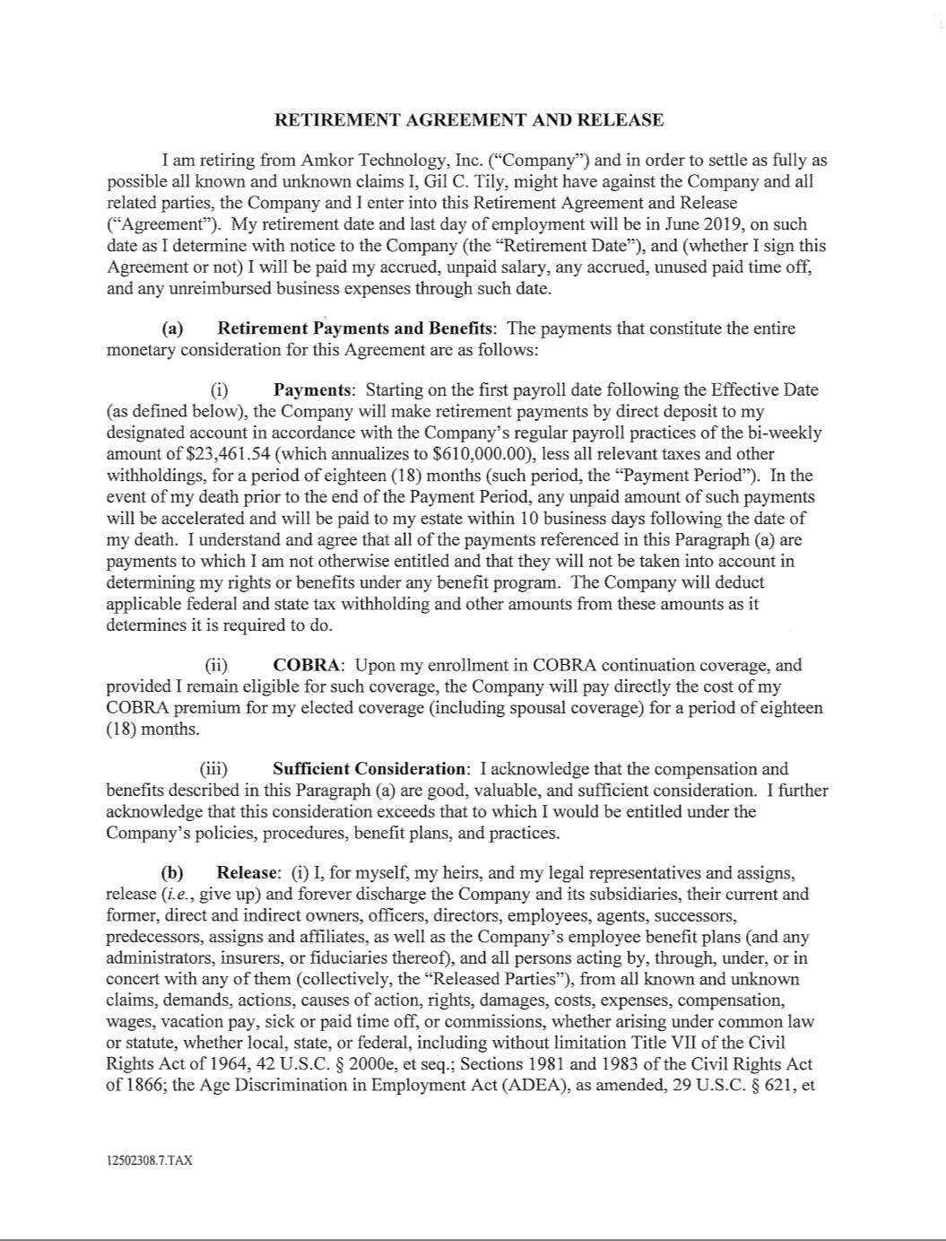

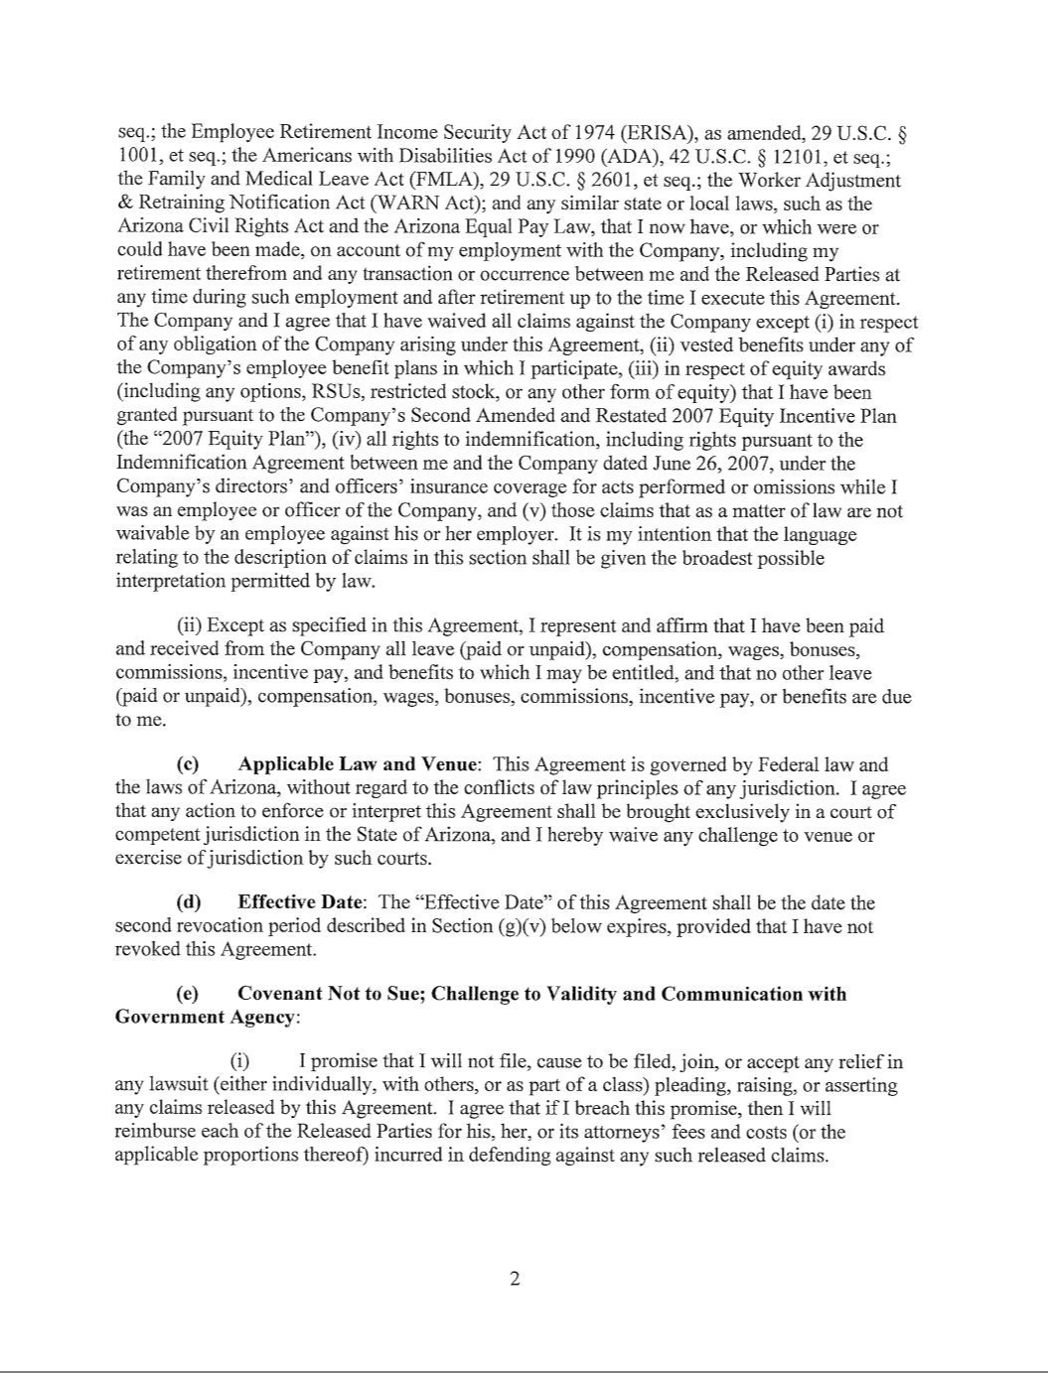

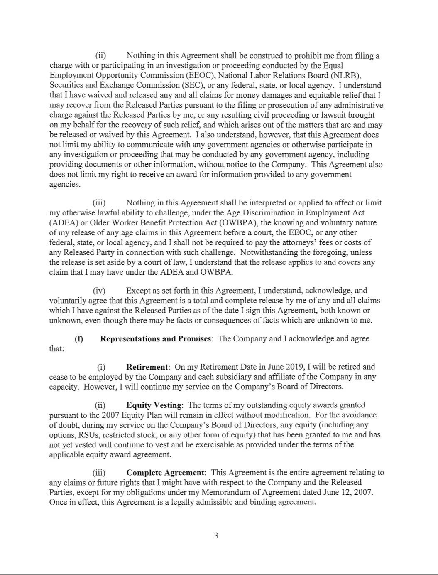

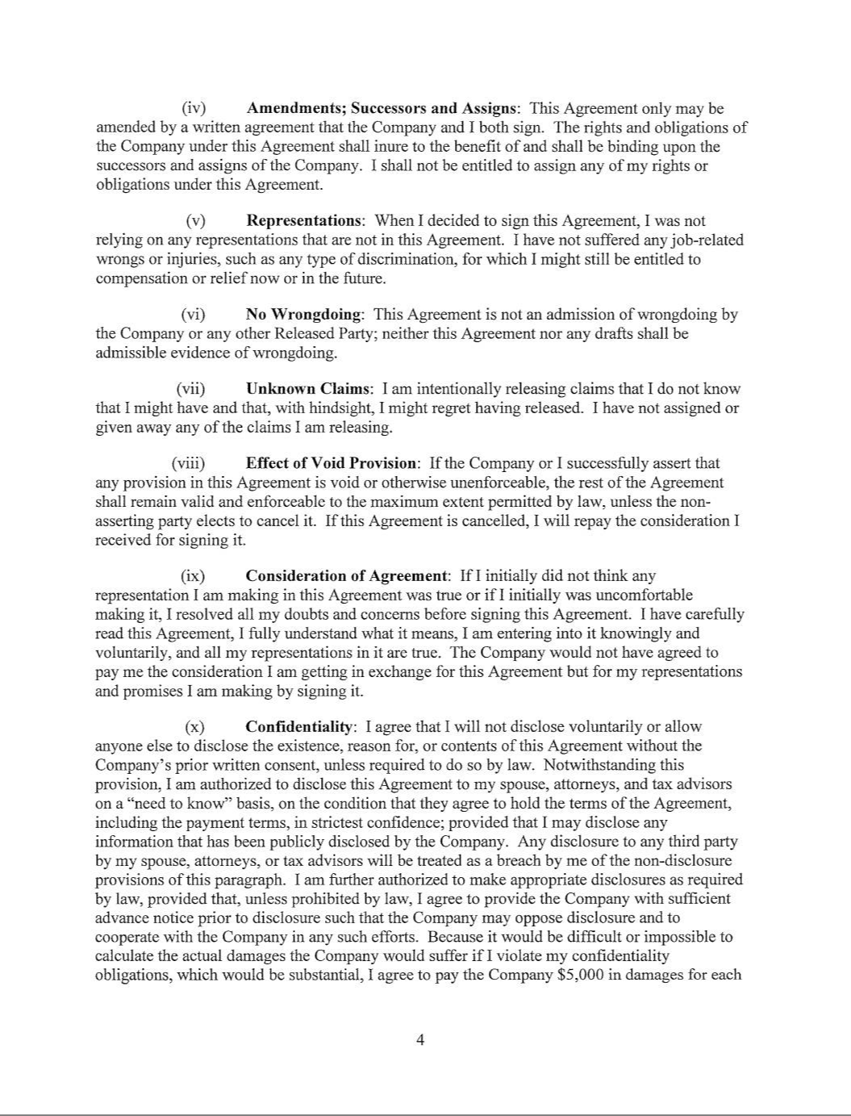

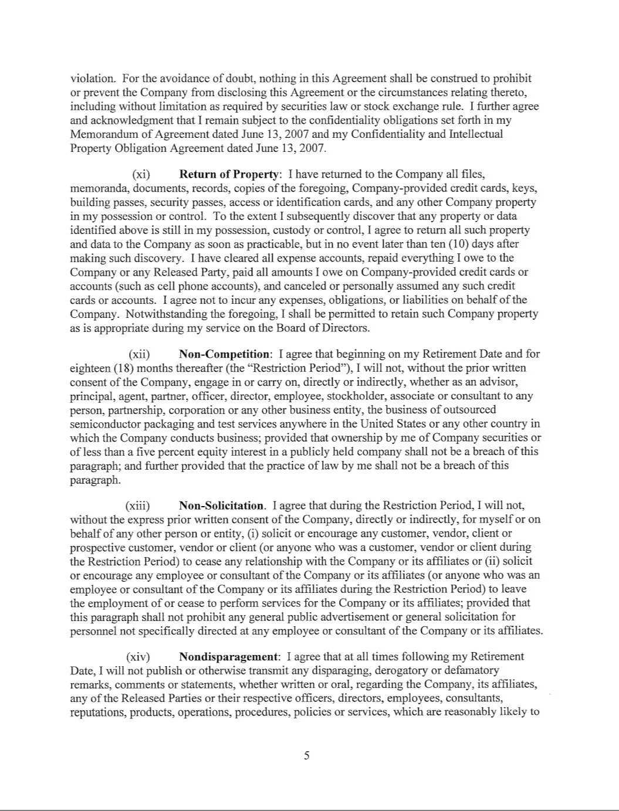

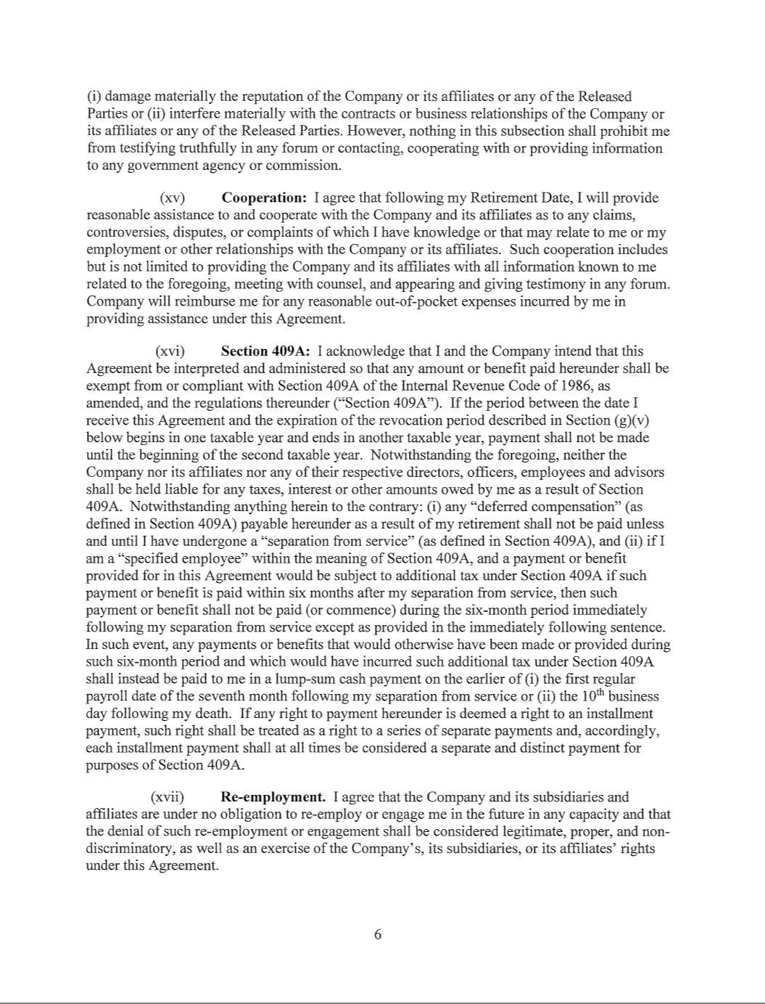

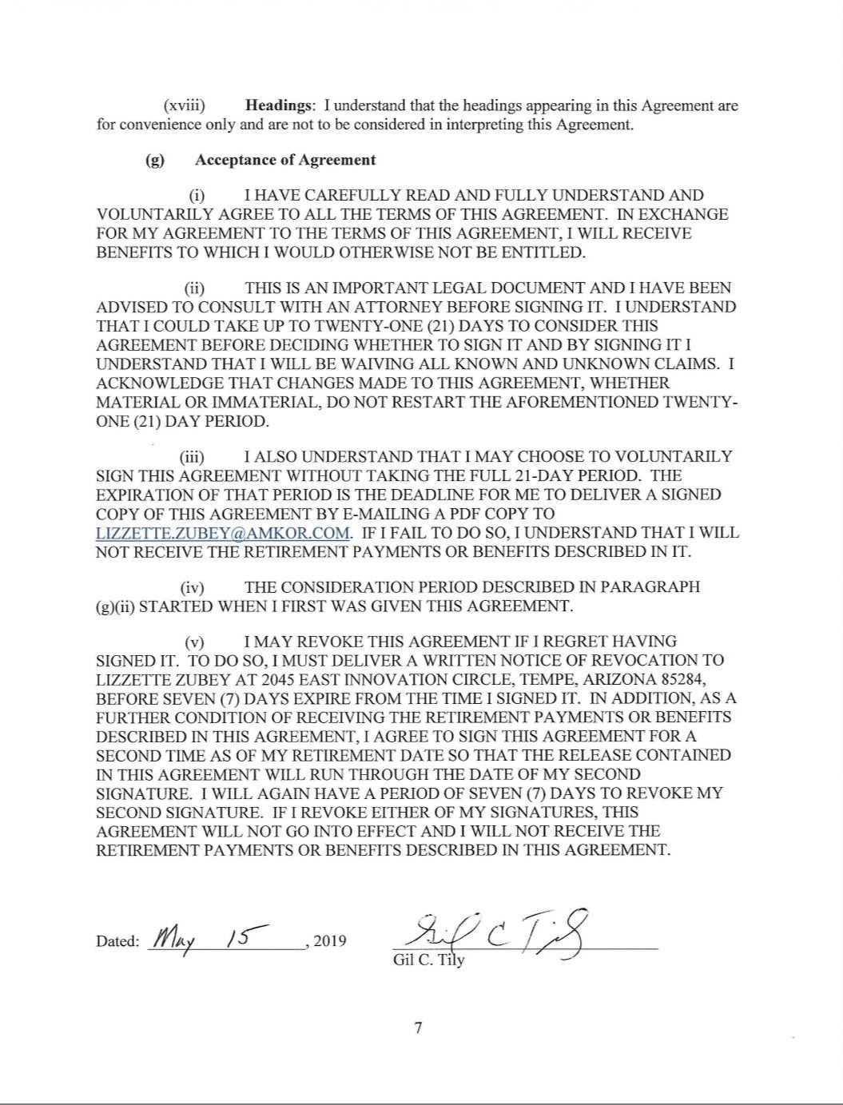

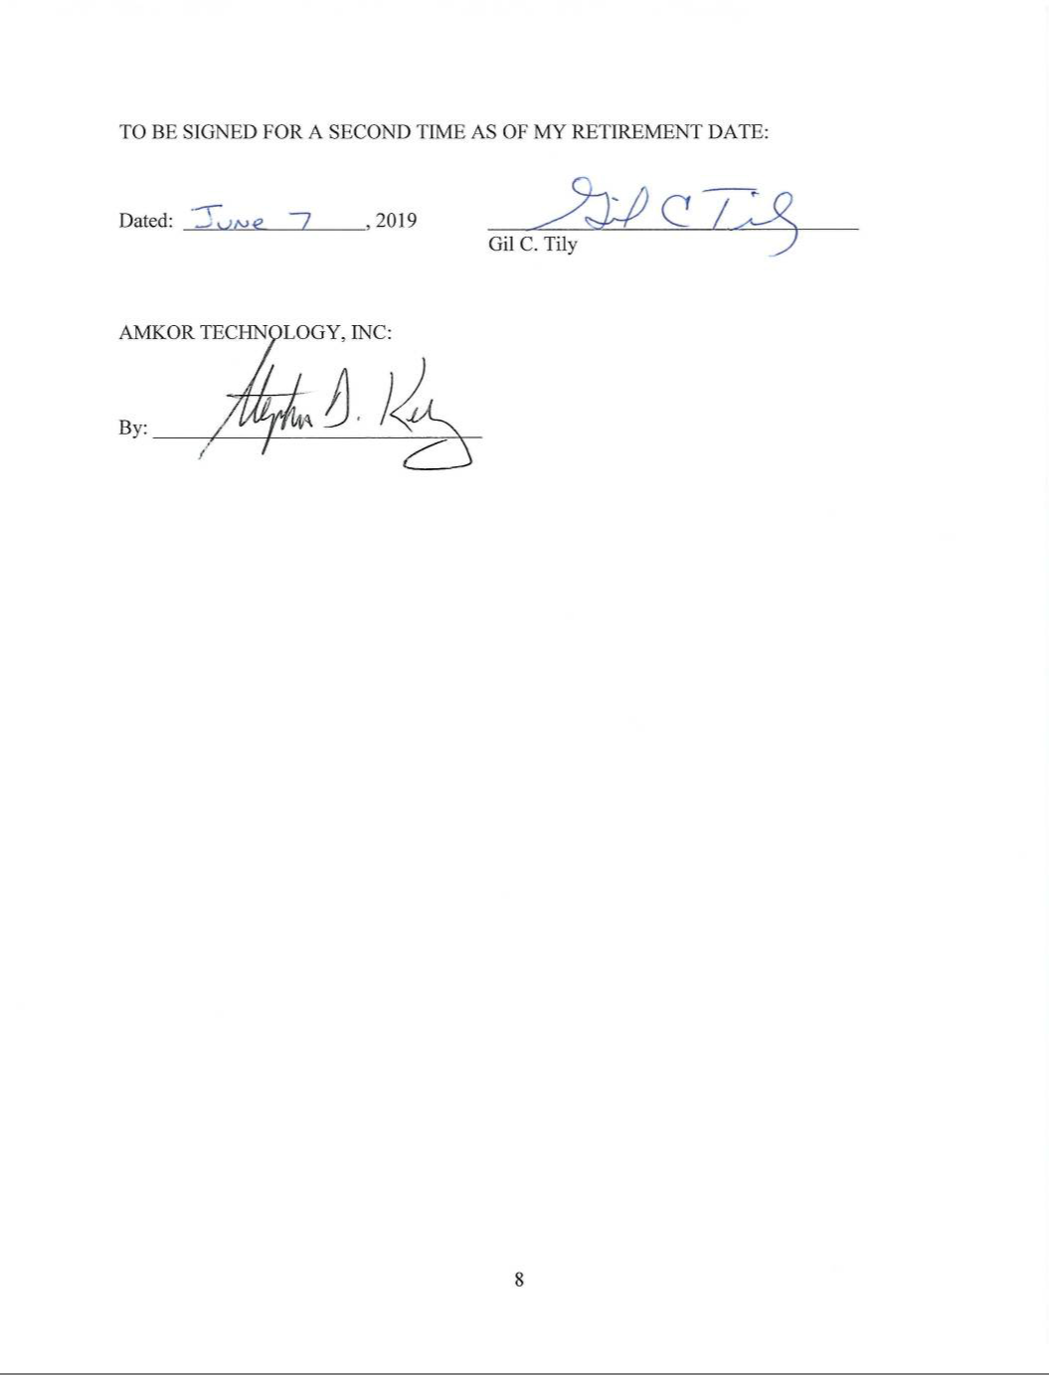

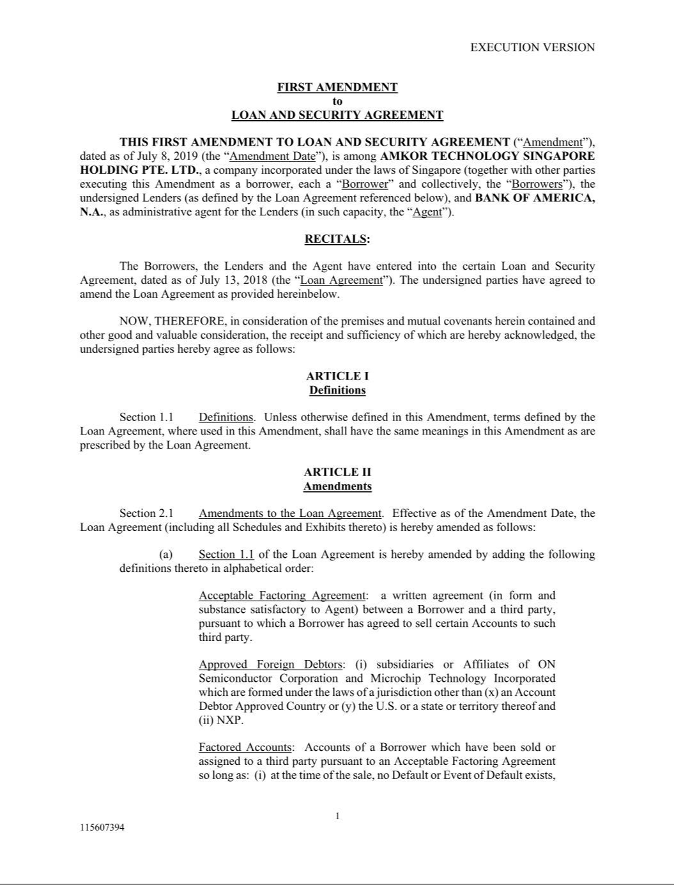

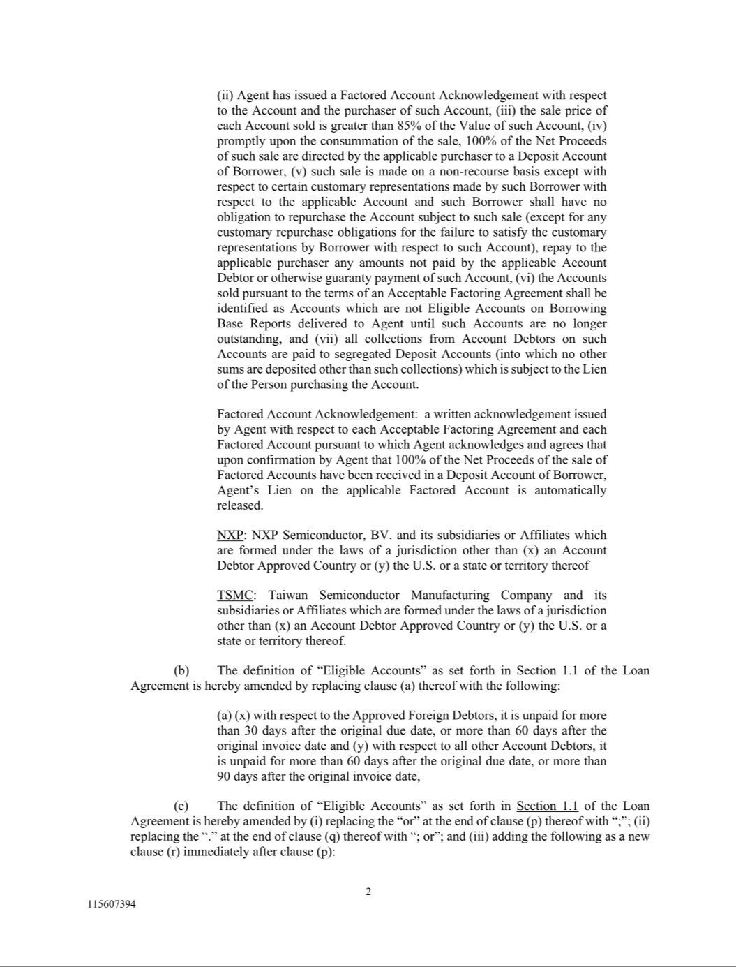

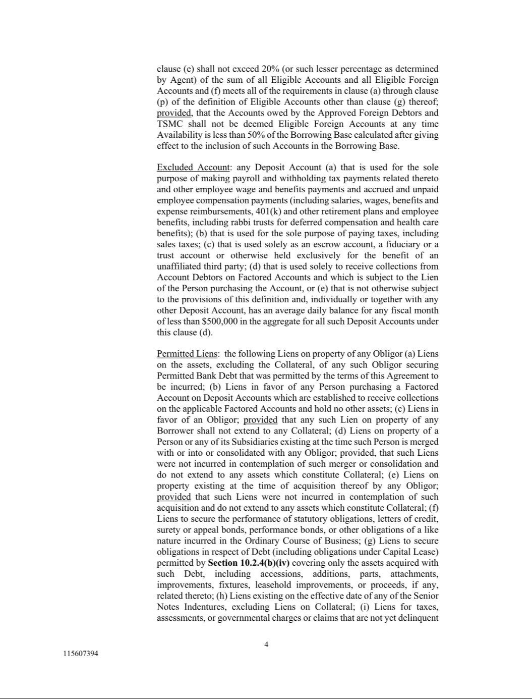

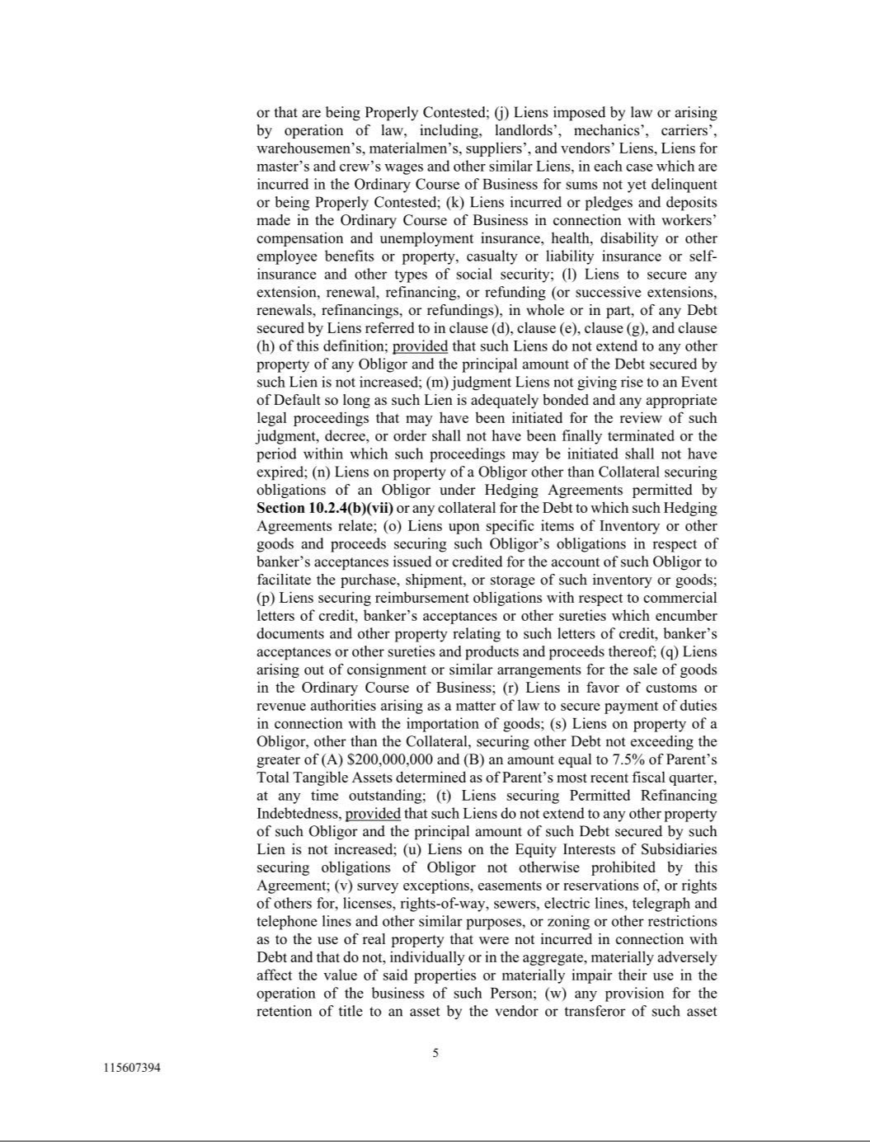

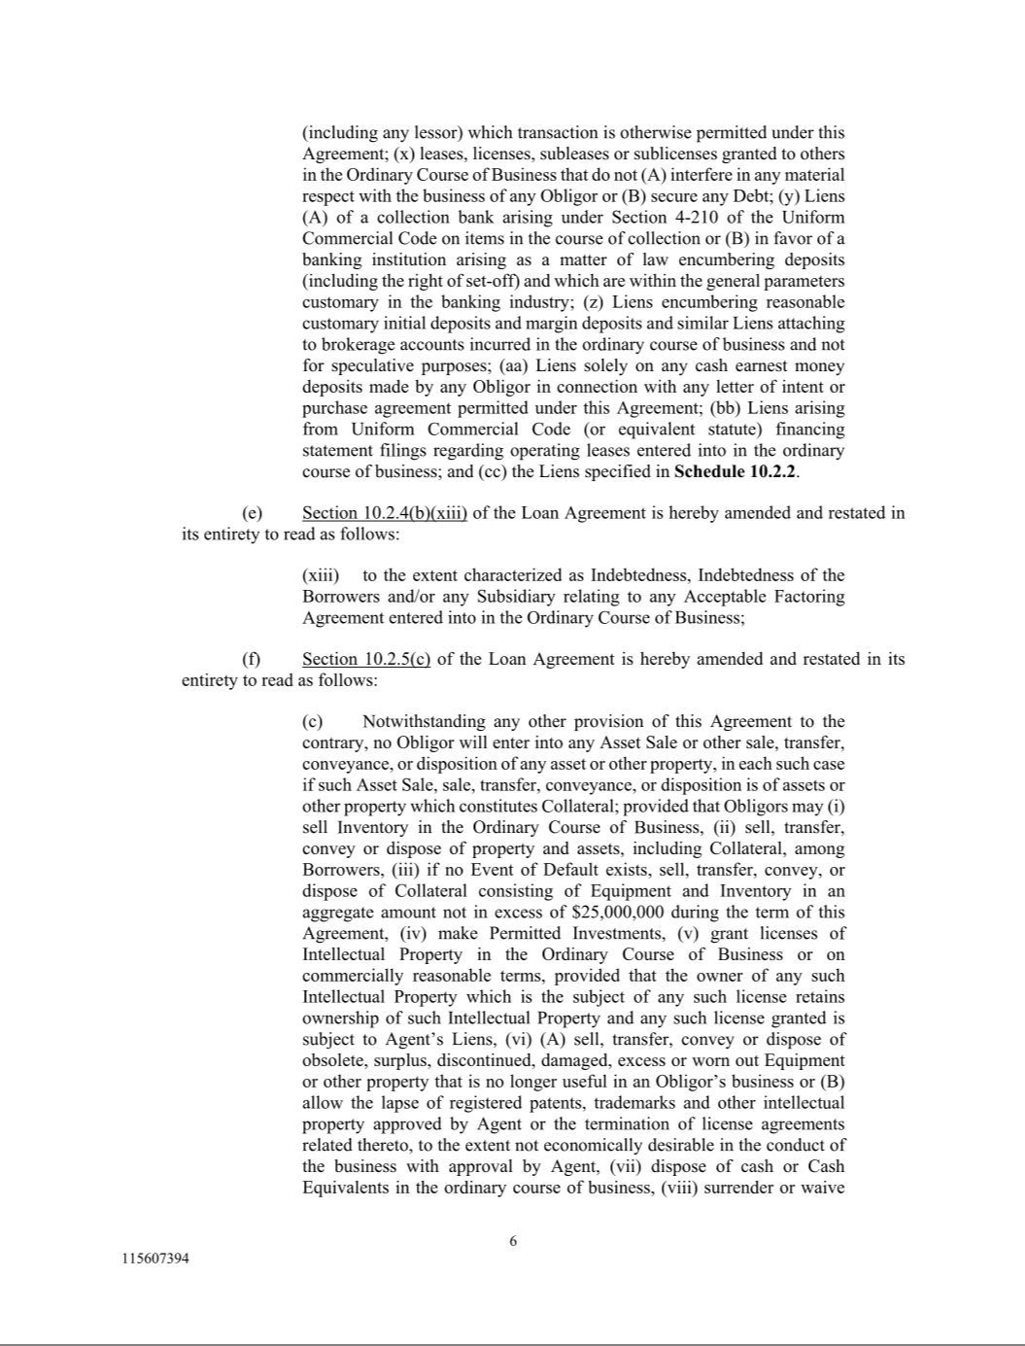

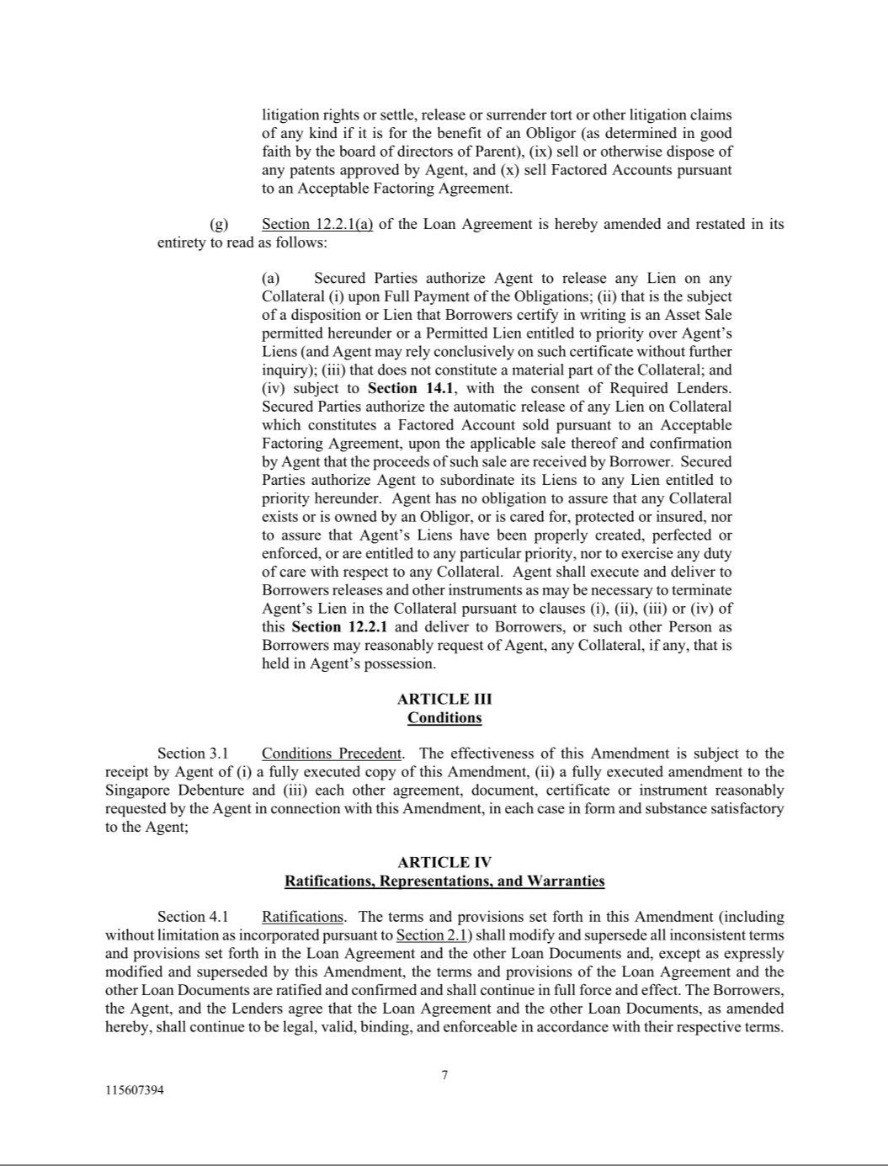

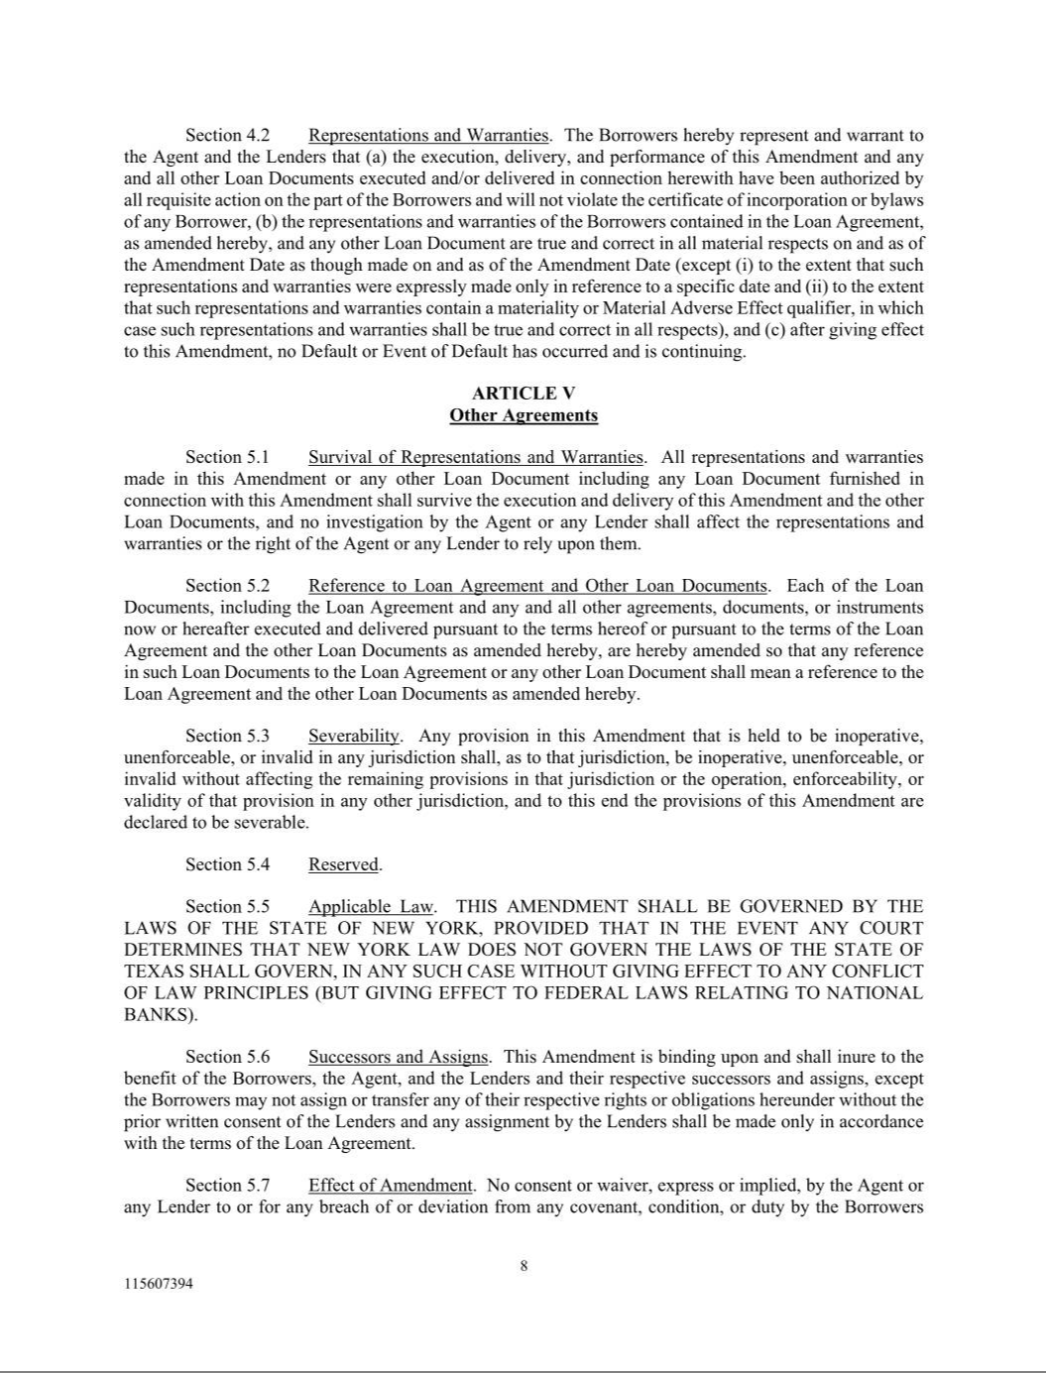

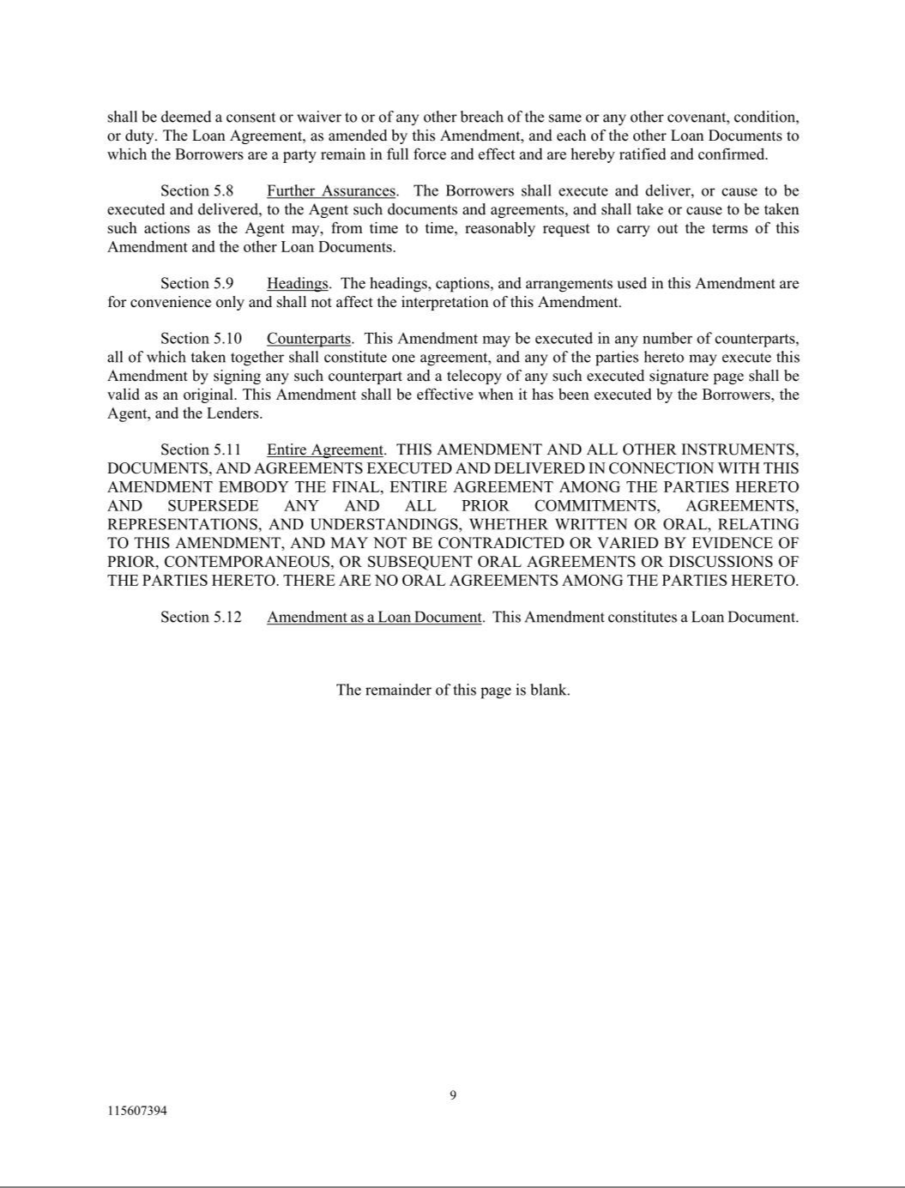

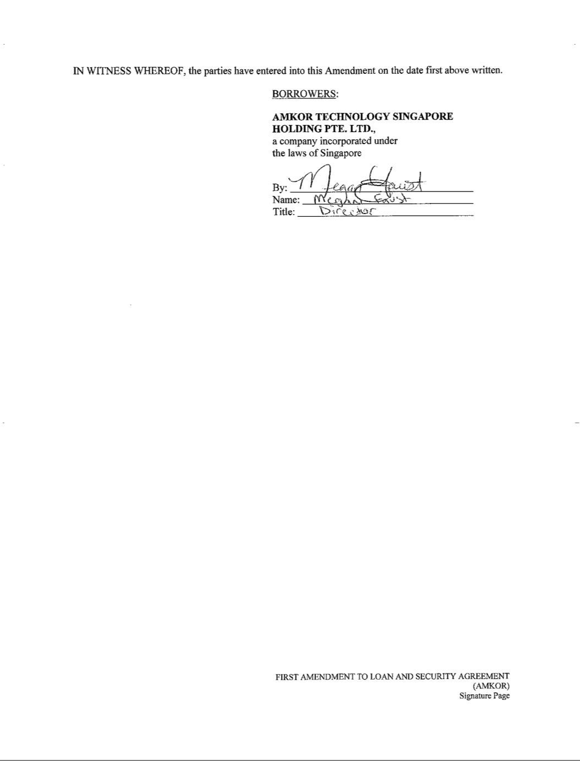

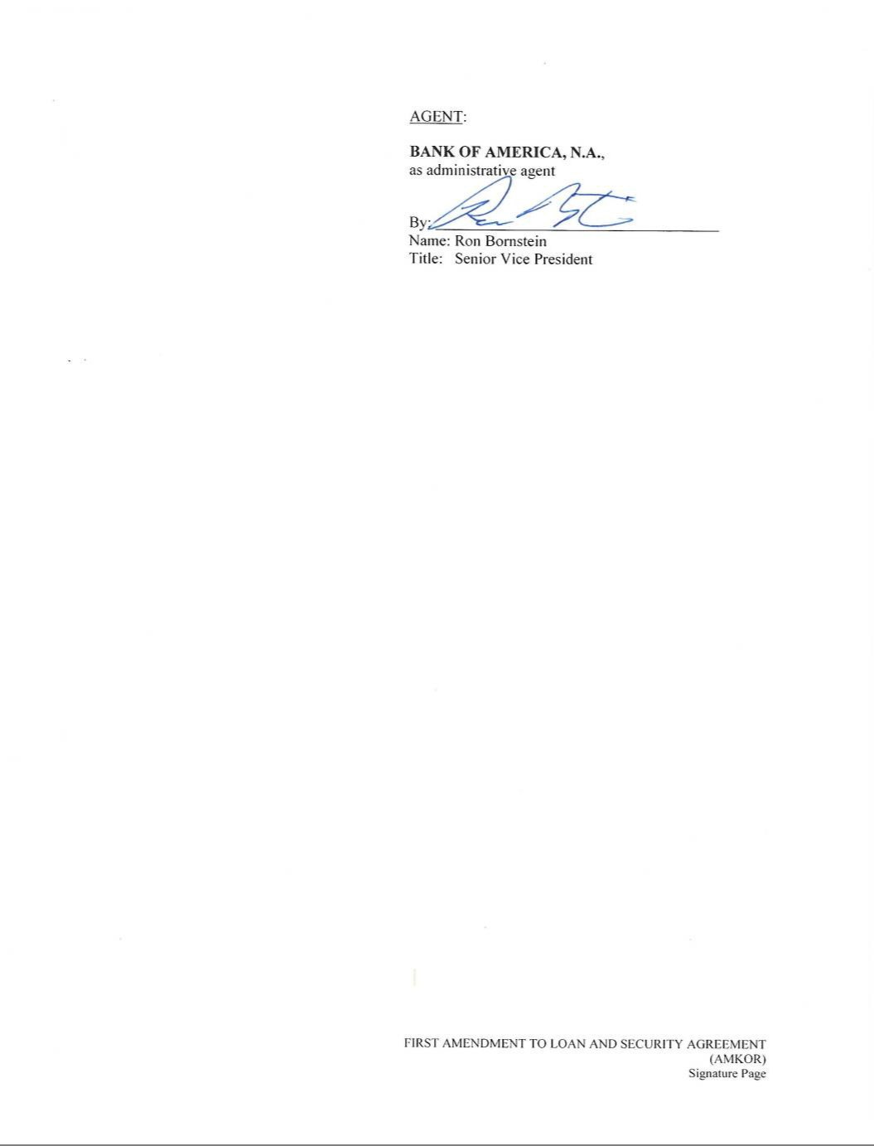



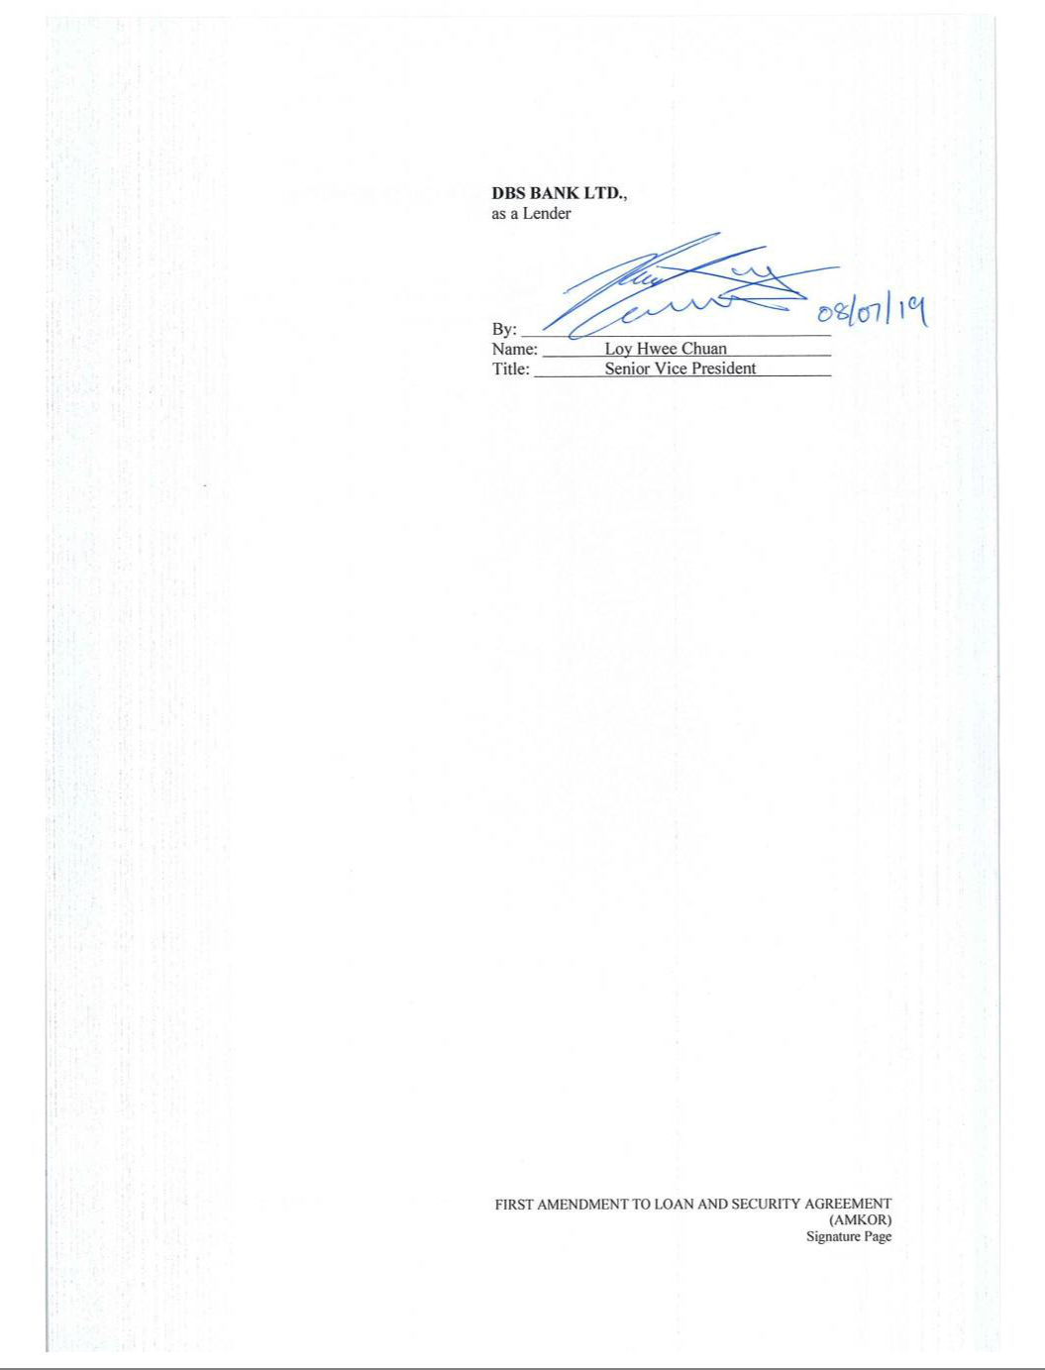



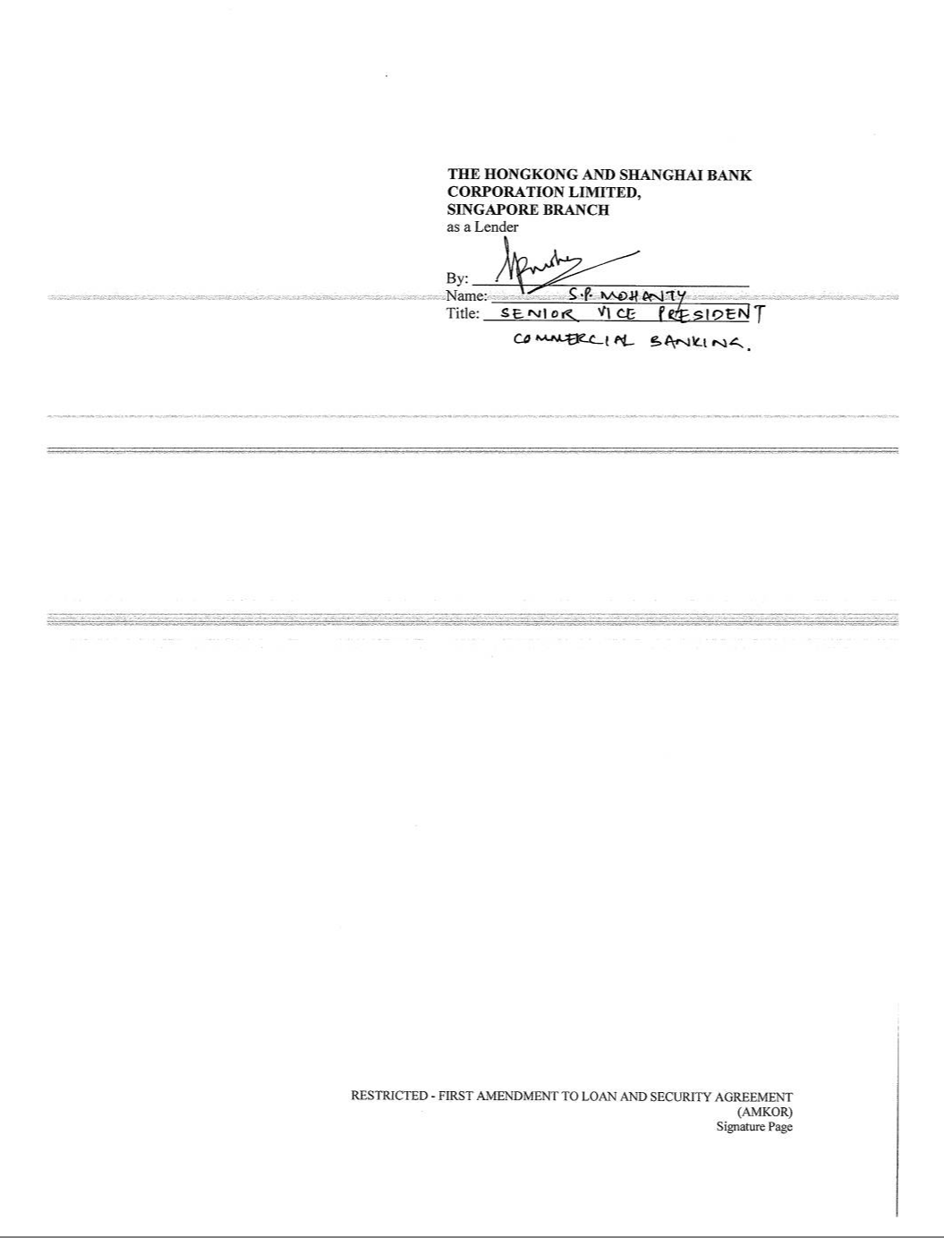

AMENDMENT ONE

TO THE

AMKOR TECHNOLOGY, INC.

SECOND AMENDED AND RESTATED 2007 EQUITY INCENTIVE PLAN

Pursuant to the authority reserved to it in Section 21 of the Amkor Technology, Inc. Second Amended and Restated 2007 Equity Incentive Plan (the “Plan”), the

Board of Directors of Amkor Technology, Inc. (the “Board”) hereby amends the Plan as follows, effective May 15, 2019:

Section 12(d) of the Plan is hereby amended in its entirety to read as follows:

- Initial Award. Each person who first becomes an Outside Director will be automatically granted: (i) an Option to purchase a number of Shares equal to the product of (I) 20,000 multiplied by (II) a fraction, the numerator of which is the number of days in the period beginning on the date such person first becomes an Outside Director and ending on the date of the first annual meeting of the stockholders of the Company thereafter, and the denominator of which is 365 (the “Fraction”) rounded down to the nearest whole number (the “Initial Option”) and (ii) an Award of Restricted Stock equal to the product of (I) $60,000 divided by the Fair Market Value of a Share on the date such person first becomes an Outside Director multiplied by (II) the Fraction rounded down to the nearest whole number (the “Initial Restricted Stock Award”). The Initial Option and the Initial Restricted Stock Award shall be granted on or about the date on which such person first becomes an Outside Director, whether through election by the stockholders of the Company or appointment by the Board to fill a vacancy; provided, however, that an Inside Director who ceases to be an Inside Director, but who remains a Director, will not receive an Initial Option or an Initial Restricted Stock Award.

Section 12(g) of the Plan is hereby amended in its entirety to read as follows:

- Annual Restricted Stock Award. Each Outside Director will be automatically granted Restricted Stock having a Fair Market Value of sixty thousand dollars ($60,000) (an “Annual Restricted Stock Award”) on each date of the annual meeting of the stockholders of the Company.

Exhibit 31.1

SECTION 302 CERTIFICATION

I, Stephen D. Kelley, certify that:

- I have reviewed this Quarterly Report on Form 10-Q of Amkor Technology, Inc.;

- Based on my knowledge, this report does not contain any untrue statement of a material fact or omit to state a material fact necessary to make the statements made, in light of the circumstances under which such statements were made, not misleading with respect to the period covered by this report;

- Based on my knowledge, the financial statements, and other financial information included in this report, fairly present in all material respects the financial condition, results of operations and cash flows of the registrant as of, and for, the periods presented in this report;

- The registrant’s other certifying officer and I are responsible for establishing and maintaining disclosure controls and procedures (as defined in Exchange Act Rules 13a-15(e) and 15d-15(e)) and internal control over financial reporting (as defined in Exchange Act Rules 13a-15(f) and 15d-15(f)) for the registrant and have:

  - Designed such disclosure controls and procedures, or caused such disclosure controls and procedures to be designed under our supervision, to ensure that material information relating to the registrant, including its consolidated subsidiaries, is made known to us by others within those entities, particularly during the period in which this report is being prepared;

  - Designed such internal control over financial reporting, or caused such internal control over financial reporting to be designed under our supervision, to provide reasonable assurance regarding the reliability of financial reporting and the preparation of financial statements for external purposes in accordance with generally accepted accounting principles;

  - Evaluated the effectiveness of the registrant’s disclosure controls and procedures and presented in this report our conclusions about the effectiveness of the disclosure controls and procedures, as of the end of the period covered by this report based on such evaluation; and

  - Disclosed in this report any change in the registrant’s internal control over financial reporting that occurred during the registrant’s most recent fiscal quarter (the registrant’s fourth fiscal quarter in the case of an annual report) that has materially affected, or is reasonably likely to materially affect, the registrant’s internal control over financial reporting; and

- The registrant’s other certifying officer and I have disclosed, based on our most recent evaluation of internal control over financial reporting, to the registrant’s auditors and the audit committee of the registrant’s board of directors (or persons performing the equivalent functions):

  - All significant deficiencies and material weaknesses in the design or operation of internal control over financial reporting which are reasonably likely to adversely affect the registrant’s ability to record, process, summarize and report financial information; and

  - Any fraud, whether or not material, that involves management or other employees who have a significant role in the registrant’s internal controls over financial reporting.

/s/ Stephen D. Kelley

Stephen D. Kelley

President and Chief Executive Officer

August 1, 2019

Exhibit 31.2

SECTION 302 CERTIFICATION

I, Megan Faust, certify that:

- I have reviewed this Quarterly Report on Form 10-Q of Amkor Technology, Inc.;

- Based on my knowledge, this report does not contain any untrue statement of a material fact or omit to state a material fact necessary to make the statements made, in light of the circumstances under which such statements were made, not misleading with respect to the period covered by this report;

- Based on my knowledge, the financial statements, and other financial information included in this report, fairly present in all material respects the financial condition, results of operations and cash flows of the registrant as of, and for, the periods presented in this report;

- The registrant’s other certifying officer and I are responsible for establishing and maintaining disclosure controls and procedures (as defined in Exchange Act Rules 13a-15(e) and 15d-15(e)) and internal control over financial reporting (as defined in Exchange Act Rules 13a-15(f) and 15d-15(f)) for the registrant and have:

  - Designed such disclosure controls and procedures, or caused such disclosure controls and procedures to be designed under our supervision, to ensure that material information relating to the registrant, including its consolidated subsidiaries, is made known to us by others within those entities, particularly during the period in which this report is being prepared;

  - Designed such internal control over financial reporting, or caused such internal control over financial reporting to be designed under our supervision, to provide reasonable assurance regarding the reliability of financial reporting and the preparation of financial statements for external purposes in accordance with generally accepted accounting principles;

  - Evaluated the effectiveness of the registrant’s disclosure controls and procedures and presented in this report our conclusions about the effectiveness of the disclosure controls and procedures, as of the end of the period covered by this report based on such evaluation; and

  - Disclosed in this report any change in the registrant’s internal control over financial reporting that occurred during the registrant’s most recent fiscal quarter (the registrant’s fourth fiscal quarter in the case of an annual report) that has materially affected, or is reasonably likely to materially affect, the registrant’s internal control over financial reporting; and

- The registrant’s other certifying officer and I have disclosed, based on our most recent evaluation of internal control over financial reporting, to the registrant’s auditors and the audit committee of the registrant’s board of directors (or persons performing the equivalent functions):

  - All significant deficiencies and material weaknesses in the design or operation of internal control over financial reporting which are reasonably likely to adversely affect the registrant’s ability to record, process, summarize and report financial information; and

  - Any fraud, whether or not material, that involves management or other employees who have a significant role in the registrant’s internal controls over financial reporting.

/s/ Megan Faust

Megan Faust

Corporate Vice President and

Chief Financial Officer

August 1, 2019

Exhibit 32

CERTIFICATIONS OF CHIEF EXECUTIVE OFFICER AND CHIEF FINANCIAL OFFICER

PURSUANT TO

18 U.S.C. SECTION 1350,

AS ADOPTED PURSUANT TO

SECTION 906 OF THE SARBANES-OXLEY ACT OF 2002

In connection with the Quarterly Report of Amkor Technology, Inc. (the “Company”) on Form 10-Q for the period ended June 30, 2019, as filed with the Securities and Exchange Commission on the date hereof (the “Report”), I, Stephen D. Kelley, President and Chief Executive Officer of the Company, certify, pursuant to 18 U.S.C. Section 1350, as adopted pursuant to Section 906 of the Sarbanes-Oxley Act of 2002, that:

- The Report fully complies with the requirements of section 13(a) or 15(d) of the Securities Exchange Act of 1934, as amended; and

- The information contained in the Report fairly presents, in all material respects, the financial condition and results of operations of the Company.

/s/ Stephen D. Kelley

Stephen D. Kelley

President and Chief Executive Officer

August 1, 2019

In connection with the Quarterly Report of Amkor Technology, Inc. (the “Company”) on Form 10-Q for the period ended June 30, 2019, as filed with the Securities and Exchange Commission on the date hereof (the “Report”), I, Megan Faust, Corporate Vice President and Chief Financial Officer of the Company, certify, pursuant to 18 U.S.C. Section 1350, as adopted pursuant to Section 906 of the Sarbanes-Oxley Act of 2002, that:

- The Report fully complies with the requirements of section 13(a) or 15(d) of the Securities Exchange Act of 1934, as amended; and

- The information contained in the Report fairly presents, in all material respects, the financial condition and results of operations of the Company.

/s/ Megan Faust

Megan Faust

Corporate Vice President and

Chief Financial Officer

August 1, 2019

